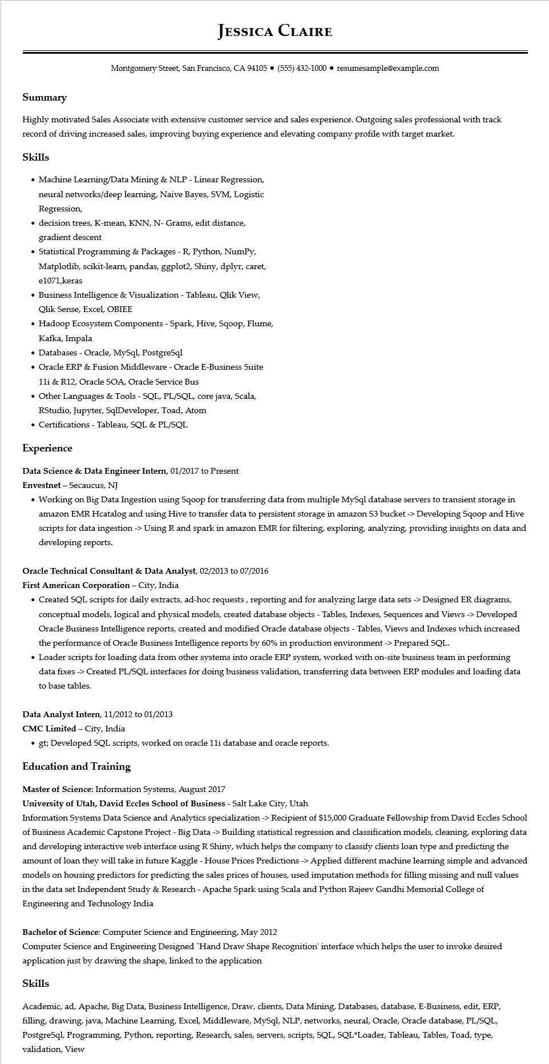

**JESSICA CLAIRE**

Montgomery Street, San Francisco, CA 94105 ⚫ (555) 432-1000⚫ resumesample@example.com

**Summary**

Highly motivated Sales Associate with extensive customer service and sales experience. Outgoing sales professional with track record of driving increased sales, improving buying experience and elevating company profile with target market.

**Skills**

• Machine Learning/Data Mining & NLP - Linear Regression, neural networks/deep learning, Naive Bayes, SVM, Logistic Regression,

⚫ decision trees, K-mean, KNN, N- Grams, edit distance, gradient descent

• Statistical Programming & Packages - R, Python, NumPy, Matplotlib, scikit-learn, pandas, ggplot2, Shiny, dplyr, caret, e1071,keras

• Business Intelligence & Visualization - Tableau, Qlik View, Qlik Sense, Excel, OBIEE

• Hadoop Ecosystem Components - Spark, Hive, Sqoop, Flume, Kafka, Impala

• Databases - Oracle, MySql, PostgreSql

• Oracle ERP & Fusion Middleware - Oracle E-Business Suite

11i & R12, Oracle SOA, Oracle Service Bus

• Other Languages & Tools - SQL, PL/SQL, core java, Scala,

RStudio, Jupyter, SqlDeveloper, Toad, Atom

• Certifications - Tableau, SQL & PL/SQL

**Experience**

Data Science & Data Engineer Intern, 01/2017 to Present

Envestnet - Secaucus, NJ

• Working on Big Data Ingestion using Sqoop for transferring data from multiple MySql database servers to transient storage in amazon EMR Hcatalog and using Hive to transfer data to persistent storage in amazon 53 bucket -> Developing Sqoop and Hive scripts for data ingestion -> Using R and spark in amazon EMR for filtering, exploring, analyzing, providing insights on data and developing reports.

Oracle Technical Consultant & Data Analyst, 02/2013 to 07/2016

First American Corporation - City, India

• Created SQL scripts for daily extracts, ad-hoc requests, reporting and for analyzing large data sets -> Designed ER diagrams, conceptual models, logical and physical models, created database objects - Tables, Indexes, Sequences and Views -> Developed Oracle Business Intelligence reports, created and modified Oracle database objects - Tables, Views and Indexes which increased the performance of Oracle Business Intelligence reports by 60% in production environment -> Prepared SQL.

• Loader scripts for loading data from other systems into oracle ERP system, worked with on-site business team in performing data fixes -> Created PL/SQL interfaces for doing business validation, transferring data between ERP modules and loading data to base tables.

**Data Analyst Intern, 11/2012 to 01/2013**

CMC Limited - City, India

• gt; Developed SQL scripts, worked on oracle 11i database and oracle reports.

**Education and Training**

Master of Science: Information Systems, August 2017

**University of Utah, David Eccles School of Business - Salt Lake City, Utah**

Information Systems Data Science and Analytics specialization-> Recipient of $15,000 Graduate Fellowship from David Eccles School of Business Academic Capstone Project - Big Data -> Building statistical regression and classification models, cleaning, exploring data and developing interactive web interface using R Shiny, which helps the company to classify clients loan type and predicting the amount of loan they will take in future Kaggle - House Prices Predictions -> Applied different machine learning simple and advanced models on housing predictors for predicting the sales prices of houses, used imputation methods for filling missing and null values in the data set Independent Study & Research - Apache Spark using Scala and Python Rajeev Gandhi Memorial College of Engineering and Technology India

Bachelor of Science: Computer Science and Engineering, May 2012

Computer Science and Engineering Designed 'Hand Draw Shape Recognition' interface which helps the user to invoke desired application just by drawing the shape, linked to the application

**Skills**

Academic, ad, Apache, Big Data, Business Intelligence, Draw, clients, Data Mining, Databases, database, E-Business, edit, ERP, filling, drawing, java, Machine Learning, Excel, Middleware, MySql, NLP, networks, neural, Oracle, Oracle database, PL/SQL, Postgresql, Programming, Python, reporting, Research, sales, servers, scripts, SQL, SQL*Loader, Tableau, Tables, Toad, type, validation, View