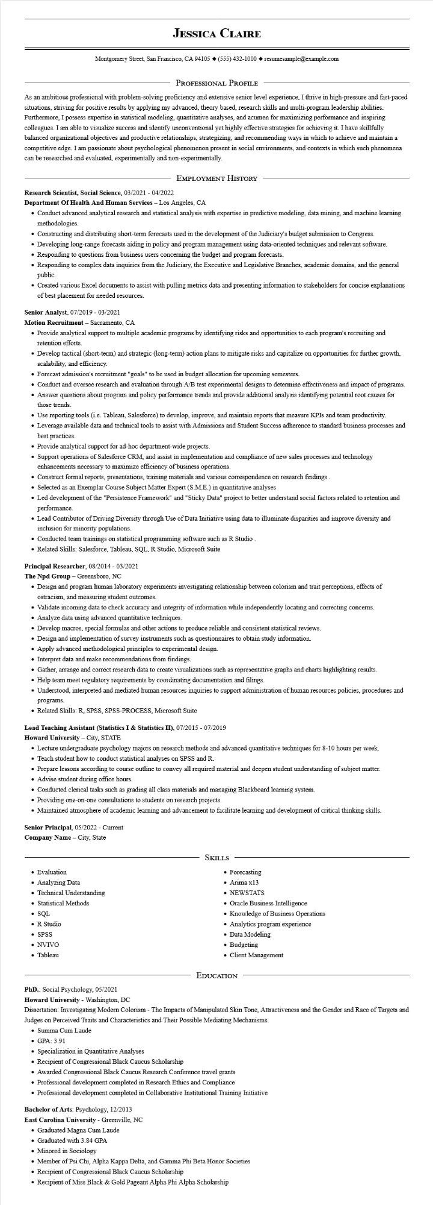

**JESSICA CLAIRE**

Montgomery Street, San Francisco, CA 94105 ♦ (555) 432-1000 resumesample@example.com

PROFESSIONAL PROFILE

As an ambitious professional with problem-solving proficiency and extensive senior level experience, I thrive in high-pressure and fast-paced situations, striving for positive results by applying my advanced, theory based, research skills and multi-program leadership abilities. Furthermore, I possess expertise in statistical modeling, quantitative analyses, and acumen for maximizing performance and inspiring colleagues. I am able to visualize success and identify unconventional yet highly effective strategies for achieving it. I have skillfully balanced organizational objectives and productive relationships, strategizing, and recommending ways in which to achieve and maintain a competitive edge. I am passionate about psychological phenomenon present in social environments, and contexts in which such phenomena can be researched and evaluated, experimentally and non-experimentally.

**Research Scientist, Social Science, 03/2021 - 04/2022**

EMPLOYMENT HISTORY

**Department Of Health And Human Services - Los Angeles, CA**

• Conduct advanced analytical research and statistical analysis with expertise in predictive modeling, data mining, and machine learning methodologies.

• Constructing and distributing short-term forecasts used in the development of the Judiciary's budget submission to Congress.

• Developing long-range forecasts aiding in policy and program management using data-oriented techniques and relevant software.

• Responding to questions from business users concerning the budget and program forecasts.

• Responding to complex data inquiries from the Judiciary, the Executive and Legislative Branches, academic domains, and the general public.

• Created various Excel documents to assist with pulling metrics data and presenting information to stakeholders for concise explanations of best placement for needed resources.

**Senior Analyst, 07/2019-03/2021**

Motion Recruitment - Sacramento, CA

• Provide analytical support to multiple academic programs by identifying risks and opportunities to each program's recruiting and retention efforts.

Develop tactical (short-term) and strategic (long-term) action plans to mitigate risks and capitalize on opportunities for further growth, scalability, and efficiency.

• Forecast admission's recruitment "goals" to be used in budget allocation for upcoming semesters.

• Conduct and oversee research and evaluation through A/B test experimental designs to determine effectiveness and impact of programs.

• Answer questions about program and policy performance trends and provide additional analysis identifying potential root causes for those trends.

• Use reporting tools (i.e. Tableau, Salesforce) to develop, improve, and maintain reports that measure KPIs and team productivity.

• Leverage available data and technical tools to assist with Admissions and Student Success adherence to standard business processes and best practices.

• Provide analytical support for ad-hoc department-wide projects.

• Support operations of Salesforce CRM, and assist in implementation and compliance of new sales processes and technology enhancements necessary to maximize efficiency of business operations.

• Construct formal reports, presentations, training materials and various correspondence on research findings.

• Selected as an Exemplar Course Subject Matter Expert (S.M.E.) in quantitative analyses

• Led development of the "Persistence Framework" and "Sticky Data" project to better understand social factors related to retention and performance.

• Lead Contributor of Driving Diversity through Use of Data Initiative using data to illuminate disparities and improve diversity and inclusion for minority populations.

• Conducted team trainings on statistical programming software such as R Studio

• Related Skills: Salesforce, Tableau, SQL, R Studio, Microsoft Suite

**Principal Researcher, 08/2014 - 03/2021**

The Npd Group - Greensboro, NC

• Design and program human laboratory experiments investigating relationship between colorism and trait perceptions, effects of ostracism, and measuring student outcomes.

• Validate incoming data to check accuracy and integrity of information while independently locating and correcting concerns.

• Analyze data using advanced quantitative techniques.

• Develop macros, special formulas and other actions to produce reliable and consistent statistical reviews.

• Design and implementation of survey instruments such as questionnaires to obtain study information.

• Apply advanced methodological principles to experimental design.

• Interpret data and make recommendations from findings.

• Gather, arrange and correct research data to create visualizations such as representative graphs and charts highlighting results.

• Help team meet regulatory requirements by coordinating documentation and filings.

• Understood, interpreted and mediated human resources inquiries to support administration of human resources policies, procedures and programs.

• Related Skills: R, SPSS, SPSS-PROCESS, Microsoft Suite

**Lead Teaching Assistant (Statistics I & Statistics II), 07/2015 - 07/2019**

**Howard University - City, STATE**

• Lecture undergraduate psychology majors on research methods and advanced quantitative techniques for 8-10 hours per week.

• Teach student how to conduct statistical analyses on SPSS and R.

• Prepare lessons according to course outline to convey all required material and deepen student understanding of subject matter. • Advise student during office hours.

• Conducted clerical tasks such as grading all class materials and managing Blackboard learning system.

• Providing one-on-one consultations to students on research projects.

• Maintained atmosphere of academic learning and advancement to facilitate learning and development of critical thinking skills.

**Senior Principal, 05/2022 - Current**

**Company Name - City, State**

• Evaluation

• Analyzing Data

• Technical Understanding

• Statistical Methods

• SQL

• R Studio

• SPSS

• NVIVO

• Tableau

SKILLS

• Forecasting

• Arima x13

• NEWSTATS

• Oracle Business Intelligence

• Knowledge of Business Operations

• Analytics program experience

• Data Modeling

• Budgeting

• Client Management

PhD.: Social Psychology, 05/2021

EDUCATION

**Howard University - Washington, DC**

Dissertation: Investigating Modern Colorism - The Impacts of Manipulated Skin Tone, Attractiveness and the Gender and Race of Targets and Judges on Perceived Traits and Characteristics and Their Possible Mediating Mechanisms.

• Summa Cum Laude

• GPA: 3.91

• Specialization in Quantitative Analyses

• Recipient of Congressional Black Caucus Scholarship

Awarded Congressional Black Caucus Research Conference travel grants

• Professional development completed in Research Ethics and Compliance

• Professional development completed in Collaborative Institutional Training Initiative

Bachelor of Arts: Psychology, 12/2013

**East Carolina University - Greenville, NC**

• Graduated Magna Cum Laude

• Graduated with 3.84 GPA

• Minored in Sociology

• Member of Psi Chi, Alpha Kappa Delta, and Gamma Phi Beta Honor Societies

• Recipient of Congressional Black Caucus Scholarship

• Recipient of Miss Black & Gold Pageant Alpha Phi Alpha Scholarship