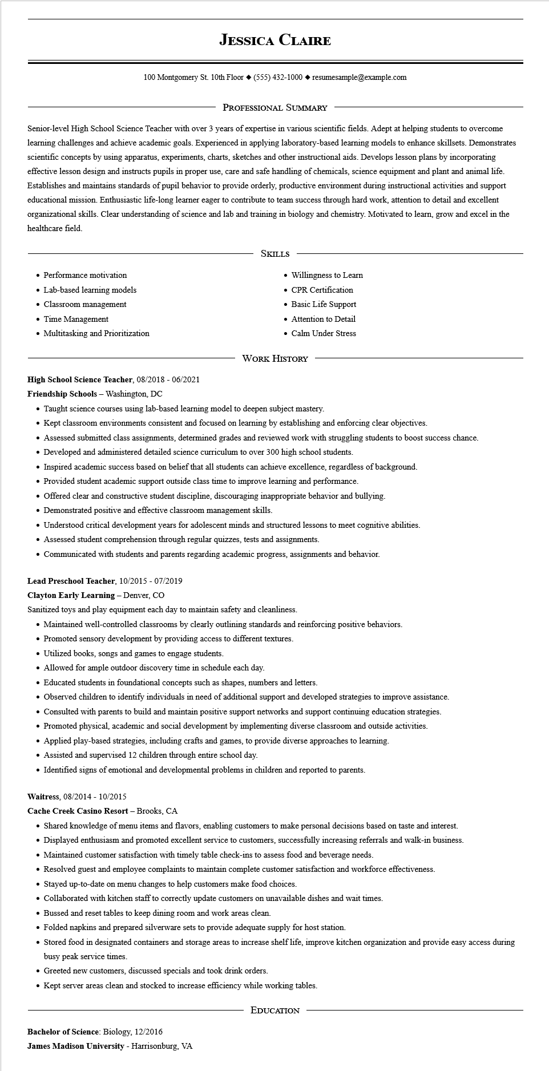

**JESSICA CLAIRE**

100 Montgomery St. 10th Floor (555) 432-1000◆ resumesample@example.com

PROFESSIONAL SUMMARY

Senior-level High School Science Teacher with over 3 years of expertise in various scientific fields. Adept at helping students to overcome learning challenges and achieve academic goals. Experienced in applying laboratory-based learning models to enhance skillsets. Demonstrates scientific concepts by using apparatus, experiments, charts, sketches and other instructional aids. Develops lesson plans by incorporating effective lesson design and instructs pupils in proper use, care and safe handling of chemicals, science equipment and plant and animal life. Establishes and maintains standards of pupil behavior to provide orderly, productive environment during instructional activities and support educational mission. Enthusiastic life-long learner eager to contribute to team success through hard work, attention to detail and excellent organizational skills. Clear understanding of science and lab and training in biology and chemistry. Motivated to learn, grow and excel in the healthcare field.

• Performance motivation

• Lab-based learning models

• Classroom management

• Time Management

• Multitasking and Prioritization

SKILLS

• Willingness to Learn

• CPR Certification

• Basic Life Support

• Attention to Detail

• Calm Under Stress

**High School Science Teacher, 08/2018 - 06/2021**

Friendship Schools - Washington, DC

WORK HISTORY

• Taught science courses using lab-based learning model to deepen subject mastery.

• Kept classroom environments consistent and focused on learning by establishing and enforcing clear objectives.

• Assessed submitted class assignments, determined grades and reviewed work with struggling students to boost success chance.

• Developed and administered detailed science curriculum to over 300 high school students.

• Inspired academic success based on belief that all students can achieve excellence, regardless of background.

• Provided student academic support outside class time to improve learning and performance.

• Offered clear and constructive student discipline, discouraging inappropriate behavior and bullying.

• Demonstrated positive and effective classroom management skills.

• Understood critical development years for adolescent minds and structured lessons to meet cognitive abilities.

• Assessed student comprehension through regular quizzes, tests and assignments.

• Communicated with students and parents regarding academic progress, assignments and behavior.

Lead Preschool Teacher, 10/2015 - 07/2019

Clayton Early Learning - Denver, CO

Sanitized toys and play equipment each day to maintain safety and cleanliness.

• Maintained well-controlled classrooms by clearly outlining standards and reinforcing positive behaviors.

• Promoted sensory development by providing access to different textures.

• Utilized books, songs and games to engage students.

• Allowed for ample outdoor discovery time in schedule each day.

• Educated students in foundational concepts such as shapes, numbers and letters.

• Observed children to identify individuals in need of additional support and developed strategies to improve assistance.

• Consulted with parents to build and maintain positive support networks and support continuing education strategies.

• Promoted physical, academic and social development by implementing diverse classroom and outside activities.

• Applied play-based strategies, including crafts and games, to provide diverse approaches to learning.

• Assisted and supervised 12 children through entire school day.

• Identified signs of emotional and developmental problems in children and reported to parents.

**Waitress, 08/2014 - 10/2015**

**Cache Creek Casino Resort - Brooks, CA**

• Shared knowledge of menu items and flavors, enabling customers to make personal decisions based on taste and interest.

• Displayed enthusiasm and promoted excellent service to customers, successfully increasing referrals and walk-in business.

• Maintained customer satisfaction with timely table check-ins to assess food and beverage needs.

• Resolved guest and employee complaints to maintain complete customer satisfaction and workforce effectiveness.

• Stayed up-to-date on menu changes to help customers make food choices.

• Collaborated with kitchen staff to correctly update customers on unavailable dishes and wait times.

• Bussed and reset tables to keep dining room and work areas clean.

• Folded napkins and prepared silverware sets to provide adequate supply for host station.

• Stored food in designated containers and storage areas to increase shelf life, improve kitchen organization and provide easy access during busy peak service times.

• Greeted new customers, discussed specials and took drink orders.

• Kept server areas clean and stocked to increase efficiency while working tables.

**Bachelor of Science: Biology, 12/2016**

**James Madison University - Harrisonburg, VA**

EDUCATION