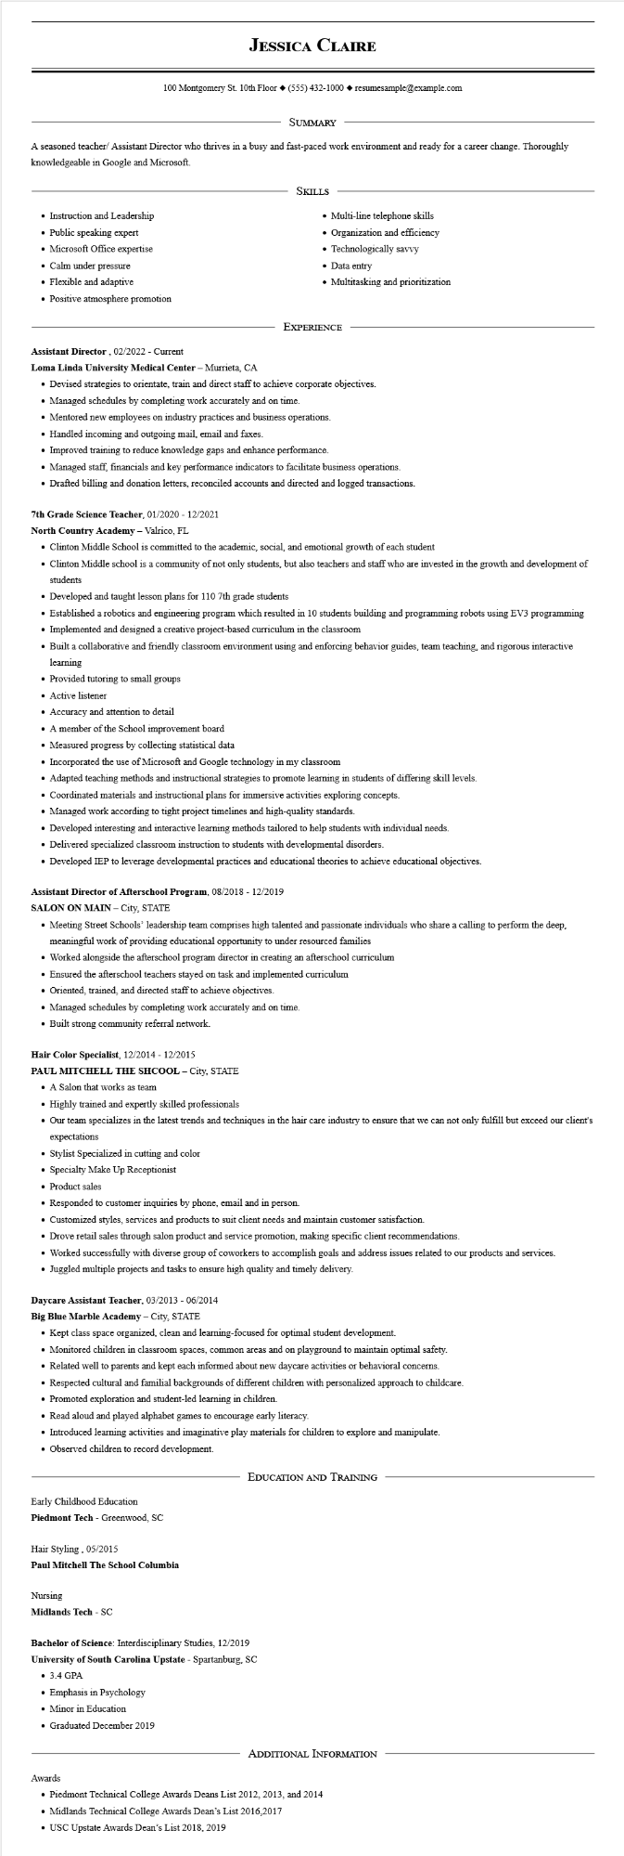

**JESSICA CLAIRE**

100 Montgomery St. 10th Floor (555) 432-1000◆ resumesample@example.com

SUMMARY

A seasoned teacher/ Assistant Director who thrives in a busy and fast-paced work environment and ready for a career change. Thoroughly knowledgeable in Google and Microsoft.

• Instruction and Leadership

• Public speaking expert

• Microsoft Office expertise

• Calm under pressure

• Flexible and adaptive

• Positive atmosphere promotion

SKILLS

• Multi-line telephone skills

Organization and efficiency Technologically savvy

• Data entry

• Multitasking and prioritization

EXPERIENCE

Assistant Director, 02/2022 - Current

**Loma Linda University Medical Center - Murrieta, CA**

• Devised strategies to orientate, train and direct staff to achieve corporate objectives.

• Managed schedules by completing work accurately and on time.

• Mentored new employees on industry practices and business operations.

• Handled incoming and outgoing mail, email and faxes.

• Improved training to reduce knowledge gaps and enhance performance.

• Managed staff, financials and key performance indicators to facilitate business operations.

• Drafted billing and donation letters, reconciled accounts and directed and logged transactions.

7th Grade Science Teacher, 01/2020 - 12/2021

**North Country Academy - Valrico, FL**

• Clinton Middle School is committed to the academic, social, and emotional growth of each student

• Clinton Middle school is a community of not only students, but also teachers and staff who are invested in the growth and development of students

• Developed and taught lesson plans for 110 7th grade students

• Established a robotics and engineering program which resulted in 10 students building and programming robots using EV3 programming

• Implemented and designed a creative project-based curriculum in the classroom

• Built a collaborative and friendly classroom environment using and enforcing behavior guides, team teaching, and rigorous interactive learning

• Provided tutoring to small groups

• Active listener

• Accuracy and attention to detail

• A member of the School improvement board

• Measured progress by collecting statistical data

• Incorporated the use of Microsoft and Google technology in my classroom

• Adapted teaching methods and instructional strategies to promote learning in students of differing skill levels.

• Coordinated materials and instructional plans for immersive activities exploring concepts.

• Managed work according to tight project timelines and high-quality standards.

• Developed interesting and interactive learning methods tailored to help students with individual needs.

• Delivered specialized classroom instruction to students with developmental disorders.

• Developed IEP to leverage developmental practices and educational theories to achieve educational objectives.

**Assistant Director of Afterschool Program, 08/2018 - 12/2019**

**SALON ON MAIN - City, STATE**

• Meeting Street Schools' leadership team comprises high talented and passionate individuals who share a calling to perform the deep, meaningful work of providing educational opportunity to under resourced families

• Worked alongside the afterschool program director in creating an afterschool curriculum

• Ensured the afterschool teachers stayed on task and implemented curriculum

• Oriented, trained, and directed staff to achieve objectives.

• Managed schedules by completing work accurately and on time.

• Built strong community referral network.

**Hair Color Specialist, 12/2014 - 12/2015**

PAUL MITCHELL THE SHCOOL - City, STATE

• A Salon that works as team

• Highly trained and expertly skilled professionals

• Our team specializes in the latest trends and techniques in the hair care industry to ensure that we can not only fulfill but exceed our client's expectations

• Stylist Specialized in cutting and color

• Specialty Make Up Receptionist

• Product sales

• Responded to customer inquiries by phone, email and in person.

• Customized styles, services and products to suit client needs and maintain customer satisfaction.

• Drove retail sales through salon product and service promotion, making specific client recommendations.

• Worked successfully with diverse group of coworkers to accomplish goals and address issues related to our products and services.

• Juggled multiple projects and tasks to ensure high quality and timely delivery.

Daycare Assistant Teacher, 03/2013 - 06/2014

**Big Blue Marble Academy - City, STATE**

• Kept class space organized, clean and learning-focused for optimal student development.

• Monitored children in classroom spaces, common areas and on playground to maintain optimal safety.

• Related well to parents and kept each informed about new daycare activities or behavioral concerns.

• Respected cultural and familial backgrounds of different children with personalized approach to childcare.

• Promoted exploration and student-led learning in children.

• Read aloud and played alphabet games to encourage early literacy.

• Introduced learning activities and imaginative play materials for children to explore and manipulate.

• Observed children to record development.

Early Childhood Education

**Piedmont Tech - Greenwood, SC**

Hair Styling, 05/2015

**Paul Mitchell The School Columbia**

Nursing

**Midlands Tech - SC**

EDUCATION AND TRAINING

Bachelor of Science: Interdisciplinary Studies, 12/2019

**University of South Carolina Upstate - Spartanburg, SC**

• 3.4 GPA

• Emphasis in Psychology

• Minor in Education

• Graduated December 2019

ADDITIONAL INFORMATION

Awards

• Piedmont Technical College Awards Deans List 2012, 2013, and 2014

⚫ Midlands Technical College Awards Dean's List 2016,2017

• USC Upstate Awards Dean's List 2018, 2019