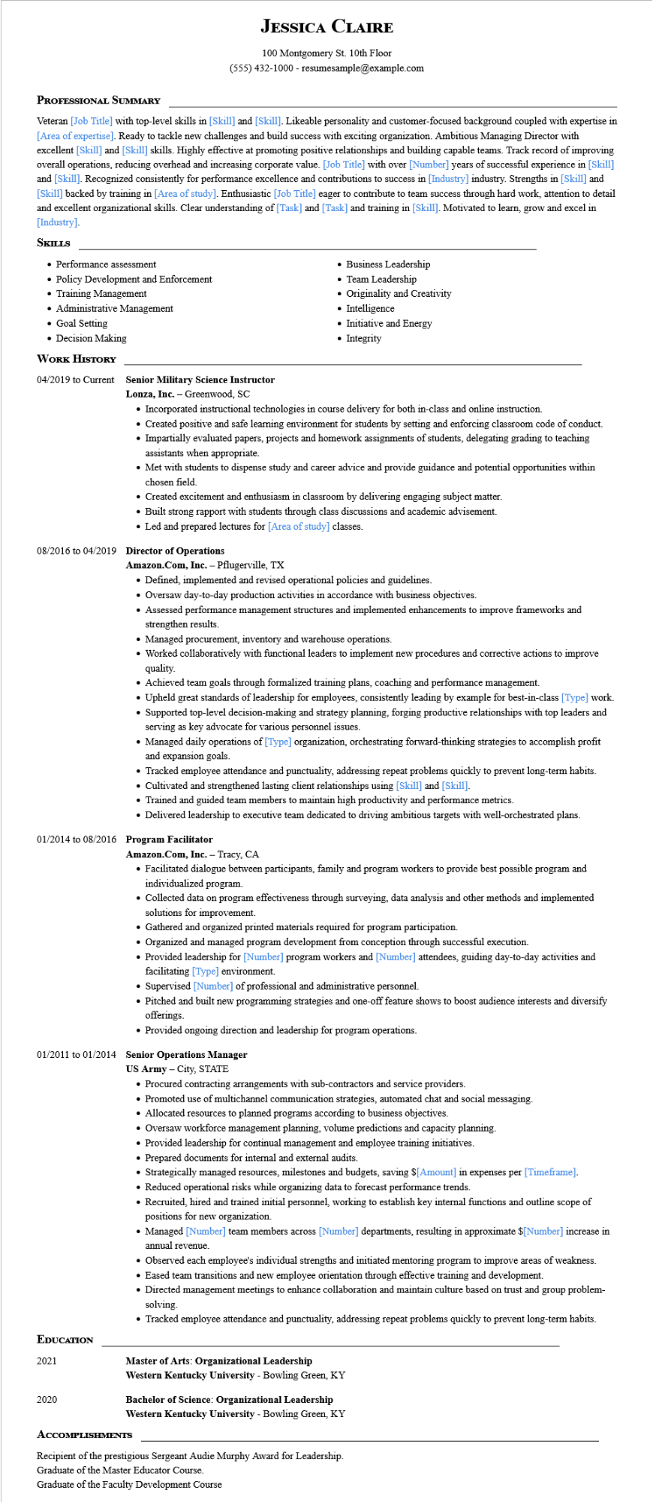

**JESSICA CLAIRE**

100 Montgomery St. 10th Floor (555) 432-1000 - resumesample@example.com

**PROFESSIONAL SUMMARY**

Veteran [Job Title] with top-level skills in [Skill] and [Skill]. Likeable personality and customer-focused background coupled with expertise in [Area of expertise]. Ready to tackle new challenges and build success with exciting organization. Ambitious Managing Director with excellent [Skill] and [Skill] skills. Highly effective at promoting positive relationships and building capable teams. Track record of improving overall operations, reducing overhead and increasing corporate value. [Job Title] with over [Number] years of successful experience in [Skill] and [Skill]. Recognized consistently for performance excellence and contributions to success in [Industry] industry. Strengths in [Skill] and [Skill] backed by training in [Area of study]. Enthusiastic [Job Title] eager to contribute to team success through hard work, attention to detail and excellent organizational skills. Clear understanding of [Task] and [Task] and training in [Skill]. Motivated to learn, grow and excel in [Industry].

**SKILLS**

• Performance assessment

• Policy Development and Enforcement

• Training Management

• Administrative Management

• Goal Setting

• Decision Making

**WORK HISTORY**

**04/2019 to Current Senior Military Science Instructor Lonza, Inc. - Greenwood, SC**

• Business Leadership

• Team Leadership

• Originality and Creativity

• Intelligence

• Initiative and Energy • Integrity

• Incorporated instructional technologies in course delivery for both in-class and online instruction.

• Created positive and safe learning environment for students by setting and enforcing classroom code of conduct.

• Impartially evaluated papers, projects and homework assignments of students, delegating grading to teaching assistants when appropriate.

• Met with students to dispense study and career advice and provide guidance and potential opportunities within chosen field.

• Created excitement and enthusiasm in classroom by delivering engaging subject matter.

• Built strong rapport with students through class discussions and academic advisement.

• Led and prepared lectures for [Area of study] classes.

**08/2016 to 04/2019 Director of Operations**

**Amazon.com, Inc. - Pflugerville, TX**

• Defined, implemented and revised operational policies and guidelines.

• Oversaw day-to-day production activities in accordance with business objectives.

• Assessed performance management structures and implemented enhancements to improve frameworks and strengthen results.

• Managed procurement, inventory and warehouse operations.

• Worked collaboratively with functional leaders to implement new procedures and corrective actions to improve quality.

• Achieved team goals through formalized training plans, coaching and performance management.

• Upheld great standards of leadership for employees, consistently leading by example for best-in-class [Type] work.

• Supported top-level decision-making and strategy planning, forging productive relationships with top leaders and serving as key advocate for various personnel issues.

• Managed daily operations of [Type] organization, orchestrating forward-thinking strategies to accomplish profit and expansion goals.

• Tracked employee attendance and punctuality, addressing repeat problems quickly to prevent long-term habits.

• Cultivated and strengthened lasting client relationships using [Skill] and [Skill].

• Trained and guided team members to maintain high productivity and performance metrics.

• Delivered leadership to executive team dedicated to driving ambitious targets with well-orchestrated plans.

**01/2014 to 08/2016 Program Facilitator**

**Amazon.com, Inc. - Tracy, CA**

• Facilitated dialogue between participants, family and program workers to provide best possible program and individualized program.

• Collected data on program effectiveness through surveying, data analysis and other methods and implemented solutions for improvement.

• Gathered and organized printed materials required for program participation.

• Organized and managed program development from conception through successful execution.

• Provided leadership for [Number] program workers and [Number] attendees, guiding day-to-day activities and facilitating [Type] environment.

• Supervised [Number] of professional and administrative personnel.

• Pitched and built new programming strategies and one-off feature shows to boost audience interests and diversify offerings.

• Provided ongoing direction and leadership for program operations.

01/2011 to 01/2014 Senior Operations Manager

**EDUCATION**

2021

US Army - City, STATE

• Procured contracting arrangements with sub-contractors and service providers.

• Promoted use of multichannel communication strategies, automated chat and social messaging.

• Allocated resources to planned programs according to business objectives.

• Oversaw workforce management planning, volume predictions and capacity planning.

• Provided leadership for continual management and employee training initiatives.

• Prepared documents for internal and external audits.

• Strategically managed resources, milestones and budgets, saving $[Amount] in expenses per [Timeframe].

• Reduced operational risks while organizing data to forecast performance trends.

• Recruited, hired and trained initial personnel, working to establish key internal functions and outline scope of positions for new organization.

• Managed [Number] team members across [Number] departments, resulting in approximate $[Number] increase in annual revenue.

• Observed each employee's individual strengths and initiated mentoring program to improve areas of weakness.

• Eased team transitions and new employee orientation through effective training and development.

• Directed management meetings to enhance collaboration and maintain culture based on trust and group problem- solving.

• Tracked employee attendance and punctuality, addressing repeat problems quickly to prevent long-term habits.

**Master of Arts: Organizational Leadership**

**Western Kentucky University - Bowling Green, KY**

2020

**Bachelor of Science: Organizational Leadership**

**Western Kentucky University - Bowling Green, KY**

**ACCOMPLISHMENTS**

Recipient of the prestigious Sergeant Audie Murphy Award for Leadership.

Graduate of the Master Educator Course.

Graduate of the Faculty Development Course