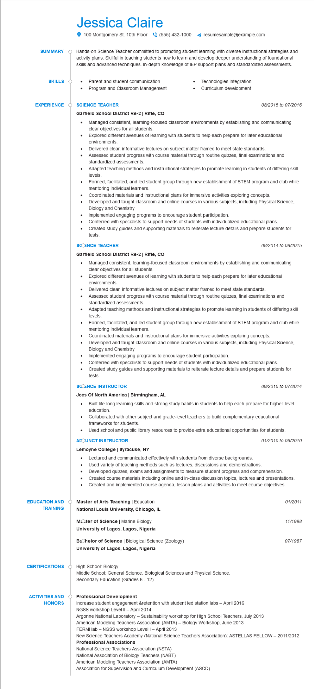

**SUMMARY**

Jessica Claire

100 Montgomery St. 10th Floor(555) 432-1000

resumesample@example.com

Hands-on Science Teacher committed to promoting student learning with diverse instructional strategies and activity plans. Skillful in teaching students how to learn and develop deeper understanding of foundational skills and advanced techniques. In-depth knowledge of IEP support plans and standardized assessments.

**SKILLS**

• Parent and student communication Program and Classroom Management

**EXPERIENCE**

**SCIENCE TEACHER**

•

Technologies Integration Curriculum development

08/2015 to 07/2016

**Garfield School District Re-2 | Rifle, CO**

•

•

•

•

Managed consistent, learning-focused classroom environments by establishing and communicating clear objectives for all students.

Explored different avenues of learning with students to help each prepare for later educational environments

Delivered clear, informative lectures on subject matter framed to meet state standards.

Assessed student progress with course material through routine quizzes, final examinations and standardized assessments.

Adapted teaching methods and instructional strategies to promote learning in students of differing skill levels

Formed, facilitated, and led student group through new establishment of STEM program and club while mentoring individual learners.

Coordinated materials and instructional plans for immersive activities exploring concepts.

Developed and taught classroom and online courses in various subjects, including Physical Science, Biology and Chemistry

Implemented engaging programs to encourage student participation.

Conferred with specialists to support needs of students with individualized educational plans.

• Created study guides and supporting materials to reiterate lecture details and prepare students for tests.

SCIENCE TEACHER

**Garfield School District Re-2 | Rifle, CO**

•

•

*08/2014 to 08/2015*

Managed consistent, learning-focused classroom environments by establishing and communicating clear objectives for all students.

•

Explored different avenues of learning with students to help each prepare for later educational environments.

Delivered clear, informative lectures on subject matter framed to meet state standards.

Assessed student progress with course material through routine quizzes, final examinations and standardized assessments.

Adapted teaching methods and instructional strategies to promote learning in students of differing skill levels.

• Formed, facilitated, and led student group through new establishment of STEM program and club while mentoring individual learners.

Coordinated materials and instructional plans for immersive activities exploring concepts.

Developed and taught classroom and online courses in various subjects, including Physical Science, Biology and Chemistry

Implemented engaging programs to encourage student participation.

Conferred with specialists to support needs of students with individualized educational plans.

Created study guides and supporting materials to reiterate lecture details and prepare students for tests.

**SCCENCE INSTRUCTOR**

**Jccs Of North America | Birmingham, AL**

09/2010 to 07/2014

• Built life-long learning skills and strong study habits in students to help each prepare for higher-level education.

•

Collaborated with other subject and grade-level teachers to build complementary educational frameworks for students.

•

Used school and public library resources to provide extra educational opportunities for students. ACOUNCT INSTRUCTOR

**Lemoyne College | Syracuse, NY**

01/2010 to 06/2010

•

Lectured and communicated effectively with students from diverse backgrounds.

Used variety of teaching methods such as lectures, discussions and demonstrations. Developed quizzes, exams and assignments to measure student progress and comprehension.

•

Created course materials including online and in-class discussion topics, lectures and presentations.

• Created and implemented course agenda, lesson plans and activities to meet course objectives.

**EDUCATION AND TRAINING**

**Master of Arts Teaching | Education**

National Louis University, Chicago, IL

**Moter of Science | Marine Biology**

**University of Lagos, Lagos, Nigeria**

Bachelor of Science | Biological Science (Zoology)

**University of Lagos, Lagos, Nigeria**

**CERTIFICATIONS**

High School: Biology

ACTIVITIES AND

**HONORS**

Middle School: General Science, Biological Sciences and Physical Science. Secondary Education (Grades 6-12)

**Professional Development**

01/2011

11/1998

07/1987

Increase student engagement &retention with student led station labs - April 2016 NGSS workshop Level II - April 2014

Argonne National Laboratory - Sustainability workshop for High School Teachers, July 2013 American Modeling Teachers Association (AMTA) - Biology Workshop, June 2013

FERMI lab - NGSS workshop Level I - April 2013

New Science Teachers Academy (National Science Teachers Association): ASTELLAS FELLOW - 2011/2012 Professional Associations

National Science Teachers Association (NSTA)

National Association of Biology Teachers (NABT)

American Modeling Teachers Association (AMTA)

Association for Supervision and Curriculum Development (ASCD)