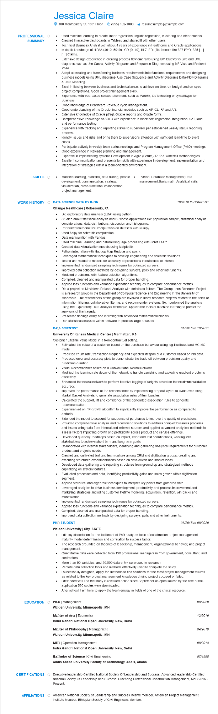

**PROFESSIONAL SUMMARY**

Jessica Claire

100 Montgomery St. 10th Floor (555) 432-1000 4 resumesample@example.com

•

•

•

•

•

Used machine learning to create linear regression, logistic regression, clustering and other models. Created interactive dashboards in Tableau and shared it with other users.

Technical Business Analyst with about 4 years of experience in Healthcare and Oracle applications. In depth knowledge of HIPAA (4010, 5010), ICD (9, 10), HL7, EDI (file formats like 837 I/P/D, 835 [...] [...] Claims.

Extensive design experience in creating process flow diagrams using IBM Blueworks Live and UML diagrams such as Use Cases, Activity Diagrams and Sequence Diagrams using MS Visio and Rational Rose.

Adept at creating and transforming business requirements into functional requirements and designing business models using UML diagrams- Use Case Sequence and Activity Diagrams Data-Flow Diagrams & Data Modeling.

Excel in liaising between business and technical areas to achieve on-time, on-budget and on-spec project completions. Good project management skills.

Experience with web-based collaboration tools such as WebEx, GoToMeeting or Lync/Skype for Business.

Good knowledge of Healthcare Revenue cycle management.

Good understanding of the Oracle financial modules such as AP, GL, FA and AR.

Extensive knowledge of Oracle pl/sql, Oracle reports and Oracle forms.

Comprehensive knowledge of SDLC with experience in black box, regression, integration, UAT, load and performance testing.

Experience with tracking and reporting status to supervisor per established weekly status reporting process.

Identify issues and risks and bring them to supervisor's attention with sufficient lead-time to avert crises.

Participate actively in weekly team status meetings and Program Management Office (PMO) meetings. Good experience in Release planning and management.

Expertise in implementing systems Development in Agile (Scrum), RUP & Waterfall Methodologies. Excellent communication and presentation skills with experience in development, implementation and integration of strategies within a team-oriented environment.

**SKILLS**

•

Machine learning, statistics, data mining, people development, communication, strategy,

• Python, Database Management, Data

management, Basic math, Analytical skills

visualization, cross-functional collaboration, project management.

**WORK HISTORY**

**DATA SCIENCE WITH PYTHON**

*10/2018 to CURRENT*

Change Healthcare | Robesonia, PA

•

•

Did exploratory data analysis (EDA) using python

Studied about statistical Analysis and Business applications like population sample, statistical analysis considerations, data distributions, dispersion and histograms.

Performed mathematical computation on datasets with Numpy.

•

Used Scipy for scientific computation.

Data manipulation with Pandas.

Used machine Learning and natural language processing with Scikit Learn.

•

Created data visualization models using Matplotlib.

Python integration with Hadoop Map Reduce and spark.

Leveraged mathematical techniques to develop engineering and scientific solutions.

•

Tested and validated models for accuracy of predictions in outcomes of interest.

Implemented randomized sampling techniques for optimized surveys.

Improved data collection methods by designing surveys, polls and other instruments.

Modeled predictions with feature selection algorithms.

·

Compiled, cleaned and manipulated data for proper handling.

· Applied loss functions and variance explanation techniques to compare performance metrics. Did a project on Movielens Dataset Analysis with details as follows: The Group Lens Research Project is a research group in the Department of Computer Science and Engineering in the University of Minnesota. The researchers of this group are involved in many research projects related to the fields of information filtering, collaborative filtering, and recommender systems. So, I performed the analysis using the Exploratory Data Analysis technique. Applied the tools of machine learning to predict the survivors of the tragedy.

Presented findings orally and in writing with advanced mathematical models.

Ran statistical analyses within software to process large datasets.

**DACA SCIENTIST**

**University Of Kansas Medical Center | Manhattan, KS**

Customer Lifetime Value Model in a Non-contractual setting.

01/2016 to 10/2021

• Estimated the value of a customer based on the purchase behaviour using log-likelihood and MC-MC model

Predicted churn rate, transaction frequency and expected lifespan of a customer based on rfm data. Produced error and accuracy plots to demonstrate the trade off between prediction quality and prediction duration.

Visual Recommender based on a Convolutional Neural Network

Modified the learning rate decay of the network to handle vanishing and exploding gradient problems effectively

Enhanced the neural network to perform iterative logging of weights based on the maximum validation accuracy.

Improved the performance of the recommender by implementing dropout layers to avoid over fitting. Market Basket Analysis to generate association rules of item bundles

Calculated the support, lift and confidence of the generated association rules to generate recommendation

Experimented on FP-growth algorithm to significantly improve the performance as compared to apriority.

Extended the model to account for sequence of purchases to improve the quality of predictions. Provided comprehensive analysis and recommend solutions to address complex business problems and issues using data from internal and external sources and applied advanced analytical methods to assess factors impacting growth and profitability across product and service offerings. Developed quarterly roadmaps based on impact, effort and test coordinations, working with stakeholders to achieve short-term and long-term goals.

Collaborated with internal stakeholders, identifying and gathering analytical requirements for customer, product and projects needs.

Created and cultivated test and learn culture among CRM and digitization groups, creating and executing structured experimentations based on data-driven and market ideas.

•

Developed data-gathering and reporting structures from ground up and strategized methods capitalizing on system features.

•

Evaluated processes and data, identifying productivity gains and sales growth within digitization segment.

Applied statistical and algebraic techniques to interpret key points from gathered data. Leveraged analytics to drive business development, productivity and process improvement and marketing strategies, including customer lifetime modeling, acquisition, retention, win backs and monetization.

Implemented randomized sampling techniques for optimized surveys.

Applied loss functions and variance explanation techniques to compare performance metrics. Compiled, cleaned and manipulated data for proper handling.

Improved data collection methods by designing surveys, polls and other instruments.

**PHO STUDENT**

**Walden University | City, STATE**

*06/2015 to 08/2020*

I did my dissertation for the fulfillment of PhD study on topic of construction project management maturity model determination and correlation to success factor.

The research grounded on theories of leadership, management, organizational behavior, and project management.

Quantitative data were collected from 190 professional managers in from government, consultant, and contractors.

•

More than 90 variables, and 20,000 data entry were used in research.

•

.

•

Remote data collection tools and methods effectively used to complete the study.

I successfully designed, apply the methods to find solutions for the most project management failures

as related to the key project management knowledge driving project succeed or failed.

I defended well and the study is released online since September as open source by the time of this application 580 copies were downloaded.

After school, I am here to apply the fresh energy in fields of one of the critical resource.

**EDUCATION**

Ph.D | Management

**Walden University, Minneapolis, MN**

**Macter of Arts | Economics**

**Indra Gandhi National Open University, New, Delhi**

**CERTIFICATIONS**

**AFFILIATIONS**

**Macter of Philosophy | Management**

**Walden University, Minneapolis, MN**

ME | Operation Management

**Indra Gandhi National Open University, New, Delhi**

**Bachelor of Science | Civil Engineering**

**Addis Ababa University Faculty of Technology, Addis, Ababa**

08/2020

12/2019

04/2019

*08/2013*

07/1998

Executive leadership Certified National Society Of Leadership and Success. Advanced leadership Certified National Society Of Leadership and Success. Practicing Professional Construction Management, MoC 2015- Present

American National Society of Leadership and Success lifetime member. American Project Management Institute Member. Ethiopian Society of Civil Engineers Member.