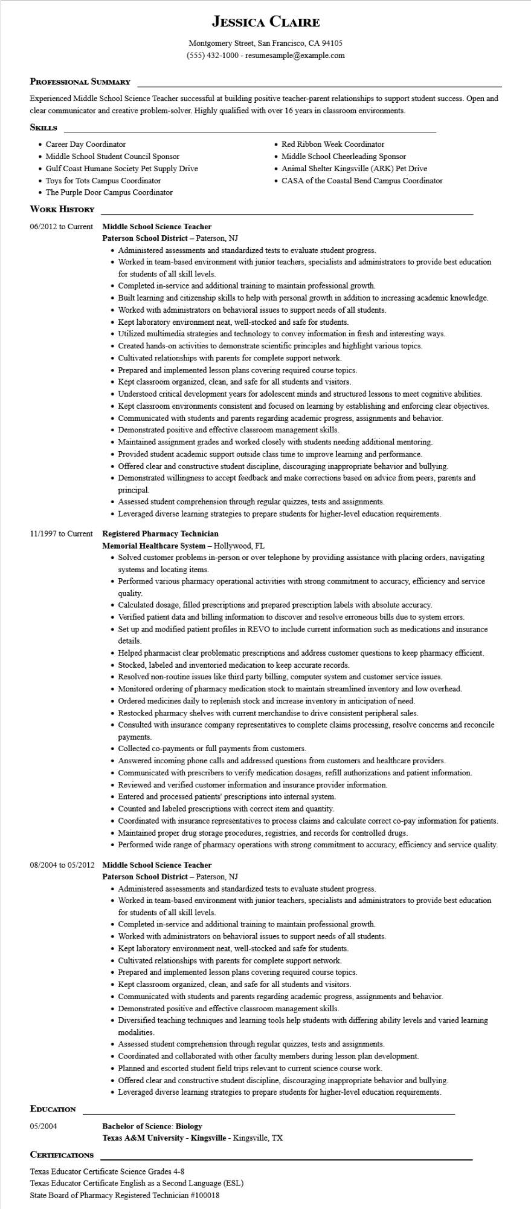

**JESSICA CLAIRE**

Montgomery Street, San Francisco, CA 94105

(555) 432-1000 - resumesample@example.com

**PROFESSIONAL SUMMARY**

Experienced Middle School Science Teacher successful at building positive teacher-parent relationships to support student success. Open and clear communicator and creative problem-solver. Highly qualified with over 16 years in classroom environments.

**SKILLS**

• Career Day Coordinator

• Middle School Student Council Sponsor

• Gulf Coast Humane Society Pet Supply Drive Toys for Tots Campus Coordinator

• The Purple Door Campus Coordinator

**WORK HISTORY**

**06/2012 to Current Middle School Science Teacher**

**Paterson School District - Paterson, NJ**

• Red Ribbon Week Coordinator

• Middle School Cheerleading Sponsor

• Animal Shelter Kingsville (ARK) Pet Drive

• CASA of the Coastal Bend Campus Coordinator

• Administered assessments and standardized tests to evaluate student progress.

• Worked in team-based environment with junior teachers, specialists and administrators to provide best education for students of all skill levels.

• Completed in-service and additional training to maintain professional growth.

• Built learning and citizenship skills to help with personal growth in addition to increasing academic knowledge.

• Worked with administrators on behavioral issues to support needs of all students.

• Kept laboratory environment neat, well-stocked and safe for students.

• Utilized multimedia strategies and technology to convey information in fresh and interesting ways.

• Created hands-on activities to demonstrate scientific principles and highlight various topics.

• Cultivated relationships with parents for complete support network.

• Prepared and implemented lesson plans covering required course topics.

• Kept classroom organized, clean, and safe for all students and visitors.

• Understood critical development years for adolescent minds and structured lessons to meet cognitive abilities.

• Kept classroom environments consistent and focused on learning by establishing and enforcing clear objectives.

• Communicated with students and parents regarding academic progress, assignments and behavior.

• Demonstrated positive and effective classroom management skills.

• Maintained assignment grades and worked closely with students needing additional mentoring.

• Provided student academic support outside class time to improve learning and performance.

• Offered clear and constructive student discipline, discouraging inappropriate behavior and bullying.

• Demonstrated willingness to accept feedback and make corrections based on advice from peers, parents and principal

• Assessed student comprehension through regular quizzes, tests and assignments.

• Leveraged diverse learning strategies to prepare students for higher-level education requirements.

11/1997 to Current Registered Pharmacy Technician

**Memorial Healthcare System - Hollywood, FL**

• Solved customer problems in-person or over telephone by providing assistance with placing orders, navigating systems and locating items.

• Performed various pharmacy operational activities with strong commitment to accuracy, efficiency and service quality.

• Calculated dosage, filled prescriptions and prepared prescription labels with absolute accuracy.

• Verified patient data and billing information to discover and resolve erroneous bills due to system errors.

• Set up and modified patient profiles in REVO to include current information such as medications and insurance details.

• Helped pharmacist clear problematic prescriptions and address customer questions to keep pharmacy efficient.

• Stocked, labeled and inventoried medication to keep accurate records.

• Resolved non-routine issues like third party billing, computer system and customer service issues.

• Monitored ordering of pharmacy medication stock to maintain streamlined inventory and low overhead.

• Ordered medicines daily to replenish stock and increase inventory in anticipation of need.

• Restocked pharmacy shelves with current merchandise to drive consistent peripheral sales.

• Consulted with insurance company representatives to complete claims processing, resolve concerns and reconcile payments.

• Collected co-payments or full payments from customers.

• Answered incoming phone calls and addressed questions from customers and healthcare providers.

• Communicated with prescribers to verify medication dosages, refill authorizations and patient information.

• Reviewed and verified customer information and insurance provider information.

• Entered and processed patients' prescriptions into internal system.

• Counted and labeled prescriptions with correct item and quantity.

• Coordinated with insurance representatives to process claims and calculate correct co-pay information for patients.

• Maintained proper drug storage procedures, registries, and records for controlled drugs.

• Performed wide range of pharmacy operations with strong commitment to accuracy, efficiency and service quality.

**08/2004 to 05/2012 Middle School Science Teacher**

**EDUCATION**

05/2004

**CERTIFICATIONS**

Paterson School District - Paterson, NJ

• Administered assessments and standardized tests to evaluate student progress.

• Worked in team-based environment with junior teachers, specialists and administrators to provide best education for students of all skill levels.

• Completed in-service and additional training to maintain professional growth.

• Worked with administrators on behavioral issues to support needs of all students.

• Kept laboratory environment neat, well-stocked and safe for students.

• Cultivated relationships with parents for complete support network.

• Prepared and implemented lesson plans covering required course topics.

• Kept classroom organized, clean, and safe for all students and visitors.

• Communicated with students and parents regarding academic progress, assignments and behavior.

• Demonstrated positive and effective classroom management skills.

• Diversified teaching techniques and learning tools help students with differing ability levels and varied learning modalities.

• Assessed student comprehension through regular quizzes, tests and assignments.

• Coordinated and collaborated with other faculty members during lesson plan development.

• Planned and escorted student field trips relevant to current science course work.

• Offered clear and constructive student discipline, discouraging inappropriate behavior and bullying.

• Leveraged diverse learning strategies to prepare students for higher-level education requirements.

**Bachelor of Science: Biology**

**Texas A&M University - Kingsville - Kingsville, TX**

Texas Educator Certificate Science Grades 4-8

Texas Educator Certificate English as a Second Language (ESL)

State Board of Pharmacy Registered Technician #100018