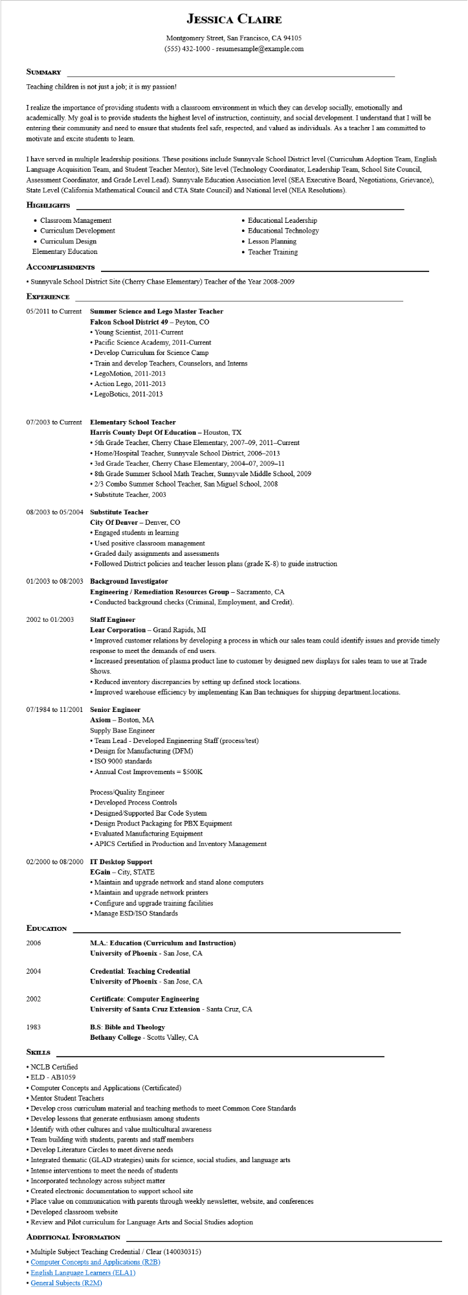

SUMMARY

**JESSICA CLAIRE**

Montgomery Street, San Francisco, CA 94105 (555) 432-1000 - resumesample@example.com

Teaching children is not just a job; it is my passion!

I realize the importance of providing students with a classroom environment in which they can develop socially, emotionally and academically. My goal is to provide students the highest level of instruction, continuity, and social development. I understand that I will be entering their community and need to ensure that students feel safe, respected, and valued as individuals. As a teacher I am committed to motivate and excite students to learn.

I have served in multiple leadership positions. These positions include Sunnyvale School District level (Curriculum Adoption Team, English Language Acquisition Team, and Student Teacher Mentor), Site level (Technology Coordinator, Leadership Team, School Site Council, Assessment Coordinator, and Grade Level Lead). Sunnyvale Education Association level (SEA Executive Board, Negotiations, Grievance), State Level (California Mathematical Council and CTA State Council) and National level (NEA Resolutions).

**HIGHLIGHTS**

• Classroom Management • Curriculum Development

• Curriculum Design

Elementary Education

**ACCOMPLISHMENTS**

• Educational Leadership

• Educational Technology

• Lesson Planning

• Teacher Training

• Sunnyvale School District Site (Cherry Chase Elementary) Teacher of the Year 2008-2009

**EXPERIENCE**

05/2011 to Current

Summer Science and Lego Master Teacher

**Falcon School District 49 - Peyton, CO**

• Young Scientist, 2011-Current

• Pacific Science Academy, 2011-Current

• Develop Curriculum for Science Camp

• Train and develop Teachers, Counselors, and Interns

• Lego Motion, 2011-2013

• Action Lego, 2011-2013

• LegoBotics, 2011-2013

**07/2003 to Current Elementary School Teacher**

**Harris County Dept Of Education - Houston, TX**

• 5th Grade Teacher, Cherry Chase Elementary, 2007-09, 2011-Current

• Home/Hospital Teacher, Sunnyvale School District, 2006-2013

• 3rd Grade Teacher, Cherry Chase Elementary, 2004-07, 2009-11

• 8th Grade Summer School Math Teacher, Sunnyvale Middle School, 2009

• 2/3 Combo Summer School Teacher, San Miguel School, 2008

• Substitute Teacher, 2003

08/2003 to 05/2004 Substitute Teacher

City of Denver - Denver, CO

•Engaged students in learning

• Used positive classroom management

• Graded daily assignments and assessments

• Followed District policies and teacher lesson plans (grade K-8) to guide instruction

01/2003 to 08/2003 Background Investigator

2002 to 01/2003

**Engineering/Remediation Resources Group - Sacramento, CA**

• Conducted background checks (Criminal, Employment, and Credit).

**Staff Engineer**

Lear Corporation - Grand Rapids, MI

• Improved customer relations by developing a process in which our sales team could identify issues and provide timely response to meet the demands of end users.

• Increased presentation of plasma product line to customer by designed new displays for sales team to use at Trade Shows.

• Reduced inventory discrepancies by setting up defined stock locations.

• Improved warehouse efficiency by implementing Kan Ban techniques for shipping department.locations.

07/1984 to 11/2001 Senior Engineer

Axiom - Boston, MA

Supply Base Engineer

• Team Lead - Developed Engineering Staff (process/test)

• Design for Manufacturing (DFM)

• ISO 9000 standards

• Annual Cost Improvements = $500K

Process/Quality Engineer

•Developed Process Controls

• Designed/Supported Bar Code System

• Design Product Packaging for PBX Equipment

• Evaluated Manufacturing Equipment

• APICS Certified in Production and Inventory Management

**02/2000 to 08/2000 IT Desktop Support**

**EGain - City, STATE**

• Maintain and upgrade network and stand alone computers

• Maintain and upgrade network printers

• Configure and upgrade training facilities

• Manage ESD/ISO Standards

**EDUCATION**

2006

**M.A.: Education (Curriculum and Instruction)**

**University of Phoenix - San Jose, CA**

2004

**Credential: Teaching Credential**

**University of Phoenix - San Jose, CA**

2002

**Certificate: Computer Engineering**

**University of Santa Cruz Extension - Santa Cruz, CA**

1983

**B.S: Bible and Theology**

**SKILLS**

Bethany College - Scotts Valley, CA

• NCLB Certified

⚫ELD - AB1059

• Computer Concepts and Applications (Certificated)

• Mentor Student Teachers.

• Develop cross curriculum material and teaching methods to meet Common Core Standards

• Develop lessons that generate enthusiasm among students

• Identify with other cultures and value multicultural awareness

• Team building with students, parents and staff members

• Develop Literature Circles to meet diverse needs

• Integrated thematic (GLAD strategies) units for science, social studies, and language arts

Intense interventions to meet the needs of students

• Incorporated technology across subject matter

• Created electronic documentation to support school site

• Place value on communication with parents through weekly newsletter, website, and conferences

•Developed classroom website

• Review and Pilot curriculum for Language Arts and Social Studies adoption

**ADDITIONAL INFORMATION**

• Multiple Subject Teaching Credential/Clear (140030315)

• Computer Concepts and Applications (R2B)

English Language Learners (ELA1)

• General Subjects (R2M)