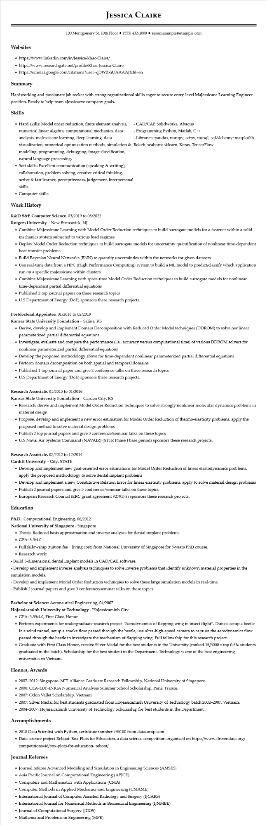

**Websites**

**JESSICA CLAIRE**

100 Montgomery St. 10th Floor⚫ (555) 432-1000⚫ resumesample@example.com

https://www.linkedin.com/in/Jessica-khac-Claire/

• https://www.researchgate.net/profile/Khac-Jessica-Claire

• https://scholar.google.com/citations?user=qDWZxiUAAAAJ&hl=en

**Summary**

Hardworking and passionate job seeker with strong organizational skills eager to secure entry-level MaJessicane Learning Engineer position. Ready to help team aJessicaeve company goals.

**Skills**

• Hard skills: Model order reduction, finite element analysis, numerical linear algebra, computational mechanics, data analysis, maJessicane learning, deep learning, data visualization, numerical optimization methods, simulation & modeling, programming, debugging, image classification, natural language processing.

• Soft skills: Excellent communication (speaking & writing), collaboration, problem solving, creative critical thinking,

active & fast learner, perceptiveness, judgement, interpersonal skills

• Computer skills:

**Work History**

R&D S&E Computer Science, 03/2019 to 08/2022

Rutgers University - New Brunswick, NJ

CAD/CAE Solidworks, Abaqus

Programming Python, Matlab, C++

- Libraries: pandas, numpy, scipy, mysql, sqlAlchemy; matplotlib, Bokeh, seaborn; sklearn, Keras, TensorFlow

• Combine MaJessicane Learning with Model Order Reduction techniques to build surrogate models for a fastener within a solid mechanics system subjected to various load regimes

• Deploy Model Order Reduction techniques to build surrogate models for uncertainty quantification of nonlinear time-dependent heat transfer problems

• Build Bayesian Neural Networks (BNN) to quantify uncertainties within the networks for given datasets

• Use real-time data from a HPC (High Performance Computing) system to build a ML model to predict/classify which application run on a specific maJessicane within clusters

• Combine MaJessicane Learning with space-time Model Order Reduction techniques to build surrogate models for nonlinear time-dependent partial differential equations

• Published 2 top journal papers on these research topics

• U.S Department of Energy (DOE) sponsors these research projects.

**Postdoctoral Appointee, 01/2016 to 02/2019**

**Kansas State University Foundation - Salina, KS**

• Derive, develop and implement Domain Decomposition with Reduced Order Model techniques (DDROM) to solve nonlinear parameterized partial differential equations

• Investigate, evaluate and compare the performance (i.e., accuracy versus computational time) of various DDROM solvers for nonlinear parameterized partial differential equations

• Develop the proposed methodology above for time-dependent nonlinear parameterized partial differential equations

• Perform domain decomposition on both spatial and temporal domains

• Published 1 top journal paper and give 2 conference talks on these research topics

• U.S Department of Energy (DOE) sponsors these research projects.

**Research Associate, 01/2015 to 01/2016**

**Kansas State University Foundation - Garden City, KS**

• Research, derive and implement Model Order Reduction techniques to solve strongly nonlinear molecular dynamics problems in material design

• Propose, develop and implement a new error estimation for Model Order Reduction of thermo-elasticity problems, apply the proposed method to solve material design problems

• Publish 2 top journal papers and give 3 conference/seminar talks on these topics

• U.S Naval Air Systems Command (NAVAIR) (STTR Phase I base period) sponsors these research projects.

**Research Associate, 07/2012 to 12/2014**

Cardiff University - City, STATE

• Develop and implement new goal-oriented error estimations for Model Order Reduction of linear elastodynamics problems, apply the proposed methodology to solve dental implant problems

• Develop and implement a new Constitutive Relation Error for linear elasticity problems, apply to solve material design problems

• Publish 2 journal papers and give 5 conference/seminar talks on these topics

• European Research Council (ERC grant agreement #279578) sponsors these research projects.

**Education**

Ph.D.: Computational Engineering, 06/2012

**National University of Singapore - Singapore**

• Thesis: Reduced basis approximation and inverse analyses for dental implant problems

• GPA: 3.5/4.0

• Full fellowship (tuition fee + living cost) from National University of Singapore for 5-years PhD course.

• Research work:

-Build 3-dimensional dental implant models in CAD/CAE software.

-Develop and implement inverse analysis techniques to solve inverse problems that identify unknown material properties in the simulation models.

-Develop and implement Model Order Reduction techniques to solve these large simulation models in real-time.

-Publish 2 journal papers and give 3 conference/seminar talks on these topics.

Bachelor of Science: Aeronautical Engineering, 04/2007

HoJessicaminh University of Technology - HoJessicaminh City

• GPA: 3.55/4.0, First Class Honor

• Perform experiments for undergraduate research project "Aerodynamics of flapping wing in insect flight". Duties: setup a beetle in a wind tunnel, setup a smoke flow passed through the beetle, use ultra-high-speed camera to capture the aerodynamics flow passed through the beetle to investigate the mechanism of flapping wing. Full fellowship for this research project.

• Graduate with First Class Honor, receive Silver Medal for the best students in the University (ranked 15/3000≈ top 0.5% students graduated in the batch). Scholarship for the best student in the Department. Technology is one of the best engineering universities in Vietnam

**Honors, Awards**

• 2007-2012: Singapore-MIT Alliance Graduate Research Fellowship, National University of Singapore.

• 2008: CEA-EDF-INRIA Numerical Analysis Summer School Scholarship, Paris, France.

• 2007: Odon Vallet Scholarship, Vietnam.

• 2007: Silver Medal for best students graduated from HoJessicaminh University of Technology batch 2002-2007, Vietnam.

• 2004-2007: HoJessicaminh University of Technology Scholarship for best students in the Department.

**Accomplishments**

⚫ 2018 Data Scientist with Python, certificate number #35100 from datacamp.com

• Data science project Reboot: Box-Plots for Education, a data science competition organized on https://www.drivendata.org/ competitions/46/box-plots-for-education- reboot/

**Journal Referees**

• Journal referee Advanced Modeling and Simulation in Engineering Sciences (AMSES)

• Asia Pacific Journal on Computational Engineering (APJCE)

• Computers and Mathematics with Applications (CMA)

• Computer Methods in Applied Mechanics and Engineering (CMAME)

• International Journal of Computer Assisted Radiology and Surgery (IJCARS)

• International Journal for Numerical Methods in Biomedical Engineering (IJNMBE)

• Journal of Computational Surgery (JCOS)

• Mathematical Problems in Engineering (MPE)