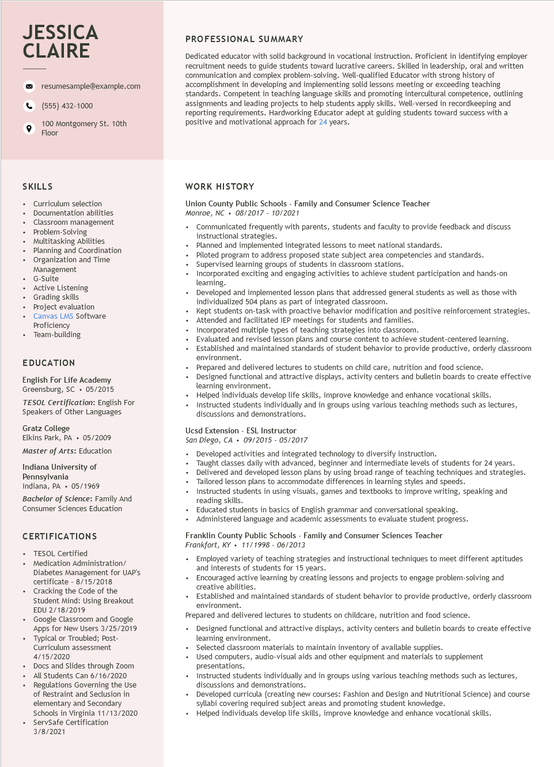

**JESSICA CLAIRE**

resumesample@example.com

(555) 432-1000

100 Montgomery St. 10th Floor

PROFESSIONAL SUMMARY

Dedicated educator with solid background in vocational instruction. Proficient in identifying employer recruitment needs to guide students toward lucrative careers. Skilled in leadership, oral and written communication and complex problem-solving. Well-qualified Educator with strong history of accomplishment in developing and implementing solid lessons meeting or exceeding teaching standards. Competent in teaching language skills and promoting intercultural competence, outlining assignments and leading projects to help students apply skills. Well-versed in recordkeeping and reporting requirements. Hardworking Educator adept at guiding students toward success with a positive and motivational approach for 24 years.

SKILLS

• Curriculum selection

•

•

Documentation abilities

Classroom management

• Problem-Solving

•

•

•

Multitasking Abilities Planning and Coordination

Organization and Time

Management

G-Suite

Active Listening

Grading skills

•

Project evaluation

• Canvas LMS Software

Proficiency • Team-building

**EDUCATION**

English For Life Academy

Greensburg, SC

05/2015

*TESOL Certification: English For*

Speakers of Other Languages

Gratz College

Elkins Park, PA⚫ 05/2009

*Master of Arts: Education*

Indiana University of Pennsylvania Indiana, PA. 05/1969

*Bachelor of Science: Family And*

Consumer Sciences Education

**CERTIFICATIONS**

• TESOL Certified

• Medication Administration/

Diabetes Management for UAP's certificate - 8/15/2018

• Cracking the Code of the

·

•

•

Student Mind: Using Breakout

EDU 2/18/2019

Google Classroom and Google

Apps for New Users 3/25/2019

Typical or Troubled; Post- Curriculum assessment 4/15/2020

Docs and Slides through Zoom

All Students Can 6/16/2020

Regulations Governing the Use

of Restraint and Seclusion in

elementary and Secondary

Schools in Virginia 11/13/2020

**WORK HISTORY**

Union County Public Schools - Family and Consumer Science Teacher Monroe, NC. 08/2017 - 10/2021

• Communicated frequently with parents, students and faculty to provide feedback and discuss instructional strategies.

• Planned and implemented integrated lessons to meet national standards.

Piloted program to address proposed state subject area competencies and standards. Supervised learning groups of students in classroom stations.

Incorporated exciting and engaging activities to achieve student participation and hands-on learning.

Developed and implemented lesson plans that addressed general students as well as those with individualized 504 plans as part of integrated classroom.

Kept students on-task with proactive behavior modification and positive reinforcement strategies.

• Attended and facilitated IEP meetings for students and families.

Incorporated multiple types of teaching strategies into classroom.

Evaluated and revised lesson plans and course content to achieve student-centered learning.

• Established and maintained standards of student behavior to provide productive, orderly classroom environment.

Prepared and delivered lectures to students on child care, nutrition and food science.

• Designed functional and attractive displays, activity centers and bulletin boards to create effective learning environment.

• Helped individuals develop life skills, improve knowledge and enhance vocational skills.

• Instructed students individually and in groups using various teaching methods such as lectures, discussions and demonstrations.

**Ucsd Extension - ESL Instructor**

*San Diego, CA⚫ 09/2015 - 05/2017*

• Developed activities and integrated technology to diversify instruction.

Taught classes daily with advanced, beginner and intermediate levels of students for 24 years.

Delivered and developed lesson plans by using broad range of teaching techniques and strategies.

• Tailored lesson plans to accommodate differences in learning styles and speeds.

• Instructed students in using visuals, games and textbooks to improve writing, speaking and reading skills.

• Educated students in basics of English grammar and conversational speaking.

• Administered language and academic assessments to evaluate student progress.

Franklin County Public Schools - Family and Consumer Sciences Teacher Frankfort, KY 11/1998-06/2013

• Employed variety of teaching strategies and instructional techniques to meet different aptitudes and interests of students for 15 years.

• Encouraged active learning by creating lessons and projects to engage problem-solving and creative abilities.

• Established and maintained standards of student behavior to provide productive, orderly classroom environment.

Prepared and delivered lectures to students on childcare, nutrition and food science.

Designed functional and attractive displays, activity centers and bulletin boards to create effective learning environment.

• Selected classroom materials to maintain inventory of available supplies.

Used computers, audio-visual aids and other equipment and materials to supplement presentations.

• Instructed students individually and in groups using various teaching methods such as lectures, discussions and demonstrations.

• Developed curricula (creating new courses: Fashion and Design and Nutritional Science) and course syllabi covering required subject areas and promoting student knowledge.

Helped individuals develop life skills, improve knowledge and enhance vocational skills.

•

ServSafe Certification

3/8/2021