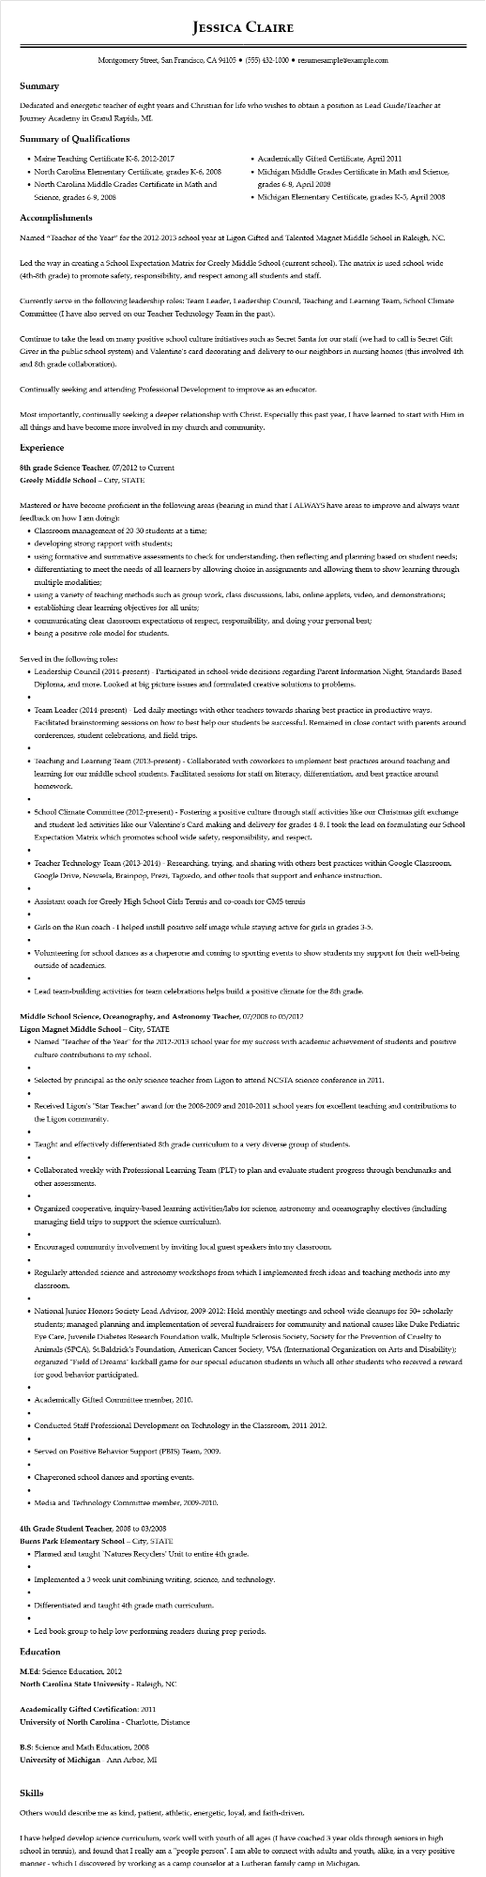

**JESSICA CLAIRE**

Montgomery Street, San Francisco, CA 94105⚫ (555) 432-1000⚫ resumesample@example.com

**Summary**

Dedicated and energetic teacher of eight years and Christian for life who wishes to obtain a position as Lead Guide/Teacher at Journey Academy in Grand Rapids, MI.

**Summary of Qualifications**

• Maine Teaching Certificate K-8, 2012-2017

• North Carolina Elementary Certificate, grades K-6, 2008

• North Carolina Middle Grades Certificate in Math and

Science, grades 6-9, 2008

**Accomplishments**

•

Academically Gifted Certificate, April 2011

• Michigan Middle Grades Certificate in Math and Science, grades 6-8, April 2008

• Michigan Elementary Certificate, grades K-5, April 2008

Named "Teacher of the Year" for the 2012-2013 school year at Ligon Gifted and Talented Magnet Middle School in Raleigh, NC.

Led the way in creating a School Expectation Matrix for Greely Middle School (current school). The matrix is used school-wide (4th-8th grade) to promote safety, responsibility, and respect among all students and staff.

Currently serve in the following leadership roles: Team Leader, Leadership Council, Teaching and Learning Team, School Climate Committee (I have also served on our Teacher Technology Team in the past).

Continue to take the lead on many positive school culture initiatives such as Secret Santa for our staff (we had to call is Secret Gift Giver in the public school system) and Valentine's card decorating and delivery to our neighbors in nursing homes (this involved 4th and 8th grade collaboration).

Continually seeking and attending Professional Development to improve as an educator.

Most importantly, continually seeking a deeper relationship with Christ. Especially this past year, I have learned to start with Him in all things and have become more involved in my church and community.

**Experience**

8th grade Science Teacher, 07/2012 to Current

**Greely Middle School - City, STATE**

Mastered or have become proficient in the following areas (bearing in mind that I ALWAYS have areas to improve and always want feedback on how I am doing):

• Classroom management of 20-30 students at a time;

• developing strong rapport with students;

• using formative and summative assessments to check for understanding, then reflecting and planning based on student needs;

⚫ differentiating to meet the needs of all learners by allowing choice in assignments and allowing them to show learning through multiple modalities;

• using a variety of teaching methods such as group work, class discussions, labs, online applets, video, and demonstrations;

• establishing clear learning objectives for all units;

⚫ communicating clear classroom expectations of respect, responsibility, and doing your personal best;

⚫ being a positive role model for students.

Served in the following roles:

• Leadership Council (2014-present) - Participated in school-wide decisions regarding Parent Information Night, Standards Based Diploma, and more. Looked at big picture issues and formulated creative solutions to problems.

• Team Leader (2014-present) - Led daily meetings with other teachers towards sharing best practice in productive ways. Facilitated brainstorming sessions on how to best help our students be successful. Remained in close contact with parents around conferences, student celebrations, and field trips.

• Teaching and Learning Team (2013-present) - Collaborated with coworkers to implement best practices around teaching and learning for our middle school students. Facilitated sessions for staff on literacy, differentiation, and best practice around homework.

• School Climate Committee (2012-present) - Fostering a positive culture through staff activities like our Christmas gift exchange and student-led activities like our Valentine's Card making and delivery for grades 4-8. I took the lead on formulating our School Expectation Matrix which promotes school wide safety, responsibility, and respect.

• Teacher Technology Team (2013-2014) - Researching, trying, and sharing with others best practices within Google Classroom, Google Drive, Newsela, Brainpop, Prezi, Tagxedo, and other tools that support and enhance instruction.

• Assistant coach for Greely High School Girls Tennis and co-coach for GMS tennis

• Girls on the Run coach - I helped instill positive self image while staying active for girls in grades 3-5.

• Volunteering for school dances as a chaperone and coming to sporting events to show students my support for their well-being outside of academics.

• Lead team-building activities for team celebrations helps build a positive climate for the 8th grade.

**Middle School Science, Oceanography, and Astronomy Teacher, 07/2008 to 05/2012**

Ligon Magnet Middle School - City, STATE

• Named "Teacher of the Year" for the 2012-2013 school year for my success with academic achievement of students and positive culture contributions to my school.

• Selected by principal as the only science teacher from Ligon to attend NCSTA science conference in 2011.

• Received Ligon's "Star Teacher" award for the 2008-2009 and 2010-2011 school years for excellent teaching and contributions to the Ligon community.

• Taught and effectively differentiated 8th grade curriculum to a very diverse group of students.

• Collaborated weekly with Professional Learning Team (PLT) to plan and evaluate student progress through benchmarks and other assessments.

• Organized cooperative, inquiry-based learning activities/labs for science, astronomy and oceanography electives (including managing field trips to support the science curriculum).

•

• Encouraged community involvement by inviting local guest speakers into my classroom.

• Regularly attended science and astronomy workshops from which I implemented fresh ideas and teaching methods into my classroom.

• National Junior Honors Society Lead Advisor, 2009-2012: Held monthly meetings and school-wide cleanups for 50+ scholarly students; managed planning and implementation of several fundraisers for community and national causes like Duke Pediatric Eye Care, Juvenile Diabetes Research Foundation walk, Multiple Sclerosis Society, Society for the Prevention of Cruelty to Animals (SPCA), St. Baldrick's Foundation, American Cancer Society, VSA (International Organization on Arts and Disability); organized "Field of Dreams" kickball game for our special education students in which all other students who received a reward for good behavior participated.

•

• Academically Gifted Committee member, 2010.

•

• Conducted Staff Professional Development on Technology in the Classroom, 2011-2012.

• Served on Positive Behavior Support (PBIS) Team, 2009.

• Chaperoned school dances and sporting events.

• Media and Technology Committee member, 2009-2010.

4th Grade Student Teacher, 2008 to 03/2008

**Burns Park Elementary School - City, STATE**

• Planned and taught 'Natures Recyclers' Unit to entire 4th grade.

• Implemented a 3 week unit combining writing, science, and technology.

• Differentiated and taught 4th grade math curriculum.

• Led book group to help low performing readers during prep periods.

**Education**

M.Ed: Science Education, 2012

North Carolina State University - Raleigh, NC

**Academically Gifted Certification: 2011**

University of North Carolina - Charlotte, Distance

B.S: Science and Math Education, 2008

University of Michigan - Ann Arbor, MI

**Skills**

Others would describe me as kind, patient, athletic, energetic, loyal, and faith-driven.

I have helped develop science curriculum, work well with youth of all ages (I have coached 3 year olds through seniors in high school in tennis), and found that I really am a "people person". I am able to connect with adults and youth, alike, in a very positive manner - which I discovered by working as a camp counselor at a Lutheran family camp in Michigan.