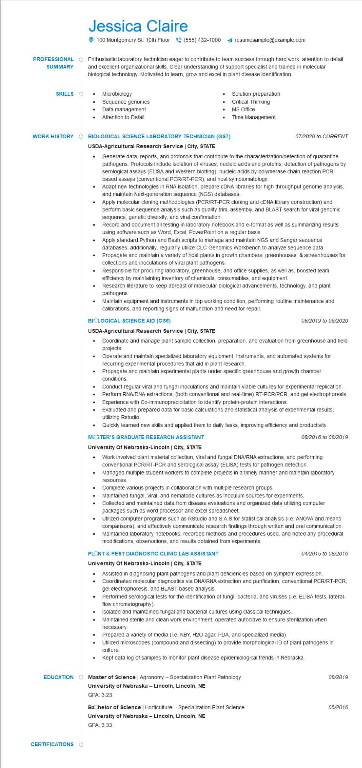

Jessica Claire

100 Montgomery St. 10th Floor (555) 432-1000

resumesample@example.com

**PROFESSIONAL**

**SUMMARY**

Enthusiastic laboratory technician eager to contribute to team success through hard work, attention to detail and excellent organizational skills. Clear understanding of support specialist and trained in molecular biological technology. Motivated to learn, grow and excel in plant disease identification.

**SKILLS**

• Microbiology

Sequence genomes

•

Data management

**WORK HISTORY**

•

Attention to Detail

•

Solution preparation

Critical Thinking

MS Office

Time Management

**BIOLOGICAL SCIENCE LABORATORY TECHNICIAN (GS7) USDA-Agricultural Research Service | City, STATE**

•

07/2020 to CURRENT

Generate data, reports, and protocols that contribute to the characterization/detection of quarantine pathogens. Protocols include isolation of viruses, nucleic acids and proteins, detection of pathogens by serological assays (ELISA and Western blotting), nucleic acids by polymerase chain reaction PCR- based assays (conventional PCR/RT-PCR), and host symptomatology.

Adapt new technologies in RNA isolation, prepare cDNA libraries for high throughput genome analysis, and maintain Next-generation sequence (NGS) databases.

Apply molecular cloning methodologies (PCR/RT-PCR cloning and cDNA library construction) and perform basic sequence analysis such as quality trim, assembly, and BLAST search for viral genomic sequence, genetic diversity, and viral confirmation.

Record and document all testing in laboratory notebook and e-format as well as summarizing results using software such as Word, Excel, PowerPoint on a regular basis.

Apply standard Python and Bash scripts to manage and maintain NGS and Sanger sequence databases, additionally, regularly utilize CLC Genomics Workbench to analyze sequence data.

· Propagate and maintain a variety of host plants in growth chambers, greenhouses, collections and inoculations of viral plant pathogens.

screenhouses for

Responsible for procuring laboratory, greenhouse, and office supplies, as well as, boosted team efficiency by maintaining inventory of chemicals, consumables, and equipment.

Research literature to keep abreast of molecular biological advancements, technology, and plant pathogens.

Maintain equipment and instruments in top working condition, performing routine maintenance and calibrations, and reporting signs of malfunction and need for repair.

**BIOLOGICAL SCIENCE AID (GS6)**

**USDA-Agricultural Research Service | City, STATE**

08/2019 to 06/2020

Coordinate and manage plant sample collection, preparation, and evaluation from greenhouse and field projects.

Operate and maintain specialized laboratory equipment, instruments, and automated systems for recurring experimental procedures that aid in plant research.

•

Propagate and maintain experimental plants under specific greenhouse and growth chamber conditions.

•

•

•

Conduct regular viral and fungal inoculations and maintain viable cultures for experimental replication.

Perform RNA/DNA extractions, (both conventional and real-time) RT-PCR/PCR, and gel electrophoresis. Experience with Co-Immunoprecipitation to identify protein-protein interactions.

Evaluated and prepared data for basic calculations and statistical analysis of experimental results, utilizing Rstudio.

Quickly learned new skills and applied them to daily tasks, improving efficiency and productivity.

**MOSTER'S GRADUATE RESEARCH ASSISTANT**

**University Of Nebraska-Lincoln | City, STATE**

•

08/2016 to 08/2019

Work involved plant material collection, viral and fungal DNA/RNA extractions, and performing conventional PCR/RT-PCR and serological assay (ELISA) tests for pathogen detection.

Managed multiple student workers to complete projects in a timely manner and maintain laboratory resources

Complete various projects in collaboration with multiple research groups.

Maintained fungal, viral, and nematode cultures as inoculum sources for experiments.

Collected and maintained data from disease evaluations and organized data utilizing computer packages such as word processor and excel spreadsheet.

Utilized computer programs such as RStudio and S.A.S for statistical analysis (i.e. ANOVA and means comparisons), and effectively communicate research findings through written and oral communication. Maintained laboratory notebooks, recorded methods and procedures used, and noted any procedural modifications, observations, and results obtained from experiments.

**PLONT & PEST DIAGNOSTIC CLINIC LAB ASSISTANT**

**University of Nebraska-Lincoln | City, STATE**

*04/2015 to 08/2016*

• Assisted in diagnosing plant pathogens and plant deficiencies based on symptom expression. Coordinated molecular diagnostics via DNA/RNA extraction and purification, conventional PCR/RT-PCR, gel electrophoresis, and BLAST-based analysis.

Performed serological tests for the identification of fungi, bacteria, and viruses (i.e. ELISA tests, lateral- flow chromatography).

• Isolated and maintained fungal and bacterial cultures using classical techniques.

•

Maintained sterile and clean work environment, operated autoclave to ensure sterilization when necessary.

Prepared a variety of media (i.e. NBY, H2O agar, PDA, and specialized media).

Utilized microscopes (compound and dissecting) to provide morphological ID of plant pathogens in culture.

Kept data log of samples to monitor plant disease epidemiological trends in Nebraska.

**EDUCATION**

**Master of Science | Agronomy - Specialization Plant Pathology University of Nebraska-Lincoln, Lincoln, NE**

**CERTIFICATIONS**

GPA: 3.23

**Bachelor of Science | Horticulture - Specialization Plant Science University of Nebraska-Lincoln, Lincoln, NE**

GPA: 3.33

08/2019

05/2016