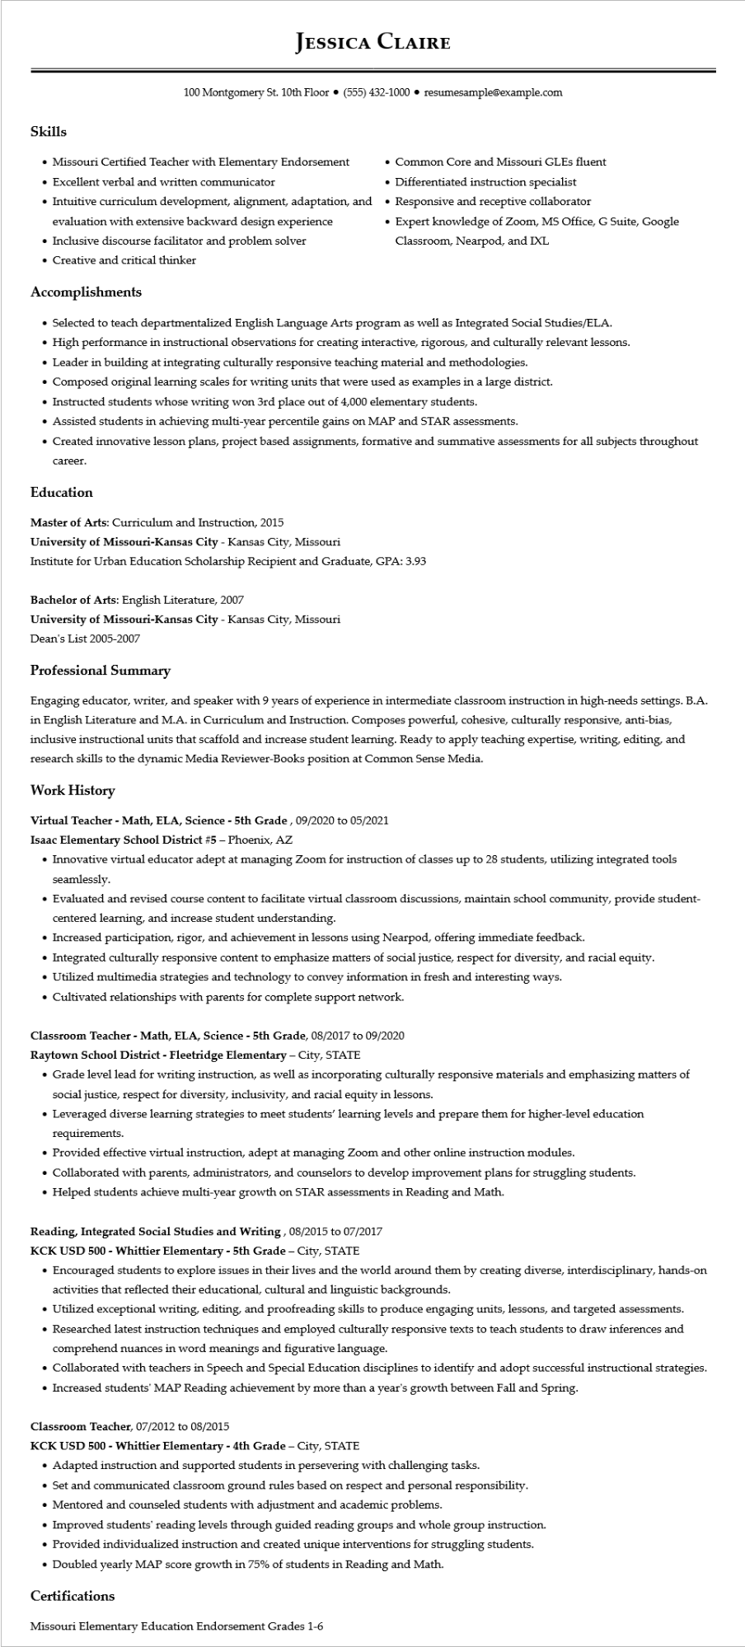

**JESSICA CLAIRE**

100 Montgomery St. 10th Floor⚫ (555) 432-1000⚫ resumesample@example.com

Skills

• Missouri Certified Teacher with Elementary Endorsement

• Excellent verbal and written communicator

• Intuitive curriculum development, alignment, adaptation, and evaluation with extensive backward design experience

• Inclusive discourse facilitator and problem solver

• Creative and critical thinker

**Accomplishments**

• Common Core and Missouri GLEs fluent

• Differentiated instruction specialist

• Responsive and receptive collaborator

Expert knowledge of Zoom, MS Office, G Suite, Google Classroom, Nearpod, and IXL

• Selected to teach departmentalized English Language Arts program as well as Integrated Social Studies/ELA.

• High performance in instructional observations for creating interactive, rigorous, and culturally relevant lessons.

• Leader in building at integrating culturally responsive teaching material and methodologies.

• Composed original learning scales for writing units that were used as examples in a large district.

• Instructed students whose writing won 3rd place out of 4,000 elementary students.

• Assisted students in achieving multi-year percentile gains on MAP and STAR assessments.

• Created innovative lesson plans, project based assignments, formative and summative assessments for all subjects throughout

career.

**Education**

Master of Arts: Curriculum and Instruction, 2015

**University of Missouri-Kansas City - Kansas City, Missouri**

Institute for Urban Education Scholarship Recipient and Graduate, GPA: 3.93

Bachelor of Arts: English Literature, 2007

**University of Missouri-Kansas City - Kansas City, Missouri**

Dean's List 2005-2007

**Professional Summary**

Engaging educator, writer, and speaker with 9 years of experience in intermediate classroom instruction in high-needs settings. B.A. in English Literature and M.A. in Curriculum and Instruction. Composes powerful, cohesive, culturally responsive, anti-bias, inclusive instructional units that scaffold and increase student learning. Ready to apply teaching expertise, writing, editing, and research skills to the dynamic Media Reviewer-Books position at Common Sense Media.

**Work History**

**Virtual Teacher - Math, ELA, Science - 5th Grade, 09/2020 to 05/2021**

Isaac Elementary School District #5 - Phoenix, AZ

• Innovative virtual educator adept at managing Zoom for instruction of classes up to 28 students, utilizing integrated tools seamlessly.

• Evaluated and revised course content to facilitate virtual classroom discussions, maintain school community, provide student- centered learning, and increase student understanding.

• Increased participation, rigor, and achievement in lessons using Nearpod, offering immediate feedback.

• Integrated culturally responsive content to emphasize matters of social justice, respect for diversity, and racial equity.

• Utilized multimedia strategies and technology to convey information in fresh and interesting ways.

• Cultivated relationships with parents for complete support network.

**Classroom Teacher - Math, ELA, Science - 5th Grade, 08/2017 to 09/2020**

Raytown School District - Fleetridge Elementary - City, STATE

• Grade level lead for writing instruction, as well as incorporating culturally responsive materials and emphasizing matters of social justice, respect for diversity, inclusivity, and racial equity in lessons.

• Leveraged diverse learning strategies to meet students' learning levels and prepare them for higher-level education requirements.

• Provided effective virtual instruction, adept at managing Zoom and other online instruction modules.

• Collaborated with parents, administrators, and counselors to develop improvement plans for struggling students.

• Helped students achieve multi-year growth on STAR assessments in Reading and Math.

**Reading, Integrated Social Studies and Writing, 08/2015 to 07/2017**

**KCK USD 500 - Whittier Elementary - 5th Grade - City, STATE**

• Encouraged students to explore issues in their lives and the world around them by creating diverse, interdisciplinary, hands-on activities that reflected their educational, cultural and linguistic backgrounds.

• Utilized exceptional writing, editing, and proofreading skills to produce engaging units, lessons, and targeted assessments.

• Researched latest instruction techniques and employed culturally responsive texts to teach students to draw inferences and comprehend nuances in word meanings and figurative language.

• Collaborated with teachers in Speech and Special Education disciplines to identify and adopt successful instructional strategies.

• Increased students' MAP Reading achievement by more than a year's growth between Fall and Spring.

Classroom Teacher, 07/2012 to 08/2015

**KCK USD 500 - Whittier Elementary - 4th Grade - City, STATE**

• Adapted instruction and supported students in persevering with challenging tasks.

• Set and communicated classroom ground rules based on respect and personal responsibility.

• Mentored and counseled students with adjustment and academic problems.

• Improved students' reading levels through guided reading groups and whole group instruction.

• Provided individualized instruction and created unique interventions for struggling students.

• Doubled yearly MAP score growth in 75% of students in Reading and Math.

Certifications

Missouri Elementary Education Endorsement Grades 1-6