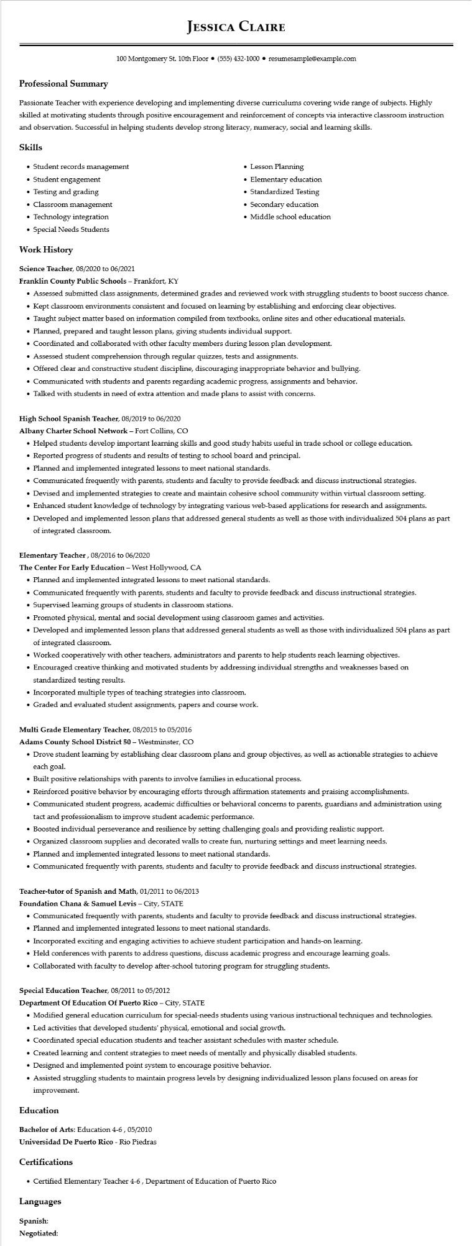

**Professional Summary**

**JESSICA CLAIRE**

100 Montgomery St. 10th Floor⚫ (555) 432-1000⚫ resumesample@example.com

Passionate Teacher with experience developing and implementing diverse curriculums covering wide range of subjects. Highly skilled at motivating students through positive encouragement and reinforcement of concepts via interactive classroom instruction and observation. Successful in helping students develop strong literacy, numeracy, social and learning skills.

**Skills**

• Student records management

• Student engagement

• Testing and grading

⚫ Classroom management

• Technology integration

• Special Needs Students

**Work History**

Science Teacher, 08/2020 to 06/2021

**Franklin County Public Schools - Frankfort, KY**

• Lesson Planning

•

Elementary education

• Standardized Testing

• Secondary education

• Middle school education

• Assessed submitted class assignments, determined grades and reviewed work with struggling students to boost success chance.

• Kept classroom environments consistent and focused on learning by establishing and enforcing clear objectives.

• Taught subject matter based on information compiled from textbooks, online sites and other educational materials.

• Planned, prepared and taught lesson plans, giving students individual support.

• Coordinated and collaborated with other faculty members during lesson plan development.

• Assessed student comprehension through regular quizzes, tests and assignments.

• Offered clear and constructive student discipline, discouraging inappropriate behavior and bullying.

• Communicated with students and parents regarding academic progress, assignments and behavior.

• Talked with students in need of extra attention and made plans to assist with concerns.

High School Spanish Teacher, 08/2019 to 06/2020

**Albany Charter School Network - Fort Collins, CO**

• Helped students develop important learning skills and good study habits useful in trade school or college education.

• Reported progress of students and results of testing to school board and principal.

• Planned and implemented integrated lessons to meet national standards.

• Communicated frequently with parents, students and faculty to provide feedback and discuss instructional strategies.

• Devised and implemented strategies to create and maintain cohesive school community within virtual classroom setting.

• Enhanced student knowledge of technology by integrating various web-based applications for research and assignments.

• Developed and implemented lesson plans that addressed general students as well as those with individualized 504 plans as part of integrated classroom.

**Elementary Teacher, 08/2016 to 06/2020**

**The Center For Early Education - West Hollywood, CA**

• Planned and implemented integrated lessons to meet national standards.

• Communicated frequently with parents, students and faculty to provide feedback and discuss instructional strategies. Supervised learning groups of students in classroom stations.

·

• Promoted physical, mental and social development using classroom games and activities.

• Developed and implemented lesson plans that addressed general students as well as those with individualized 504 plans as part of integrated classroom.

• Worked cooperatively with other teachers, administrators and parents to help students reach learning objectives.

• Encouraged creative thinking and motivated students by addressing individual strengths and weaknesses based on standardized testing results.

• Incorporated multiple types of teaching strategies into classroom.

• Graded and evaluated student assignments, papers and course work.

**Multi Grade Elementary Teacher, 08/2015 to 05/2016**

Adams County School District 50 - Westminster, CO

• Drove student learning by establishing clear classroom plans and group objectives, as well as actionable strategies to achieve each goal.

• Built positive relationships with parents to involve families in educational process.

• Reinforced positive behavior by encouraging efforts through affirmation statements and praising accomplishments.

• Communicated student progress, academic difficulties or behavioral concerns to parents, guardians and administration using tact and professionalism to improve student academic performance.

• Boosted individual perseverance and resilience by setting challenging goals and providing realistic support.

• Organized classroom supplies and decorated walls to create fun, nurturing settings and meet learning needs.

• Planned and implemented integrated lessons to meet national standards.

• Communicated frequently with parents, students and faculty to provide feedback and discuss instructional strategies.

**Teacher-tutor of Spanish and Math, 01/2011 to 06/2013**

Foundation Chana & Samuel Levis - City, STATE

• Communicated frequently with parents, students and faculty to provide feedback and discuss instructional strategies.

• Planned and implemented integrated lessons to meet national standards.

• Incorporated exciting and engaging activities to achieve student participation and hands-on learning.

• Held conferences with parents to address questions, discuss academic progress and encourage learning goals.

• Collaborated with faculty to develop after-school tutoring program for struggling students.

**Special Education Teacher, 08/2011 to 05/2012**

Department of Education Of Puerto Rico - City, STATE

• Modified general education curriculum for special-needs students using various instructional techniques and technologies.

• Led activities that developed students' physical, emotional and social growth.

• Coordinated special education students and teacher assistant schedules with master schedule.

• Created learning and content strategies to meet needs of mentally and physically disabled students.

• Designed and implemented point system to encourage positive behavior.

• Assisted struggling students to maintain progress levels by designing individualized lesson plans focused on areas for improvement.

**Education**

Bachelor of Arts: Education 4-6, 05/2010

**Universidad De Puerto Rico - Rio Piedras**

**Certifications**

• Certified Elementary Teacher 4-6, Department of Education of Puerto Rico

**Languages**

**Spanish: Negotiated:**