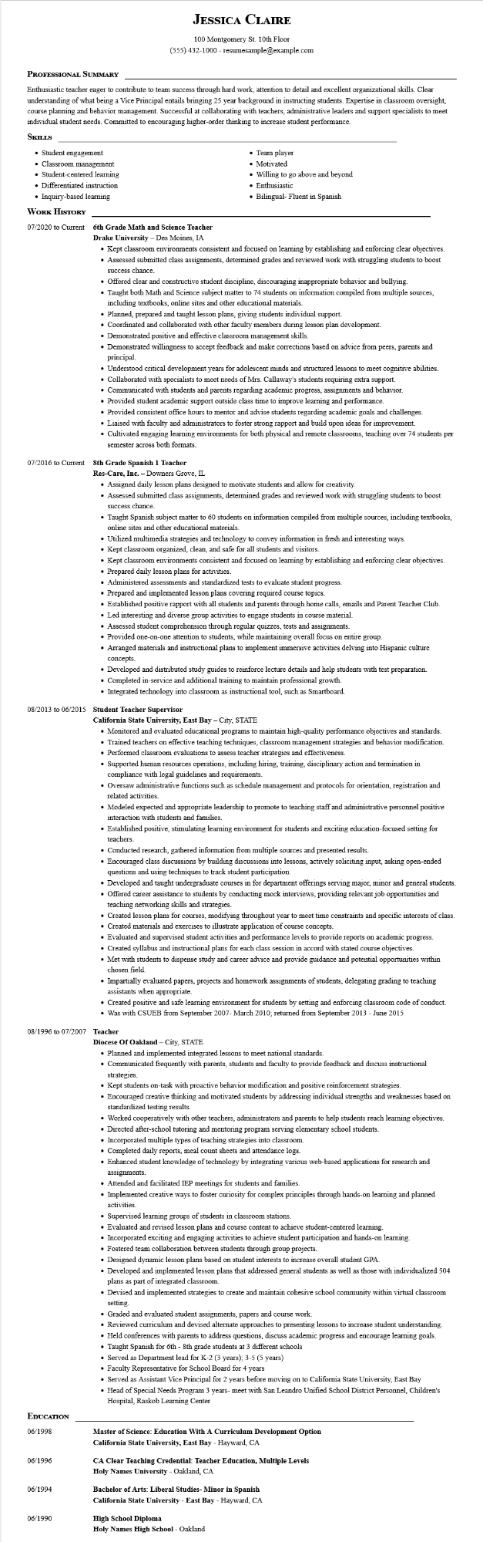

**JESSICA CLAIRE**

100 Montgomery St. 10th Floor

(555) 432-1000 - resumesample@example.com

**PROFESSIONAL SUMMARY**

Enthusiastic teacher eager to contribute to team success through hard work, attention to detail and excellent organizational skills. Clear understanding of what being a Vice Principal entails bringing 25 year background in instructing students. Expertise in classroom oversight, course planning and behavior management. Successful at collaborating with teachers, administrative leaders and support specialists to meet individual student needs. Committed to encouraging higher-order thinking to increase student performance.

**SKILLS**

• Student engagement • Classroom management • Student-centered learning

• Differentiated instruction

• Inquiry-based learning

**WORK HISTORY**

07/2020 to Current 6th Grade Math and Science Teacher Drake University - Des Moines, IA

07/2016 to Current

• Team player

• Motivated

• Willing to go above and beyond • Enthusiastic

• Bilingual-Fluent in Spanish

• Kept classroom environments consistent and focused on learning by establishing and enforcing clear objectives.

• Assessed submitted class assignments, determined grades and reviewed work with struggling students to boost success chance.

• Offered clear and constructive student discipline, discouraging inappropriate behavior and bullying.

• Taught both Math and Science subject matter to 74 students on information compiled from multiple sources, including textbooks, online sites and other educational materials.

• Planned, prepared and taught lesson plans, giving students individual support.

• Coordinated and collaborated with other faculty members during lesson plan development.

• Demonstrated positive and effective classroom management skills.

• Demonstrated willingness to accept feedback and make corrections based on advice from peers, parents and principal.

• Understood critical development years for adolescent minds and structured lessons to meet cognitive abilities.

• Collaborated with specialists to meet needs of Mrs. Callaway's students requiring extra support.

• Communicated with students and parents regarding academic progress, assignments and behavior.

• Provided student academic support outside class time to improve learning and performance.

• Provided consistent office hours to mentor and advise students regarding academic goals and challenges.

• Liaised with faculty and administrators to foster strong rapport and build upon ideas for improvement.

• Cultivated engaging learning environments for both physical and remote classrooms, teaching over 74 students per semester across both formats.

**8th Grade Spanish 1 Teacher**

Res-Care, Inc. - Downers Grove, IL

• Assigned daily lesson plans designed to motivate students and allow for creativity.

• Assessed submitted class assignments, determined grades and reviewed work with struggling students to boost success chance.

• Taught Spanish subject matter to 60 students on information compiled from multiple sources, including textbooks, online sites and other educational materials.

• Utilized multimedia strategies and technology to convey information in fresh and interesting ways.

• Kept classroom organized, clean, and safe for all students and visitors.

• Kept classroom environments consistent and focused on learning by establishing and enforcing clear objectives.

• Prepared daily lesson plans for activities.

• Administered assessments and standardized tests to evaluate student progress.

• Prepared and implemented lesson plans covering required course topics.

• Established positive rapport with all students and parents through home calls, emails and Parent Teacher Club.

• Led interesting and diverse group activities to engage students in course material.

• Assessed student comprehension through regular quizzes, tests and assignments.

• Provided one-on-one attention to students, while maintaining overall focus on entire group.

• Arranged materials and instructional plans to implement immersive activities delving into Hispanic culture concepts.

• Developed and distributed study guides to reinforce lecture details and help students with test preparation.

• Completed in-service and additional training to maintain professional growth.

• Integrated technology into classroom as instructional tool, such as Smartboard.

**08/2013 to 06/2015 Student Teacher Supervisor**

**California State University, East Bay - City, STATE**

• Monitored and evaluated educational programs to maintain high-quality performance objectives and standards. • Trained teachers on effective teaching techniques, classroom management strategies and behavior modification.

• Performed classroom evaluations to assess teacher strategies and effectiveness.

• Supported human resources operations, including hiring, training, disciplinary action and termination in compliance with legal guidelines and requirements.

• Oversaw administrative functions such as schedule management and protocols for orientation, registration and related activities.

• Modeled expected and appropriate leadership to promote to teaching staff and administrative personnel positive interaction with students and families.

• Established positive, stimulating learning environment for students and exciting education-focused setting for teachers.

• Conducted research, gathered information from multiple sources and presented results.

• Encouraged class discussions by building discussions into lessons, actively soliciting input, asking open-ended questions and using techniques to track student participation.

• Developed and taught undergraduate courses in for department offerings serving major, minor and general students.

• Offered career assistance to students by conducting mock interviews, providing relevant job opportunities and teaching networking skills and strategies.

• Created lesson plans for courses, modifying throughout year to meet time constraints and specific interests of class. • Created materials and exercises to illustrate application of course concepts.

• Evaluated and supervised student activities and performance levels to provide reports on academic progress.

• Created syllabus and instructional plans for each class session in accord with stated course objectives.

• Met with students to dispense study and career advice and provide guidance and potential opportunities within chosen field.

• Impartially evaluated papers, projects and homework assignments of students, delegating grading to teaching assistants when appropriate.

• Created positive and safe learning environment for students by setting and enforcing classroom code of conduct.

• Was with CSUEB from September 2007- March 2010; returned from September 2013 - June 2015

08/1996 to 07/2007 Teacher

Diocese of Oakland - City, STATE

• Planned and implemented integrated lessons to meet national standards.

• Communicated frequently with parents, students and faculty to provide feedback and discuss instructional strategies.

• Kept students on-task with proactive behavior modification and positive reinforcement strategies.

• Encouraged creative thinking and motivated students by addressing individual strengths and weaknesses based on standardized testing results.

• Worked cooperatively with other teachers, administrators and parents to help students reach learning objectives.

• Directed after-school tutoring and mentoring program serving elementary school students.

• Incorporated multiple types of teaching strategies into classroom.

• Completed daily reports, meal count sheets and attendance logs.

• Enhanced student knowledge of technology by integrating various web-based applications for research and assignments.

• Attended and facilitated IEP meetings for students and families.

• Implemented creative ways to foster curiosity for complex principles through hands-on learning and planned activities.

• Supervised learning groups of students in classroom stations.

• Evaluated and revised lesson plans and course content to achieve student-centered learning.

• Incorporated exciting and engaging activities to achieve student participation and hands-on learning.

• Fostered team collaboration between students through group projects.

• Designed dynamic lesson plans based on student interests to increase overall student GPA.

• Developed and implemented lesson plans that addressed general students as well as those with individualized 504 plans as part of integrated classroom.

• Devised and implemented strategies to create and maintain cohesive school community within virtual classroom

setting.

• Graded and evaluated student assignments, papers and course work.

• Reviewed curriculum and devised alternate approaches to presenting lessons to increase student understanding.

• Held conferences with parents to address questions, discuss academic progress and encourage learning goals.

• Taught Spanish for 6th - 8th grade students at 3 different schools

• Served as Department lead for K-2 (3 years); 3-5 (5 years)

• Faculty Representative for School Board for 4 years

• Served as Assistant Vice Principal for 2 years before moving on to California State University, East Bay

• Head of Special Needs Program 3 years- meet with San Leandro Unified School District Personnel, Children's Hospital, Raskob Learning Center

**EDUCATION**

06/1998

**Master of Science: Education With A Curriculum Development Option**

**California State University, East Bay - Hayward, CA**

06/1996

**CA Clear Teaching Credential: Teacher Education, Multiple Levels Holy Names University - Oakland, CA**

06/1994

**Bachelor of Arts: Liberal Studies- Minor in Spanish**

**California State University - East Bay - Hayward, CA**

06/1990

High School Diploma

**Holy Names High School - Oakland**