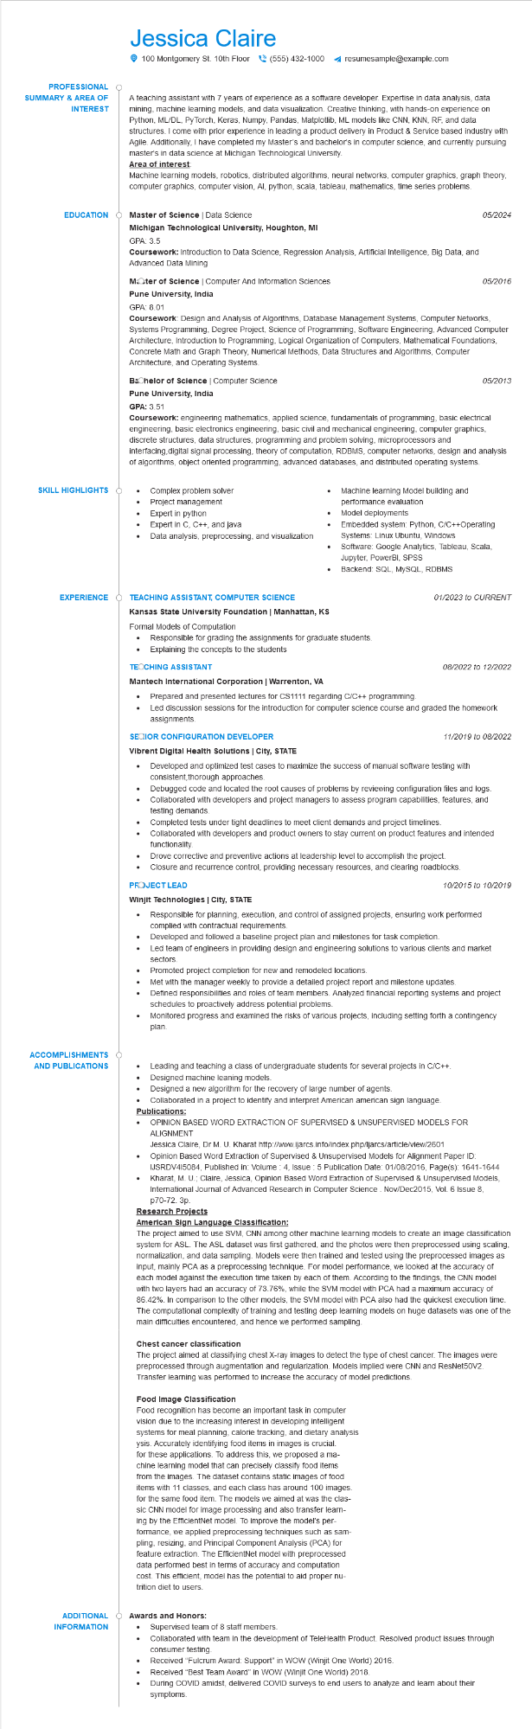

Jessica Claire

100 Montgomery St. 10th Floor (555) 432-1000 ◄ resumesample@example.com

**PROFESSIONAL**

**SUMMARY & AREA OF INTEREST**

A teaching assistant with 7 years of experience as a software developer. Expertise in data analysis, data mining, machine learning models, and data visualization. Creative thinking, with hands-on experience on Python, ML/DL, PyTorch, Keras, Numpy, Pandas, Matplotlib, ML models like CNN, KNN, RF, and data structures. I come with prior experience in leading a product delivery in Product & Service based industry with Agile. Additionally, I have completed my Master's and bachelor's in computer science, and currently pursuing master's in data science at Michigan Technological University.

**Area of interest**

Machine learning models, robotics, distributed algorithms, neural networks, computer graphics, graph theory, computer graphics, computer vision, Al, python, scala, tableau, mathematics, time series problems.

**EDUCATION**

**SKILL HIGHLIGHTS**

Master of Science | Data Science

**Michigan Technological University, Houghton, MI**

GPA: 3.5

Coursework: Introduction to Data Science, Regression Analysis, Artificial Intelligence, Big Data, and Advanced Data Mining

MOOter of Science | Computer And Information Sciences Pune University, India

05/2024

*05/2016*

GPA: 8.01

Coursework: Design and Analysis of Algorithms, Database Management Systems, Computer Networks, Systems Programming, Degree Project, Science of Programming, Software Engineering, Advanced Computer Architecture, Introduction to Programming, Logical Organization of Computers, Mathematical Foundations, Concrete Math and Graph Theory, Numerical Methods, Data Structures and Algorithms, Computer Architecture, and Operating Systems.

**Bachelor of Science | Computer Science**

**Pune University, India**

GPA: 3.51

*05/2013*

Coursework: engineering mathematics, applied science, fundamentals of programming, basic electrical engineering, basic electronics engineering, basic civil and mechanical engineering, computer graphics, discrete structures, data structures, programming and problem solving, microprocessors and interfacing, digital signal processing, theory of computation, RDBMS, computer networks, design and analysis of algorithms, object oriented programming, advanced databases, and distributed operating systems.

Complex problem solver

Project management

Expert in python

•

Expert in C, C++, and java

•

•

Machine learning Model building and performance evaluation

Data analysis, preprocessing, and visualization

Model deployments

Embedded system: Python, C/C++Operating

Systems: Linux Ubuntu, Windows

Software: Google Analytics, Tableau, Scala, Jupyter, PowerBI, SPSS

Backend: SQL, MySQL, RDBMS

**EXPERIENCE**

**TEACHING ASSISTANT, COMPUTER SCIENCE**

**Kansas State University Foundation | Manhattan, KS**

Formal Models of Computation

· Responsible for grading the assignments for graduate students.

Explaining the concepts to the students

**TEOCHING ASSISTANT**

**Mantech International Corporation | Warrenton, VA**

•

Prepared and presented lectures for CS1111 regarding C/C++ programming.

01/2023 to CURRENT

08/2022 to 12/2022

Led discussion sessions for the introduction for computer science course and graded the homework assignments.

**SECIOR CONFIGURATION DEVELOPER**

**Vibrent Digital Health Solutions | City, STATE**

*11/2019 to 08/2022*

Developed and optimized test cases to maximize the success of manual software testing with consistent, thorough approaches.

•

Debugged code and located the root causes of problems by reviewing configuration files and logs. Collaborated with developers and project managers to assess program capabilities, features, and testing demands.

Completed tests under tight deadlines to meet client demands and project timelines.

Collaborated with developers and product owners to stay current on product features and intended functionality.

Drove corrective and preventive actions at leadership level to accomplish the project. Closure and recurrence control, providing necessary resources, and clearing roadblocks.

PROJECT LEAD

**Winjit Technologies | City, STATE**

•

10/2015 to 10/2019

Responsible for planning, execution, and control of assigned projects, ensuring work performed complied with contractual requirements.

Developed and followed a baseline project plan and milestones for task completion.

Led team of engineers in providing design and engineering solutions to various clients and market sectors.

Promoted project completion for new and remodeled locations.

Met with the manager weekly to provide a detailed project report and milestone updates.

Defined responsibilities and roles of team members. Analyzed financial reporting systems and project schedules to proactively address potential problems.

Monitored progress and examined the risks of various projects, including setting forth a contingency plan.

**ACCOMPLISHMENTS AND PUBLICATIONS**

•

Leading and teaching a class of undergraduate students for several projects in C/C++. Designed machine leaning models.

• Designed a new algorithm for the recovery of large number of agents.

•

Collaborated in a project to identify and interpret American american sign language. Publications:

• OPINION BASED WORD EXTRACTION OF SUPERVISED & UNSUPERVISED MODELS FOR ALIGNMENT

Jessica Claire, Dr M. U. Kharat http://www.ijarcs.info/index.php/ljarcs/article/view/2601

Opinion Based Word Extraction of Supervised & Unsupervised Models for Alignment Paper ID: IJSRDV415084, Published in: Volume 4, Issue: 5 Publication Date: 01/08/2016, Page(s): 1641-1644 Kharat, M. U.; Claire, Jessica, Opinion Based Word Extraction of Supervised & Unsupervised Models, International Journal of Advanced Research in Computer Science. Nov/Dec2015, Vol. 6 Issue 8, p70-72. 3p.

**Research Projects**

**American Sign Language Classification:**

The project aimed to use SVM, CNN among other machine learning models to create an image classification system for ASL. The ASL dataset was first gathered, and the photos were then preprocessed using scaling, normalization, and data sampling. Models were then trained and tested using the preprocessed images as input, mainly PCA as a preprocessing technique. For model performance, we looked at the accuracy of each model against the execution time taken by each of them. According to the findings, the CNN model with two layers had an accuracy of 73.76%, while the SVM model with PCA had a maximum accuracy of 86.42%. In comparison to the other models, the SVM model with PCA also had the quickest execution time. The computational complexity of training and testing deep learning models on huge datasets was one of the main difficulties encountered, and hence we performed sampling.

**Chest cancer classification**

The project aimed at classifying chest X-ray images to detect the type of chest cancer. The images were preprocessed through augmentation and regularization. Models implied were CNN and ResNet50V2. Transfer learning was performed to increase the accuracy of model predictions.

**Food Image Classification**

Food recognition has become an important task in computer vision due to the increasing interest in developing intelligent systems for meal planning, calorie tracking, and dietary analysis ysis. Accurately identifying food items in images is crucial. for these applications. To address this, we proposed a ma- chine learning model that can precisely classify food items from the images. The dataset contains static images of food items with 11 classes, and each class has around 100 images. for the same food item. The models we aimed at was the clas- sic CNN model for image processing and also transfer learn- ing by the EfficientNet model. To improve the model's per- formance, we applied preprocessing techniques such as sam- pling, resizing, and Principal Component Analysis (PCA) for feature extraction. The EfficientNet model with preprocessed data performed best in terms of accuracy and computation cost. This efficient, model has the potential to aid proper nu- trition diet to users.

**ADDITIONAL INFORMATION**

**Awards and Honors:**

Supervised team of 8 staff members.

•

Collaborated with team in the development of TeleHealth Product. Resolved product issues through consumer testing.

•

Received "Fulcrum Award: Support" in WOW (Winjit One World) 2016.

Received "Best Team Award" in WOW (Winjit One World) 2018.

During COVID amidst, delivered COVID surveys to end users to analyze and learn about their

symptoms.