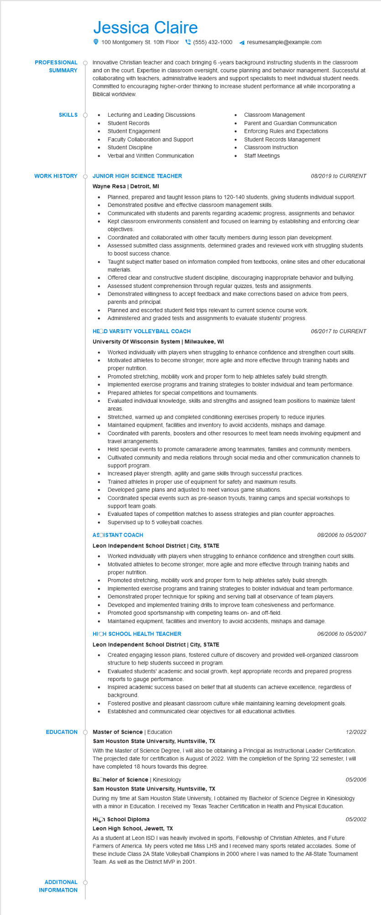

**PROFESSIONAL**

**SUMMARY**

Jessica Claire

100 Montgomery St. 10th Floor(555) 432-1000

resumesample@example.com

Innovative Christian teacher and coach bringing 6-years background instructing students in the classroom and on the court. Expertise in classroom oversight, course planning and behavior management. Successful at collaborating with teachers, administrative leaders and support specialists to meet individual student needs. Committed to encouraging higher-order thinking to increase student performance all while incorporating a Biblical worldview.

**SKILLS**

•

Lecturing and Leading Discussions

Student Records

Classroom Management

Parent and Guardian Communication

•

Student Engagement

•

Enforcing Rules and Expectations

Faculty Collaboration and Support

• Student Discipline

Student Records Management

Classroom Instruction

Verbal and Written Communication

Staff Meetings

**WORK HISTORY**

**JUNIOR HIGH SCIENCE TEACHER Wayne Resa | Detroit, MI**

*08/2019 to CURRENT*

•

•

•

•

Planned, prepared and taught lesson plans to 120-140 students, giving students individual support. Demonstrated positive and effective classroom management skills.

Communicated with students and parents regarding academic progress, assignments and behavior. Kept classroom environments consistent and focused on learning by establishing and enforcing clear objectives.

Coordinated and collaborated with other faculty members during lesson plan development.

Assessed submitted class assignments, determined grades and reviewed work with struggling students to boost success chance.

Taught subject matter based on information compiled from textbooks, online sites and other educational materials.

Offered clear and constructive student discipline, discouraging inappropriate behavior and bullying. Assessed student comprehension through regular quizzes, tests and assignments.

Demonstrated willingness to accept feedback and make corrections based on advice from peers, parents and principal.

Planned and escorted student field trips relevant to current science course work. Administered and graded tests and assignments to evaluate students' progress.

**HEOD VARSITY VOLLEYBALL COACH**

**University Of Wisconsin System | Milwaukee, WI**

•

•

•

•

•

*06/2017 to CURRENT*

Worked individually with players when struggling to enhance confidence and strengthen court skills. Motivated athletes to become stronger, more agile and more effective through training habits and proper nutrition.

Promoted stretching, mobility work and proper form to help athletes safely build strength.

Implemented exercise programs and training strategies to bolster individual and team performance. Prepared athletes for special competitions and tournaments.

Evaluated individual knowledge, skills and strengths and assigned team positions to maximize talent

areas

Stretched, warmed up and completed conditioning exercises properly to reduce injuries.

Maintained equipment, facilities and inventory to avoid accidents, mishaps and damage.

Coordinated with parents, boosters and other resources to meet team needs involving equipment and travel arrangements.

Held special events to promote camaraderie among teammates, families and community members. Cultivated community and media relations through social media and other communication channels to support program.

Increased player strength, agility and game skills through successful practices.

•

Trained athletes in proper use of equipment for safety and maximum results. Developed game plans and adjusted to meet various game situations.

Coordinated special events such as pre-season tryouts, training camps and special workshops to support team goals.

Evaluated tapes of competition matches to assess strategies and plan counter approaches.

• Supervised up to 5 volleyball coaches.

**ASOISTANT COACH**

**Leon Independent School District | City, STATE**

•

*08/2006 to 05/2007*

Worked individually with players when struggling to enhance confidence and strengthen court skills. Motivated athletes to become stronger, more agile and more effective through training habits and proper nutrition.

Promoted stretching, mobility work and proper form to help athletes safely build strength.

Implemented exercise programs and training strategies to bolster individual and team performance. Demonstrated proper technique for spiking and serving ball at observance of team players.

• Developed and implemented training drills to improve team cohesiveness and performance.

· Promoted good sportsmanship with competing teams on- and off-field.

• Maintained equipment, facilities and inventory to avoid accidents, mishaps and damage.

**HICH SCHOOL HEALTH TEACHER**

**Leon Independent School District | City, STATE**

06/2006 to 05/2007

• Created engaging lesson plans, fostered culture of discovery and provided well-organized classroom structure to help students succeed in program.

•

Evaluated students' academic and social growth, kept appropriate records and prepared progress reports to gauge performance.

Inspired academic success based on belief that all students can achieve excellence, regardless of background.

• Fostered positive and pleasant classroom culture while maintaining learning development goals. Established and communicated clear objectives for all educational activities.

**EDUCATION Master of Science | Education**

**ADDITIONAL INFORMATION**

**Sam Houston State University, Huntsville, TX**

*12/2022*

With the Master of Science Degree, I will also be obtaining a Principal as Instructional Leader Certification. The projected date for certification is August of 2022. With the completion of the Spring '22 semester, I will have completed 18 hours towards this degree.

Bachelor of Science | Kinesiology

**Sam Houston State University, Huntsville, TX**

05/2006

During my time at Sam Houston State University, I obtained my Bachelor of Science Degree in Kinesiology with a minor in Education. I received my Texas Teacher Certification in Health and Physical Education.

High School Diploma

**Leon High School, Jewett, TX**

*05/2002*

As a student at Leon ISD I was heavily involved in sports, Fellowship of Christian Athletes, and Future Farmers of America. My peers voted me Miss LHS and I received many sports related accolades. Some of these include Class 2A State Volleyball Champions in 2000 where I was named to the All-State Tournament Team. As well as the District MVP in 2001.