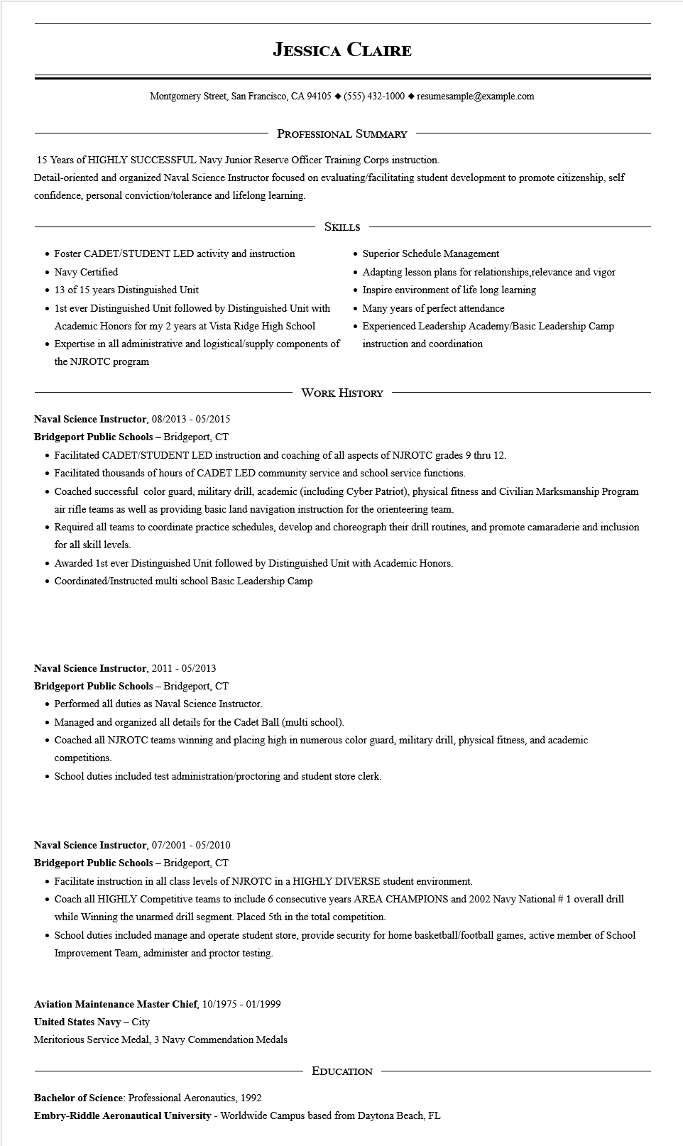

**JESSICA CLAIRE**

Montgomery Street, San Francisco, CA 94105 ♦ (555) 432-1000 resumesample@example.com

PROFESSIONAL SUMMARY

15 Years of HIGHLY SUCCESSFUL Navy Junior Reserve Officer Training Corps instruction.

Detail-oriented and organized Naval Science Instructor focused on evaluating/facilitating student development to promote citizenship, self confidence, personal conviction/tolerance and lifelong learning.

• Foster CADET/STUDENT LED activity and instruction • Navy Certified

• 13 of 15 years Distinguished Unit

SKILLS

• 1st ever Distinguished Unit followed by Distinguished Unit with Academic Honors for my 2 years at Vista Ridge High School

• Expertise in all administrative and logistical/supply components of the NJROTC program

• Superior Schedule Management

• Adapting lesson plans for relationships,relevance and vigor

• Inspire environment of life long learning

• Many years of perfect attendance

• Experienced Leadership Academy/Basic Leadership Camp instruction and coordination

WORK HISTORY

**Naval Science Instructor, 08/2013 - 05/2015**

**Bridgeport Public Schools - Bridgeport, CT**

• Facilitated CADET/STUDENT LED instruction and coaching of all aspects of NJROTC grades 9 thru 12.

• Facilitated thousands of hours of CADET LED community service and school service functions.

• Coached successful color guard, military drill, academic (including Cyber Patriot), physical fitness and Civilian Marksmanship Program

air rifle teams as well as providing basic land navigation instruction for the orienteering team.

• Required all teams to coordinate practice schedules, develop and choreograph their drill routines, and promote camaraderie and inclusion for all skill levels.

• Awarded 1st ever Distinguished Unit followed by Distinguished Unit with Academic Honors.

• Coordinated/Instructed multi school Basic Leadership Camp

**Naval Science Instructor, 2011 - 05/2013**

**Bridgeport Public Schools - Bridgeport, CT**

• Performed all duties as Naval Science Instructor.

• Managed and organized all details for the Cadet Ball (multi school).

• Coached all NJROTC teams winning and placing high in numerous color guard, military drill, physical fitness, and academic competitions.

• School duties included test administration/proctoring and student store clerk.

Naval Science Instructor, 07/2001 - 05/2010

**Bridgeport Public Schools - Bridgeport, CT**

• Facilitate instruction in all class levels of NJROTC in a HIGHLY DIVERSE student environment.

• Coach all HIGHLY Competitive teams to include 6 consecutive years AREA CHAMPIONS and 2002 Navy National # 1 overall drill while Winning the unarmed drill segment. Placed 5th in the total competition.

• School duties included manage and operate student store, provide security for home basketball/football games, active member of School Improvement Team, administer and proctor testing.

**Aviation Maintenance Master Chief, 10/1975 - 01/1999**

**United States Navy - City**

Meritorious Service Medal, 3 Navy Commendation Medals

Bachelor of Science: Professional Aeronautics, 1992

EDUCATION

**Embry-Riddle Aeronautical University - Worldwide Campus based from Daytona Beach, FL**