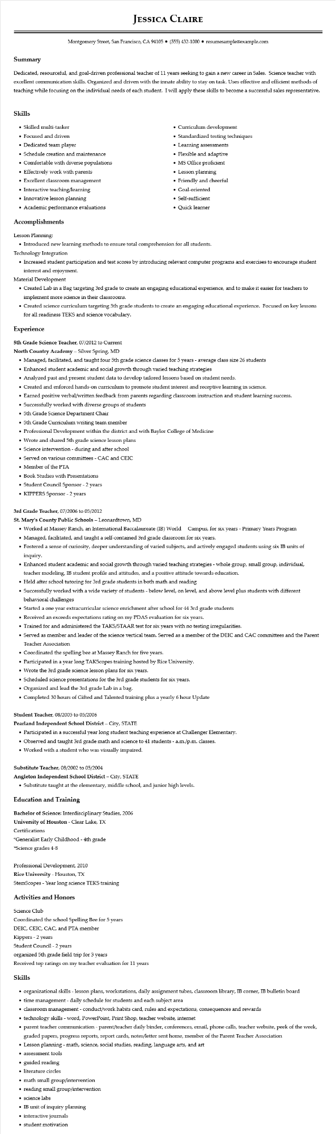

**JESSICA CLAIRE**

Montgomery Street, San Francisco, CA 94105⚫ (555) 432-1000⚫ resumesample@example.com

**Summary**

Dedicated, resourceful, and goal-driven professional teacher of 11 years seeking to gain a new career in Sales. Science teacher with excellent communication skills. Organized and driven with the innate ability to stay on task. Uses effective and efficient methods of teaching while focusing on the individual needs of each student. I will apply these skills to become a successful sales representative.

**Skills**

• Skilled multi-tasker

• Focused and driven

• Dedicated team player

• Schedule creation and maintenance

• Comfortable with diverse populations

• Effectively work with parents

• Excellent classroom management

• Interactive teaching/learning

• Innovative lesson planning

• Academic performance evaluations

• Curriculum development

• Standardized testing techniques

• Learning assessments

• Flexible and adaptive

• MS Office proficient

• Lesson planning

• Friendly and cheerful

• Goal-oriented

• Self-sufficient

• Quick learner

**Accomplishments**

Lesson Planning:

• Introduced new learning methods to ensure total comprehension for all students.

Technology Integration

• Increased student participation and test scores by introducing relevant computer programs and exercises to encourage student interest and enjoyment.

Material Development

• Created Lab in a Bag targeting 3rd grade to create an engaging educational experience, and to make it easier for teachers to implement more science in their classrooms.

• Created science curriculum targeting 5th grade students to create an engaging educational experience. Focused on key lessons for all readiness TEKS and science vocabulary.

**Experience**

5th Grade Science Teacher, 07/2012 to Current

North Country Academy - Silver Spring, MD

• Managed, facilitated, and taught four 5th grade science classes for 5 years - average class size 26 students

• Enhanced student academic and social growth through varied teaching strategies

• Analyzed past and present student data to develop tailored lessons based on student needs.

• Created and enforced hands-on curriculum to promote student interest and receptive learning in science.

• Earned positive verbal/written feedback from parents regarding classroom instruction and student learning success.

• Successfully worked with diverse groups of students

• 5th Grade Science Department Chair

• 5th Grade Curriculum writing team member

• Professional Development within the district and with Baylor College of Medicine

• Wrote and shared 5th grade science lesson plans

• Science intervention - during and after school

• Served on various committees - CAC and CEIC

• Member of the PTA

• Book Studies with Presentations

• Student Council Sponsor - 2 years

• KIPPERS Sponsor - 2 years

3rd Grade Teacher, 07/2006 to 05/2012

**St. Mary's County Public Schools - Leonardtown, MD**

• Worked at Massey Ranch, an International Baccalaureate (IB) World

Campus, for six years - Primary Years Program

• Managed, facilitated, and taught a self-contained 3rd grade classroom for six years.

• Fostered a sense of curiosity, deeper understanding of varied subjects, and actively engaged students using six IB units of inquiry.

• Enhanced student academic and social growth through varied teaching strategies - whole group, small group, individual, teacher modeling, IB student profile and attitudes, and a positive attitude towards education.

• Held after school tutoring for 3rd grade students in both math and reading

• Successfully worked with a wide variety of students - below level, on level, and above level plus students with different behavioral challenges

• Started a one year extracurricular science enrichment after school for 44 3rd grade students

• Received an exceeds expectations rating on my PDAS evaluation for six years.

• Trained for and administered the TAKS/STAAR test for six years with no testing irregularities.

• Served as member and leader of the science vertical team. Served as a member of the DEIC and CAC committees and the Parent Teacher Association

• Coordinated the spelling bee at Massey Ranch for five years.

• Participated in a year long TAKScopes training hosted by Rice University.

• Wrote the 3rd grade science lesson plans for six years.

• Scheduled science presentations for the 3rd grade students for six years.

• Organized and lead the 3rd grade Lab in a bag.

• Completed 30 hours of Gifted and Talented training plus a yearly 6 hour Update

Student Teacher, 08/2005 to 05/2006

Pearland Independent School District – City, STATE

• Participated in a successful year long student teaching experience at Challenger Elementary.

• Observed and taught 3rd grade math and science to 41 students - a.m./p.m. classes.

• Worked with a student who was visually impaired.

Substitute Teacher, 08/2002 to 05/2004

Angleton Independent School District - City, STATE

• Substitute taught at the elementary, middle school, and junior high levels.

**Education and Training**

Bachelor of Science: Interdisciplinary Studies, 2006

**University of Houston - Clear Lake, TX**

Certifications

*Generalist Early Childhood - 4th grade

*Science grades 4-8

Professional Development, 2010

Rice University - Houston, TX

StemScopes - Year long science TEKS training

**Activities and Honors**

Science Club

Coordinated the school Spelling Bee for 5 years

DEIC, CEIC, CAC, and PTA member

Kippers - 2 years

Student Council - 2 years

organized 5th grade field trip for 3 years

Received top ratings on my teacher evaluation for 11 years

**Skills**

• organizational skills - lesson plans, workstations, daily assignment tubes, classroom library, IB corner, IB bulletin board

⚫ time management - daily schedule for students and each subject area

⚫ classroom management - conduct/work habits card, rules and expectations, consequences and rewards

• technology skills - word, PowerPoint, Print Shop, teacher website, internet

• parent teacher communication - parent/teacher daily binder, conferences, email, phone calls, teacher website, peek of the week,

graded papers, progress reports, report cards, notes/letter sent home, member of the Parent Teacher Association

• Lesson planning - math, science, social studies, reading, language arts, and art

• assessment tools

⚫ guided reading

• literature circles

• math small group/intervention

• reading small group/intervention

• science labs

• IB unit of inquiry planning

⚫ interactive journals

• student motivation