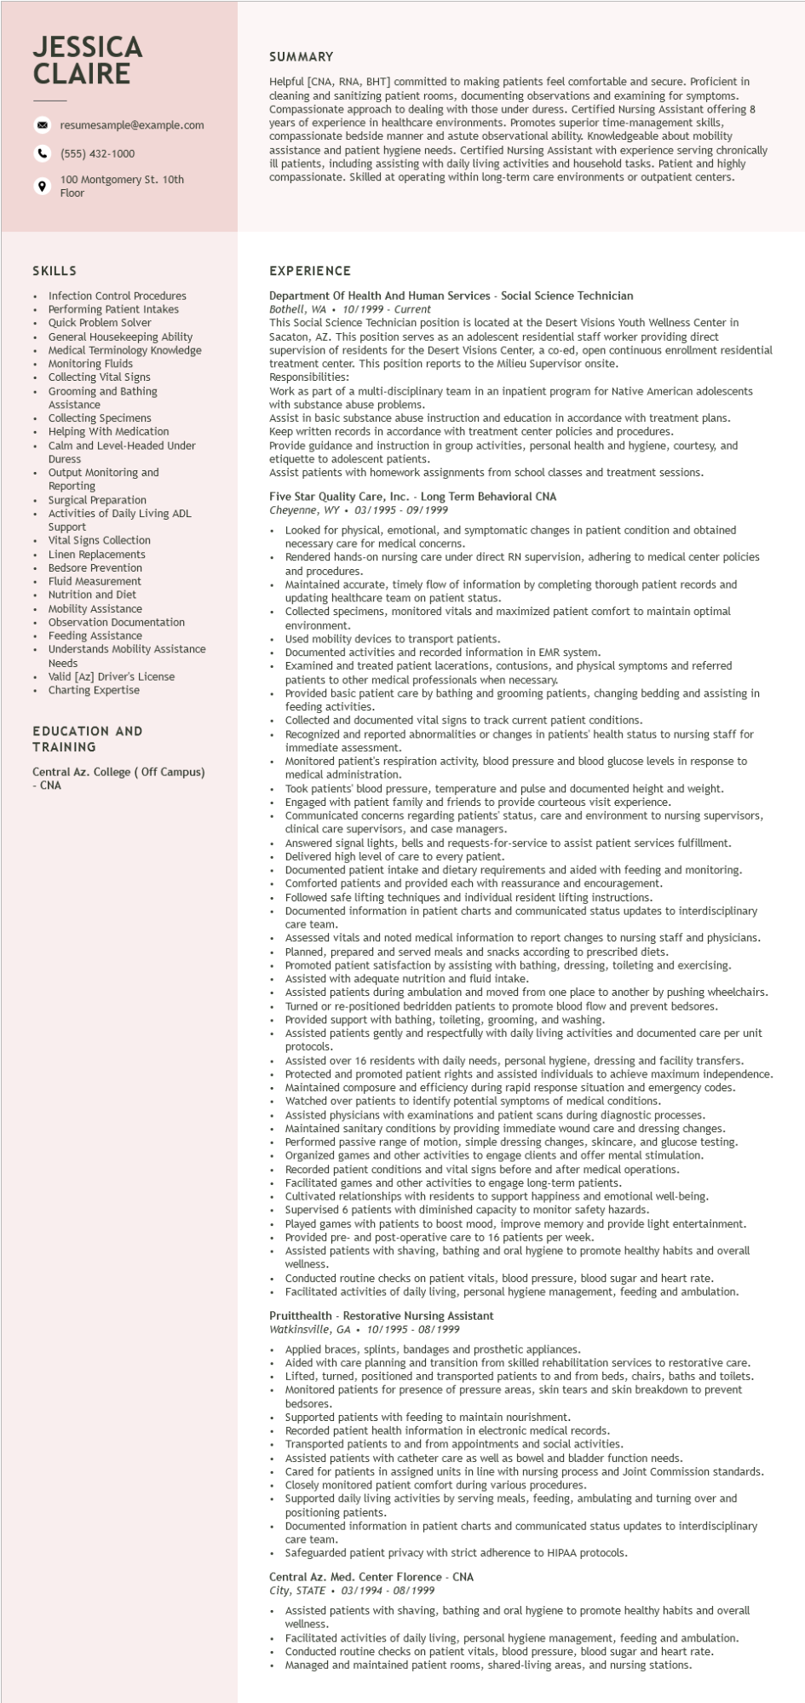

**JESSICA CLAIRE**

resumesample@example.com

(555) 432-1000

100 Montgomery St. 10th Floor

SUMMARY

Helpful [CNA, RNA, BHT] committed to making patients feel comfortable and secure. Proficient in cleaning and sanitizing patient rooms, documenting observations and examining for symptoms. Compassionate approach to dealing with those under duress. Certified Nursing Assistant offering 8 years of experience in healthcare environments. Promotes superior time-management skills, compassionate bedside manner and astute observational ability. Knowledgeable about mobility assistance and patient hygiene needs. Certified Nursing Assistant with experience serving chronically ill patients, including assisting with daily living activities and household tasks. Patient and highly compassionate. Skilled at operating within long-term care environments or outpatient centers.

SKILLS

Infection Control Procedures Performing Patient Intakes Quick Problem Solver

General Housekeeping Ability

Medical Terminology Knowledge Monitoring Fluids

Collecting Collecting Vital Signs

Grooming and Bathing

Assistance

Collecting Specimens

Helping With Medication

Calm and Level-Headed Under Duress

• Output Monitoring and Reporting

• Surgical Preparation

Activities of Daily Living ADL

ACLIVI

Support

Vital Signs Collection

Linen Replacements

Bedsore Prevention

Fluid Measurement

• Nutrition and Diet

• Mobility Assistance

Observation Documentation

• Feeding Assistance

Understands Mobility Assistance Needs

Valid [Az] Driver's License

• Charting Expertise

EDUCATION AND

TRAINING

Central Az. College (Off Campus) CNA

**EXPERIENCE**

Department Of Health And Human Services - Social Science Technician Bothell, WA. 10/1999 - Current

This Social Science Technician position is located at the Desert Visions Youth Wellness Center in Sacaton, AZ. This position serves as an adolescent residential staff worker providing direct

supervision of residents for the Desert Visions Center, a co-ed, open continuous enrollment residential treatment center. This position reports to the Milieu Supervisor onsite.

Responsibilities:

Work as part of a multi-disciplinary team in an inpatient program for Native American adolescents with substance abuse problems.

Assist in basic substance abuse instruction and education in accordance with treatment plans. Keep written records in accordance with treatment center policies and procedures.

Provide guidance and instruction in group activities, personal health and hygiene, courtesy, and etiquette to adolescent patients.

Assist patients with homework assignments from school classes and treatment sessions.

Five Star Quality Care, Inc. - Long Term Behavioral CNA Cheyenne, WY 03/1995 - 09/1999

•

Looked for physical, emotional, and symptomatic changes in patient condition and obtained necessary care for medical concerns.

Rendered hands-on nursing care under direct RN supervision, adhering to medical center policies and procedures.

• Maintained accurate, timely flow of information by completing thorough patient records and updating healthcare team on patient status.

Collected specimens, monitored vitals and maximized patient comfort to maintain optimal environment.

environm

Used mobility devices to transport patients.

Documented activities and recorded information in EMR system.

Examined and treated patient lacerations, contusions, and physical symptoms and referred patients to other medical professionals when necessary.

patien

Provided basic patient care by bathing and grooming patients, changing bedding and assisting in feeding activities.

Collected and documented vital signs to track current patient conditions.

Recognized and reported abnormalities or changes in patients' health status to nursing staff for immediate assessment.

Monitored patient's respiration activity, blood pressure and blood glucose levels in response to

medical administration.

Took patients' blood pressure, temperature and pulse and documented height and weight. Engaged with patient family and friends to provide courteous visit experience.

Communicated concerns regarding patients' status, care and environment to nursing supervisors, clinical care supervisors, and case managers.

Answered signal lights, bells and requests-for-service to assist patient services fulfillment. Delivered high level of care to every patient.

Documented patient intake and dietary requirements and aided with feeding and monitoring. Comforted patients and provided each with reassurance and encouragement.

Followed safe lifting techniques and individual resident lifting instructions.

Documented

care team.

care team.

information in patient charts and communicated status updates to interdisciplinary

Assessed vitals and noted medical information to report changes to nursing staff and physicians. Planned, prepared and served meals and snacks according to prescribed diets.

Promoted patient satisfaction by assisting with bathing, dressing, toileting and exercising. Assisted with adequate nutrition and fluid intake.

Assisted patients during ambulation and moved from one place to another by pushing wheelchairs. Turned or re-positioned bedridden patients to promote blood flow and prevent bedsores. Provided support with bathing, toileting, grooming, and washing.

Assisted patients gently and respectfully with daily living activities and documented care per unit protocols.

Assisted over 16 residents with daily needs, personal hygiene, dressing and facility transfers. Protected and promoted patient rights and assisted individuals to achieve maximum independence. Maintained composure and efficiency during rapid response situation and emergency codes. Watched over patients to identify potential symptoms of medical conditions. Assisted physicians with examinations and patient scans during diagnostic processes. Maintained sanitary conditions by providing immediate wound care and dressing changes.

Performed passive range of motion, simple dressing changes, skincare, and glucose testing. Organized games and other activities to engage clients and offer mental stimulation. Recorded patient conditions and vital signs before and after medical operations. Facilitated games and other activities to engage long-term patients.

Cultivated relationships with residents to support happiness and emotional well-being. Supervised 6 patients with diminished capacity to monitor safety hazards.

Played games with patients to boost mood, improve memory and provide light entertainment. Provided pre- and post-operative care to 16 patients per week.

Assisted patients with shaving, bathing and oral hygiene to promote healthy habits and overall wellness.

Conducted routine checks on patient vitals, blood pressure, blood sugar and heart rate. Facilitated activities of daily living, personal hygiene management, feeding and ambulation.

Pruitthealth - Restorative Nursing Assistant

Watkinsville, GA 10/1995 - 08/1999

Applied braces, splints, bandages and prosthetic appliances.

Aided with care planning and transition from skilled rehabilitation services to restorative care. Lifted, turned, positioned and transported patients to and from beds, chairs, baths and toilets. Monitored patients for presence of pressure areas, skin tears and skin breakdown to prevent bedsores.

Supported patients with feeding to maintain nourishment.

Recorded patient health information in electronic medical records.

Recorde

Transported patients to and from appointments and social activities.

Assisted patients with catheter care as well as bowel and bladder function needs.

Cared for patients in assigned units in line with nursing process and Joint Commission standards.

Closely monitored patient comfort during various procedures.

Supported daily living activities by serving meals, feeding, ambulating and turning over and positioning patients.

Documented information in patient charts and communicated status updates to interdisciplinary

care team.

• Safeguarded patient privacy with strict adherence to HIPAA protocols.

Central Az. Med. Center Florence - CNA

City, STATE 03/1994 - 08/1999

.

Assisted patients with shaving, bathing and oral hygiene to promote healthy habits and overall wellness.

Facilitated activities of daily living, personal hygiene management, feeding and ambulation. Conducted routine checks on patient vitals, blood pressure, blood sugar and heart rate. Managed and maintained patient rooms, shared-living areas, and nursing stations.