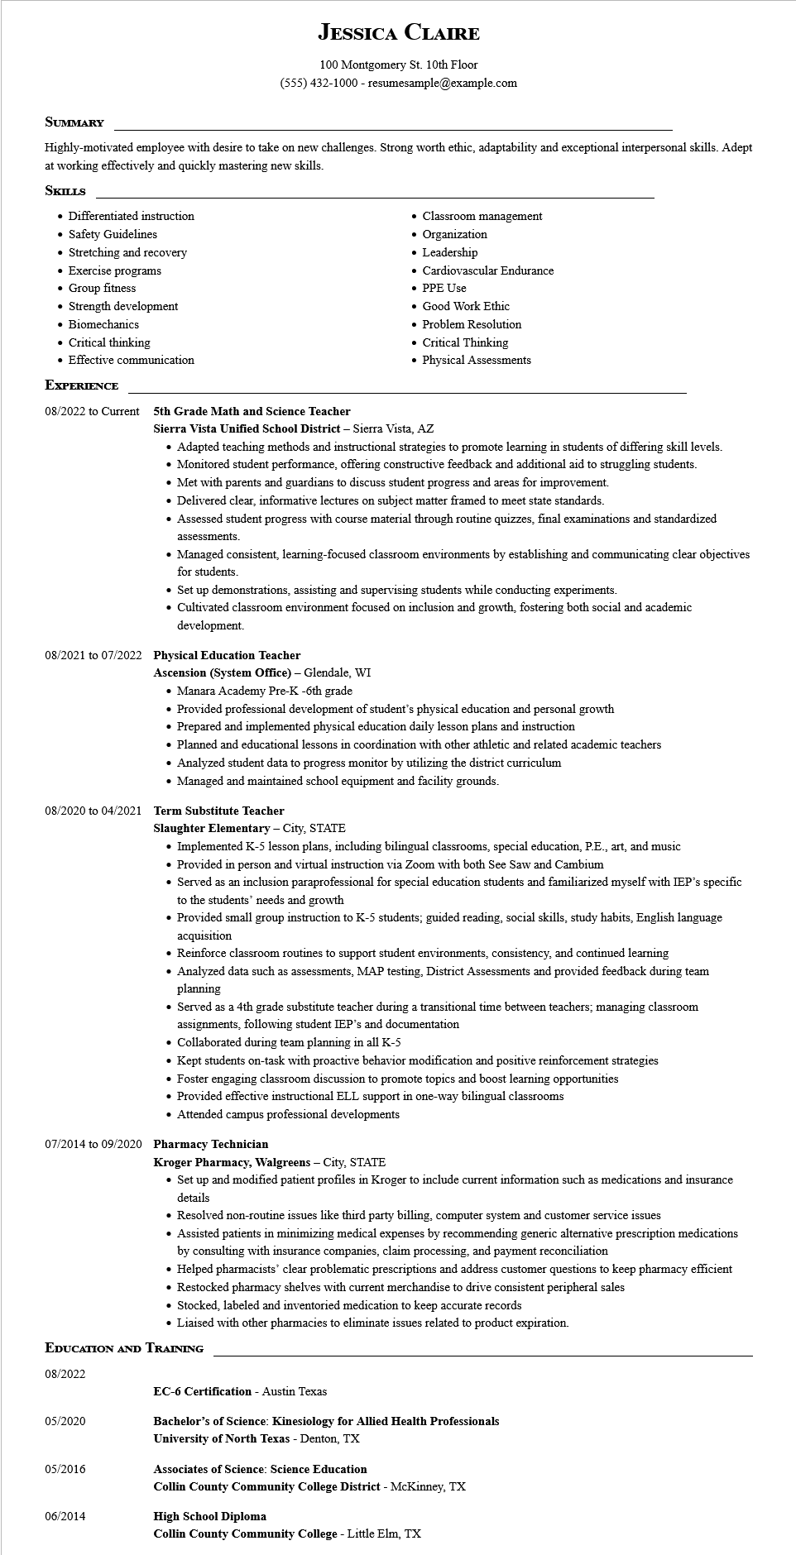

**JESSICA CLAIRE**

100 Montgomery St. 10th Floor

(555) 432-1000 - resumesample@example.com

SUMMARY

Highly-motivated employee with desire to take on new challenges. Strong worth ethic, adaptability and exceptional interpersonal skills. Adept at working effectively and quickly mastering new skills.

**SKILLS**

• Differentiated instruction

• Safety Guidelines

• Stretching and recovery

• Exercise programs

• Group fitness

• Strength development

• Biomechanics

• Critical thinking

• Effective communication

• Classroom management

• Organization

• Leadership

• Cardiovascular Endurance

• PPE Use

• Good Work Ethic

• Problem Resolution

• Critical Thinking

• Physical Assessments

**EXPERIENCE**

08/2022 to Current

5th Grade Math and Science Teacher

**Sierra Vista Unified School District - Sierra Vista, AZ**

• Adapted teaching methods and instructional strategies to promote learning in students of differing skill levels.

• Monitored student performance, offering constructive feedback and additional aid to struggling students.

• Met with parents and guardians to discuss student progress and areas for improvement.

• Delivered clear, informative lectures on subject matter framed to meet state standards.

• Assessed student progress with course material through routine quizzes, final examinations and standardized assessments.

• Managed consistent, learning-focused classroom environments by establishing and communicating clear objectives for students.

• Set up demonstrations, assisting and supervising students while conducting experiments.

• Cultivated classroom environment focused on inclusion and growth, fostering both social and academic

development.

**08/2021 to 07/2022 Physical Education Teacher**

**Ascension (System Office) - Glendale, WI**

• Manara Academy Pre-K -6th grade

• Provided professional development of student's physical education and personal growth

• Prepared and implemented physical education daily lesson plans and instruction

• Planned and educational lessons in coordination with other athletic and related academic teachers

• Analyzed student data to progress monitor by utilizing the district curriculum

• Managed and maintained school equipment and facility grounds.

08/2020 to 04/2021 Term Substitute Teacher

**Slaughter Elementary - City, STATE**

• Implemented K-5 lesson plans, including bilingual classrooms, special education, P.E., art, and music

• Provided in person and virtual instruction via Zoom with both See Saw and Cambium

• Served as an inclusion paraprofessional for special education students and familiarized myself with IEP's specific to the students' needs and growth

• Provided small group instruction to K-5 students; guided reading, social skills, study habits, English language acquisition

• Reinforce classroom routines to support student environments, consistency, and continued learning

• Analyzed data such as assessments, MAP testing, District Assessments and provided feedback during team planning

• Served as a 4th grade substitute teacher during a transitional time between teachers; managing classroom assignments, following student IEP's and documentation

• Collaborated during team planning in all K-5

• Kept students on-task with proactive behavior modification and positive reinforcement strategies

• Foster engaging classroom discussion to promote topics and boost learning opportunities

• Provided effective instructional ELL support in one-way bilingual classrooms

• Attended campus professional developments

**07/2014 to 09/2020 Pharmacy Technician**

**Kroger Pharmacy, Walgreens - City, STATE**

• Set up and modified patient profiles in Kroger to include current information such as medications and insurance details

• Resolved non-routine issues like third party billing, computer system and customer service issues

• Assisted patients in minimizing medical expenses by recommending generic alternative prescription medications by consulting with insurance companies, claim processing, and payment reconciliation

• Helped pharmacists' clear problematic prescriptions and address customer questions to keep pharmacy efficient

• Restocked pharmacy shelves with current merchandise to drive consistent peripheral sales

• Stocked, labeled and inventoried medication to keep accurate records

• Liaised with other pharmacies to eliminate issues related to product expiration.

**EDUCATION AND TRAINING**

08/2022

**EC-6 Certification - Austin Texas**

05/2020

Bachelor's of Science: Kinesiology for Allied Health Professionals

**University of North Texas - Denton, TX**

05/2016

**Associates of Science: Science Education**

**Collin County Community College District - McKinney, TX**

06/2014

**High School Diploma**

**Collin County Community College - Little Elm, TX**