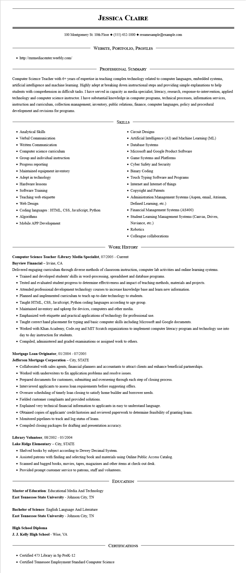

**JESSICA CLAIRE**

100 Montgomery St. 10th Floor (555) 432-1000◆ resumesample@example.com

• http://rnrmediacenter.weebly.com/

WEBSITE, PORTFOLIO, PROFILES

PROFESSIONAL SUMMARY

Computer Science Teacher with 6+ years of expertise in teaching complex technology related to computer languages, embedded systems, artificial intelligence and machine learning. Highly adept at breaking down instructional steps and providing simple explanations to help students with comprehension in difficult tasks. I have served in capacity as media specialist, literacy, research, response-to-intervention, applied technology and computer science instructor. I have substantial knowledge in computer programs, technical processes, information services, instruction and curriculum, collection management, inventory, public relations, finance, computer languages, policy and procedural development and revisions for programs.

• Analytical Skills

• Verbal Communication

• Written Communication

• Computer science curriculum

• Group and individual instruction

• Progress reporting

• Maintained equipment inventory

• Adept in technology

• Hardware lessons

• Software Training

• Teaching web etiquette

• Web Design

• Coding languages: HTML, CSS, JavaScript, Python

•

Algorithms

• Mobile APP Development

SKILLS

• Circuit Designs

• Artificial Intelligence (AI) and Machine Learning (ML)

• Database Systems

• Microsoft and Google Product Software

• Game Systems and Platforms

• Cyber Safety and Security

• Binary Coding

• Touch Typing Software and Programs

• Internet and Internet of things

• Copyright and Patents

• Administration Management Systems (Aspen, email, Atriuum, Defined Learning, etc.)

• Financial Management Systems (AS400)

• Student Learning Management Systems (Canvas, Drives, Naviance, etc.)

• Robotics

• Colleague collaborations

WORK HISTORY

**Computer Science Teacher /Library Media Specialist, 07/2005 - Current**

**Bayview Financial - Irvine, CA**

Delivered engaging curriculum through diverse methods of classroom instruction, computer lab activities and online learning systems.

• Trained and developed students' skills in word-processing, spreadsheet and database programs.

• Tested and evaluated student progress to determine effectiveness and impact of teaching methods, materials and projects.

• Attended professional development technology courses to increase knowledge base and learn new information.

• Planned and implemented curriculum to teach up-to-date technology to students.

• Taught HTML, CSS, JavaScript, Python coding languages according to age group.

• Maintained inventory and upkeep for devices, computers and other media.

• Emphasized web etiquette and practical applications of technology for professional use.

• Taught correct hand placement for typing and basic computer skills including Microsoft and Google documents.

• Worked with Khan Academy, Code.org and MIT Scratch organizations to implement computer literacy program and technology use into day to day instruction for students.

• Compiled, administered and graded examinations or assigned work to others.

**Mortgage Loan Originator, 01/2004 - 07/2005**

**Jefferson Mortgage Corporation - City, STATE**

• Collaborated with sales agents, financial planners and accountants to attract clients and enhance beneficial partnerships.

• Worked with underwriters to fix application problems and resolve issues.

• Prepared documents for customers, submitting and overseeing through each step of closing process.

• Interviewed applicants to assess loan requirements before suggesting offers.

• Oversaw scheduling of timely loan closing to satisfy home builder and borrower needs.

• Fielded customer complaints and provided solutions.

• Explained very technical financial information to applicants in easy to understand language.

• Obtained copies of applicants' credit histories and reviewed paperwork to determine feasibility of granting loans.

• Monitored pipelines to track and log status of loans.

• Compiled closing packages for drafting and presentation accuracy.

Library Volunteer, 08/2002 - 05/2004

**Lake Ridge Elementary - City, STATE**

• Shelved books by subject according to Dewey Decimal System.

• Assisted patrons with finding and selecting book and materials using Online Public Access Catalog.

• Scanned and bagged books, movies, tapes, magazines and other items at check-out desk.

• Provided prompt customer service to patrons, staff and volunteers.

Master of Education: Educational Media And Technology East Tennessee State University - Johnson City, TN

**Bachelor of Science: English Language And Literature East Tennessee State University - Johnson City, TN**

**High School Diploma**

**J. J. Kelly High School - Wise, VA**

EDUCATION

CERTIFICATIONS

• Certified 473 Library in Sp PreK-12

• Certified Tennessee Employment Standard Computer Science