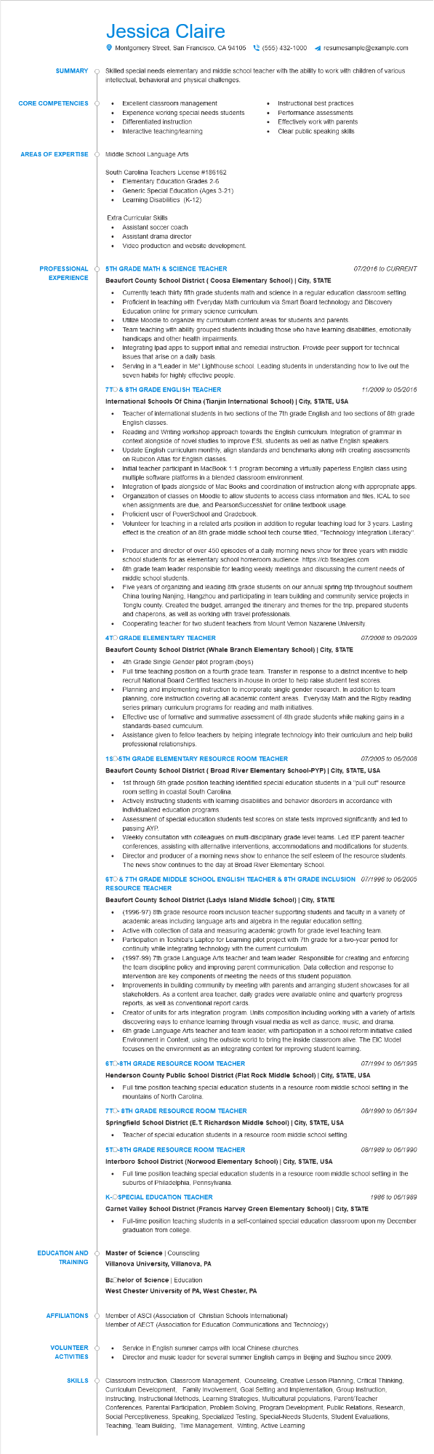

**SUMMARY**

**CORE COMPETENCIES**

Jessica Claire

Montgomery Street, San Francisco, CA 94105 (555) 432-1000 ◄ resumesample@example.com

Skilled special needs elementary and middle school teacher with the ability to work with children of various intellectual, behavioral and physical challenges.

• Excellent classroom management

•

Experience working special needs students Differentiated instruction

Interactive teaching/learning

•

•

Instructional best practices Performance assessments Effectively work with parents Clear public speaking skills

**AREAS OF EXPERTISE**

Middle School Language Arts

South Carolina Teachers License #186162

•

•

Elementary Education Grades 2-6

Generic Special Education (Ages 3-21)

Learning Disabilities (K-12)

Extra Curricular Skills

Assistant soccer coach

• Assistant drama director

Video production and website development.

**PROFESSIONAL 5TH GRADE MATH & SCIENCE TEACHER**

**EXPERIENCE**

**Beaufort County School District (Coosa Elementary School) | City, STATE**

•

07/2016 to CURRENT

•

•

Currently teach thirty fifth grade students math and science in a regular education classroom setting.

Proficient in teaching with Everyday Math curriculum via Smart Board technology and Discovery Education online for primary science curriculum.

Utilize Moodle to organize my curriculum content areas for students and parents.

Team teaching with ability grouped students including those who have learning disabilities, emotionally handicaps and other health impairments.

Integrating Ipad apps to support initial and remedial instruction. Provide peer support for technical issues that arise on a daily basis.

• Serving in a "Leader in Me" Lighthouse school. Leading students in understanding how to live out the seven habits for highly effective people.

**7TO & 8TH GRADE ENGLISH TEACHER**

**International Schools Of China (Tianjin International School) | City, STATE, USA**

*11/2009 to 05/2016*

Teacher of international students in two sections of the 7th grade English and two sections of 8th grade English classes.

Reading and Writing workshop approach towards the English curriculum. Integration of grammar in context alongside of novel studies to improve ESL students as well as native English speakers. Update English curriculum monthly, align standards and benchmarks along with creating assessments on Rubicon Atlas for English classes.

Initial teacher participant in MacBook 1:1 program becoming a virtually paperless English class using multiple software platforms in a blended classroom environment.

Integration of Ipads alongside of Mac Books and coordination of instruction along with appropriate apps. Organization of classes on Moodle to allow students to access class information and files, ICAL to see when assignments are due, and PearsonSuccessNet for online textbook usage. Proficient user of PowerSchool and Gradebook.

Volunteer for teaching in a related arts position in addition to regular teaching load for 3 years. Lasting effect is the creation of an 8th grade middle school tech course titled, "Technology Integration Literacy".

• Producer and director of over 450 episodes of a daily morning news show for three years with middle school students for as elementary school homeroom audience. https://cb.tiseagles.com

8th grade team leader responsible for leading weekly meetings and discussing the current needs of middle school students.

Five years of organizing and leading 8th grade students on our annual spring trip throughout southern China touring Nanjing, Hangzhou and participating in team building and community service projects in Tonglu county. Created the budget, arranged the itinerary and themes for the trip, prepared students and chaperons, as well as working with travel professionals.

• Cooperating teacher for two student teachers from Mount Vernon Nazarene University. 4TO GRADE ELEMENTARY TEACHER

**Beaufort County School District (Whale Branch Elementary School) | City, STATE**

• 4th Grade Single Gender pilot program (boys)

•

•

07/2008 to 09/2009

Full time teaching position on a fourth grade team. Transfer in response to a district incentive to help recruit National Board Certified teachers in-house in order to help raise student test scores.

Planning and implementing instruction to incorporate single gender research. In addition to team planning, core instruction covering all academic content areas. Everyday Math and the Rigby reading series primary curriculum programs for reading and math initiatives.

Effective use of formative and summative assessment of 4th grade students while making gains in a standards-based curriculum.

Assistance given to fellow teachers by helping integrate technology into their curriculum and help build professional relationships.

**1SO-5TH GRADE ELEMENTARY RESOURCE ROOM TEACHER**

*07/2005 to 06/2008*

**Beaufort County School District (Broad River Elementary School-PYP) | City, STATE, USA**

1st through 5th grade position teaching identified special education students in a "pull out" resource room setting in coastal South Carolina.

Actively instructing students with learning disabilities and behavior disorders in accordance with individualized education programs.

Assessment of special education students test scores on state tests improved significantly and led to passing AYP.

Weekly consultation with colleagues on multi-disciplinary grade level teams. Led IEP parent-teacher conferences, assisting with alternative interventions, accommodations and modifications for students. Director and producer of a morning news show to enhance the self esteem of the resource students. The news show continues to the day at Broad River Elementary School.

**6TO & 7TH GRADE MIDDLE SCHOOL ENGLISH TEACHER & 8TH GRADE INCLUSION 07/1996 to 06/2005 RESOURCE TEACHER**

**Beaufort County School District (Ladys Island Middle School) | City, STATE**

(1996-97) 8th grade resource room inclusion teacher supporting students and faculty in a variety of academic areas including language arts and algebra in the regular education setting.

Active with collection of data and measuring academic growth for grade level teaching team. Participation in Toshiba's Laptop for Learning pilot project with 7th grade for a two-year period for continuity while integrating technology with the current curriculum.

(1997-99) 7th grade Language Arts teacher and team leader. Responsible for creating and enforcing the team discipline policy and improving parent communication. Data collection and response to intervention are key components of meeting the needs of this student population. Improvements in building community by meeting with parents and arranging student showcases for all stakeholders. As a content area teacher, daily grades were available online and quarterly progress reports, as well as conventional report cards.

Creator of units for arts integration program. Units composition including working with a variety of artists discovering ways to enhance learning through visual media as well as dance, music, and drama. 6th grade Language Arts teacher and team leader, with participation in a school reform initiative called Environment in Context, using the outside world to bring the inside classroom alive. The EIC Model focuses on the environment as an integrating context for improving student learning.

**6TO-8TH GRADE RESOURCE ROOM TEACHER**

*07/1994 to 06/1995*

**Henderson County Public School District (Flat Rock Middle School) | City, STATE, USA**

• Full time position teaching special education students in a resource room middle school setting in the mountains of North Carolina.

**7TO-8TH GRADE RESOURCE ROOM TEACHER**

08/1990 to 06/1994

**Springfield School District (E.T. Richardson Middle School) | City, STATE, USA**

• Teacher of special education students in a resource room middle school setting. 5TO-8TH GRADE RESOURCE ROOM TEACHER

*08/1989 to 06/1990*

**Interboro School District (Norwood Elementary School) | City, STATE, USA**

•

Full time position teaching special education students in a resource room middle school setting in the suburbs of Philadelphia, Pennsylvania.

**K-OSPECIAL EDUCATION TEACHER**

*1986 to 06/1989*

Garnet Valley School District (Francis Harvey Green Elementary School) | City, STATE Full-time position teaching students in a self-contained special education classroom upon my December graduation from college.

•

**EDUCATION AND TRAINING**

**Master of Science | Counseling**

**AFFILIATIONS**

**Villanova University, Villanova, PA**

**Bachelor of Science | Education**

**West Chester University of PA, West Chester, PA**

Member of ASCI (Association of Christian Schools International) Member of AECT (Association for Education Communications and Technology)

**VOLUNTEER ACTIVITIES**

Service in English summer camps with local Chinese churches.

**SKILLS**

Director and music leader for several summer English camps in Beijing and Suzhou since 2009.

Classroom Instruction, Classroom Management, Counseling, Creative Lesson Planning, Critical Thinking, Curriculum Development, Family Involvement, Goal Setting and Implementation, Group Instruction, Instructing, Instructional Methods, Learning Strategies, Multicultural populations, Parent/Teacher Conferences, Parental Participation, Problem Solving, Program Development, Public Relations, Research, Social Perceptiveness, Speaking, Specialized Testing, Special-Needs Students, Student Evaluations, Teaching, Team Building, Time Management, Writing, Active Learning