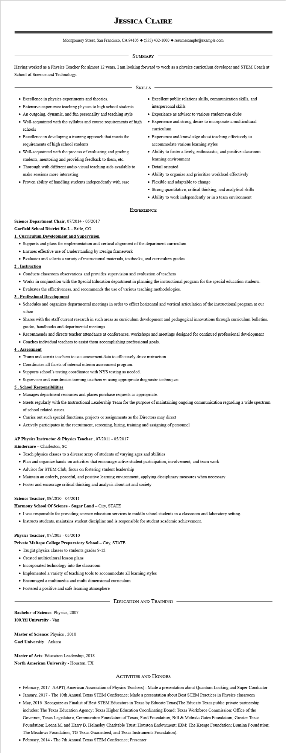

**JESSICA CLAIRE**

Montgomery Street, San Francisco, CA 94105 ♦ (555) 432-1000 resumesample@example.com

SUMMARY

Having worked as a Physics Teacher for almost 12 years, I am looking forward to work as a physics curriculum developer and STEM Coach at School of Science and Technology.

• Excellence in physics experiments and theories.

• Extensive experience teaching physics to high school students

• An outgoing, dynamic, and fun personality and teaching style

SKILLS

• Well-acquainted with the syllabus and course requirements of high schools

• Excellence in developing a training approach that meets the requirements of high school students

• Well-acquainted with the process of evaluating and grading students, mentoring and providing feedback to them, etc.

• Thorough with different audio-visual teaching aids available to make sessions more interesting

• Proven ability of handling students independently with ease

**Science Department Chair, 07/2014 - 05/2017 Garfield School District Re-2 - Rifle, CO**

**1. Curriculum Development and Supervision**

• Excellent public relations skills, communication skills, and interpersonal skills

• Experience as advisor to various student-run clubs

• Experience and strong desire to incorporate a multicultural curriculum

• Experience and knowledge about teaching effectively to accommodate various learning styles

• Ability to foster a lively, enthusiastic, and positive classroom learning environment

• Detail oriented

• Ability to organize and prioritize workload effectively

• Flexible and adaptable to change

• Strong quantitative, critical thinking, and analytical skills • Ability to work independently or in a team environment

EXPERIENCE

• Supports and plans for implementation and vertical alignment of the department curriculum

• Ensures effective use of Understanding by Design framework

• Evaluates and selects a variety of instructional materials, textbooks, and curriculum guides

**2. Instruction**

• Conducts classroom observations and provides supervision and evaluation of teachers

• Works in conjunction with the Special Education department in planning the instructional program for the special education students.

• Evaluates the effectiveness, and recommends the use of various teaching methodologies.

3. Professional Development

• Schedules and organizes departmental meetings in order to effect horizontal and vertical articulation of the instructional program at our schoo

• Shares with the staff current research in such areas as curriculum development and pedagogical innovations through curriculum bulletins, guides, handbooks and departmental meetings.

• Recommends and directs teacher attendance at conferences, workshops and meetings designed for continued professional development

• Coaches individual teachers to assist them accomplishing professional goals.

**4. Assessment**

• Trains and assists teachers to use assessment data to effectively drive instruction.

• Coordinates all facets of internal interim assessment program.

• Supports school's testing coordinator with NYS testing as needed.

• Supervises and coordinates training teachers in using appropriate diagnostic techniques.

**5. School Responsibilities**

• Manages department resources and places purchase requests as appropriate.

• Meets regularly with the Instructional Leadership Team for the purpose of maintaining ongoing communication regarding a wide spectrum of school related issues.

• Carries out such special functions, projects or assignments as the Directors may direct

• Actively participates in the recruitment, screening, hiring, training and assigning of personnel

**AP Physics Instructor & Physics Teacher, 07/2011 - 05/2017**

Kindercare - Charleston, SC

• Teach physics classes to a diverse array of students of varying ages and abilities

• Plan and organize hands-on activities that encourage active student participation, involvement, and team work

• Advisor for STEM Club, focus on fostering student leadership

• Maintain an orderly, peaceful, and positive learning environment, applying disciplinary measures when necessary

• Foster and encourage critical thinking and analysis about art and society

Science Teacher, 09/2010 - 04/2011

**Harmony School Of Science - Sugar Land - City, STATE**

• I was responsible for providing science education services to middle school students in a classroom and laboratory setting.

• Instructs students, maintains student discipline and is responsible for student academic achievement.

Physics Teacher, 07/2005 - 05/2010

**Private Maltepe College Preparatory School - City, STATE**

• Taught physics classes to students grades 9-12

• Created multicultural lesson plans

• Incorporated technology into the classroom

• Implemented a variety of teaching tools to accommodate all learning styles

• Encouraged a multimedia and multi-dimensional curriculum

• Fostered a positive and safe learning atmosphere

**Bachelor of Science: Physics, 2007**

**100. Yil University - Van**

**Master of Science: Physics, 2010**

**Gazi University - Ankara**

Master of Arts: Education Leadership, 2018

**North American University - Houston, TX**

**EDUCATION AND TRAINING**

ACTIVITIES AND HONORS

• February, 2017- AAPT(American Association of Physics Teachers): Made a presentation about Quantum Locking and Super Conductor ⚫ January, 2017 - The 10th Annual Texas STEM Conference; Made a presentation about Best STEM Practices in Physics classroom

• May, 2016- Recognize as Finalist of Best STEM Educators in Texas by Educate Texas (The Educate Texas public-private partnership includes: The Texas Education Agency; Texas Higher Education Coordinating Board; Texas Workforce Commission; Office of the Governor, Texas Legislature; Communities Foundation of Texas; Ford Foundation; Bill & Melinda Gates Foundation; Greater Texas Foundation; Leona M. and Harry B. Helmsley Charitable Trust; Houston Endowment; IBM; The Kresge Foundation; Lumina Foundation; The Meadows Foundation; TG Texas Guaranteed; and Texas Instruments Foundation).

• February, 2014 - The 7th Annual Texas STEM Conference; Presenter