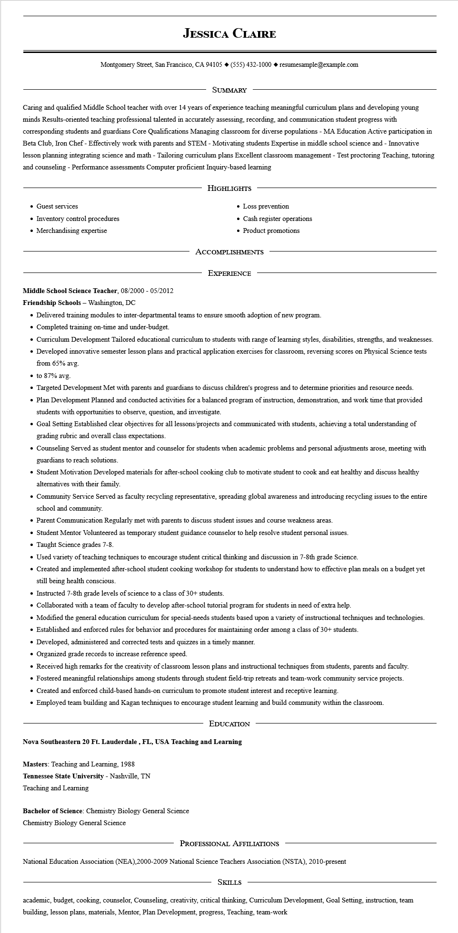

**JESSICA CLAIRE**

Montgomery Street, San Francisco, CA 94105 ♦ (555) 432-1000 resumesample@example.com

SUMMARY

Caring and qualified Middle School teacher with over 14 years of experience teaching meaningful curriculum plans and developing young minds Results-oriented teaching professional talented in accurately assessing, recording, and communication student progress with corresponding students and guardians Core Qualifications Managing classroom for diverse populations - MA Education Active participation in Beta Club, Iron Chef - Effectively work with parents and STEM - Motivating students Expertise in middle school science and - Innovative lesson planning integrating science and math - Tailoring curriculum plans Excellent classroom management - Test proctoring Teaching, tutoring and counseling - Performance assessments Computer proficient Inquiry-based learning

• Guest services

• Inventory control procedures

• Merchandising expertise

HIGHLIGHTS

• Loss prevention

• Cash register operations

• Product promotions

ACCOMPLISHMENTS

EXPERIENCE

**Middle School Science Teacher, 08/2000-05/2012**

**Friendship Schools - Washington, DC**

• Delivered training modules to inter-departmental teams to ensure smooth adoption of new program.

• Completed training on-time and under-budget.

• Curriculum Development Tailored educational curriculum to students with range of learning styles, disabilities, strengths, and weaknesses.

• Developed innovative semester lesson plans and practical application exercises for classroom, reversing scores on Physical Science tests from 65% avg.

⚫ to 87% avg.

• Targeted Development Met with parents and guardians to discuss children's progress and to determine priorities and resource needs.

• Plan Development Planned and conducted activities for a balanced program of instruction, demonstration, and work time that provided students with opportunities to observe, question, and investigate.

• Goal Setting Established clear objectives for all lessons/projects and communicated with students, achieving a total understanding of grading rubric and overall class expectations.

• Counseling Served as student mentor and counselor for students when academic problems and personal adjustments arose, meeting with guardians to reach solutions.

• Student Motivation Developed materials for after-school cooking club to motivate student to cook and eat healthy and discuss healthy alternatives with their family.

• Community Service Served as faculty recycling representative, spreading global awareness and introducing recycling issues to the entire school and community.

• Parent Communication Regularly met with parents to discuss student issues and course weakness areas.

• Student Mentor Volunteered as temporary student guidance counselor to help resolve student personal issues.

•

Taught Science grades 7-8.

• Used variety of teaching techniques to encourage student critical thinking and discussion in 7-8th grade Science.

• Created and implemented after-school student cooking workshop for students to understand how to effective plan meals on a budget yet still being health conscious.

• Instructed 7-8th grade levels of science to a class of 30+ students.

• Collaborated with a team of faculty to develop after-school tutorial program for students in need of extra help.

• Modified the general education curriculum for special-needs students based upon a variety of instructional techniques and technologies.

• Established and enforced rules for behavior and procedures for maintaining order among a class of 30+ students.

• Developed, administered and corrected tests and quizzes in a timely manner.

• Organized grade records to increase reference speed.

• Received high remarks for the creativity of classroom lesson plans and instructional techniques from students, parents and faculty.

• Fostered meaningful relationships among students through student field-trip retreats and team-work community service projects.

• Created and enforced child-based hands-on curriculum to promote student interest and receptive learning.

• Employed team building and Kagan techniques to encourage student learning and build community within the classroom.

EDUCATION

**Nova Southeastern 20 Ft. Lauderdale, FL, USA Teaching and Learning**

Masters: Teaching and Learning, 1988

**Tennessee State University - Nashville, TN**

Teaching and Learning

Bachelor of Science: Chemistry Biology General Science

Chemistry Biology General Science

PROFESSIONAL AFFILIATIONS

National Education Association (NEA), 2000-2009 National Science Teachers Association (NSTA), 2010-present

SKILLS

academic, budget, cooking, counselor, Counseling, creativity, critical thinking, Curriculum Development, Goal Setting, instruction, team building, lesson plans, materials, Mentor, Plan Development, progress, Teaching, team-work