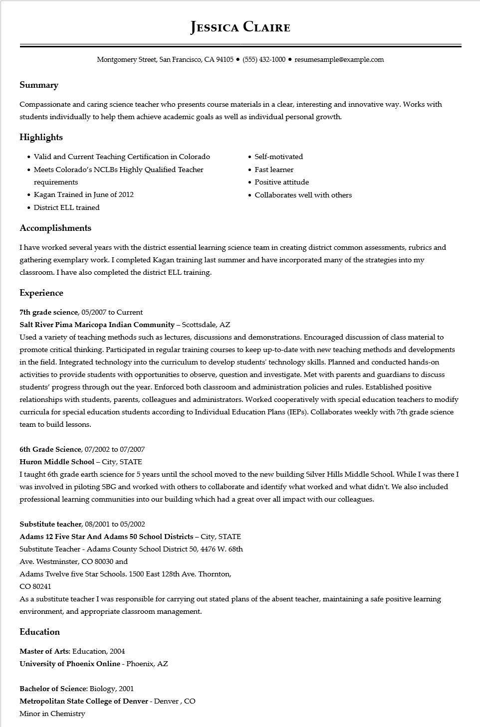

**JESSICA CLAIRE**

Montgomery Street, San Francisco, CA 94105 ● (555) 432-1000⚫ resumesample@example.com

**Summary**

Compassionate and caring science teacher who presents course materials in a clear, interesting and innovative way. Works with students individually to help them achieve academic goals as well as individual personal growth.

**Highlights**

Valid and Current Teaching Certification in Colorado

• Meets Colorado's NCLBS Highly Qualified Teacher requirements

• Kagan Trained in June of 2012

• District ELL trained

**Accomplishments**

Self-motivated

• Fast learner

• Positive attitude

• Collaborates well with others

I have worked several years with the district essential learning science team in creating district common assessments, rubrics and gathering exemplary work. I completed Kagan training last summer and have incorporated many of the strategies into my classroom. I have also completed the district ELL training.

**Experience**

7th grade science, 05/2007 to Current

**Salt River Pima Maricopa Indian Community - Scottsdale, AZ**

Used a variety of teaching methods such as lectures, discussions and demonstrations. Encouraged discussion of class material to promote critical thinking. Participated in regular training courses to keep up-to-date with new teaching methods and developments in the field. Integrated technology into the curriculum to develop students' technology skills. Planned and conducted hands-on activities to provide students with opportunities to observe, question and investigate. Met with parents and guardians to discuss students' progress through out the year. Enforced both classroom and administration policies and rules. Established positive relationships with students, parents, colleagues and administrators. Worked cooperatively with special education teachers to modify curricula for special education students according to Individual Education Plans (IEPs). Collaborates weekly with 7th grade science team to build lessons.

6th Grade Science, 07/2002 to 07/2007

**Huron Middle School - City, STATE**

I taught 6th grade earth science for 5 years until the school moved to the new building Silver Hills Middle School. While I was there I was involved in piloting SBG and worked with others to collaborate and identify what worked and what didn't. We also included professional learning communities into our building which had a great over all impact with our colleagues.

**Substitute teacher, 08/2001 to 05/2002**

**Adams 12 Five Star And Adams 50 School Districts - City, STATE**

Substitute Teacher - Adams County School District 50, 4476 W. 68th

Ave. Westminster, CO 80030 and

Adams Twelve five Star Schools. 1500 East 128th Ave. Thornton,

CO 80241

As a substitute teacher I was responsible for carrying out stated plans of the absent teacher, maintaining a safe positive learning environment, and appropriate classroom management.

**Education**

Master of Arts: Education, 2004

**University of Phoenix Online - Phoenix, AZ**

Bachelor of Science: Biology, 2001

**Metropolitan State College of Denver - Denver, CO Minor in Chemistry**