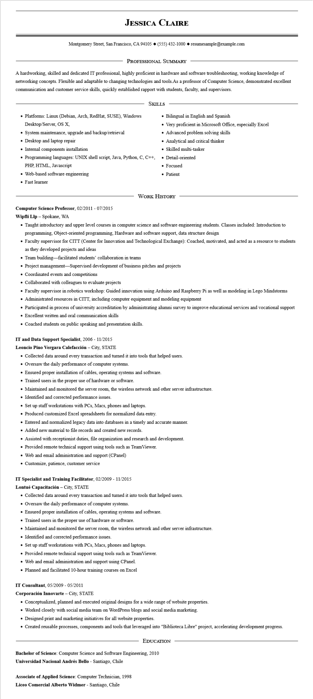

**JESSICA CLAIRE**

Montgomery Street, San Francisco, CA 94105 ♦ (555) 432-1000 resumesample@example.com

PROFESSIONAL SUMMARY

A hardworking, skilled and dedicated IT professional, highly proficient in hardware and software troubleshooting, working knowledge of networking concepts. Flexible and adaptable to changing technologies and tools. As a professor of Computer Science, demonstrated excellent communication and customer service skills, quickly established rapport with students, faculty, and supervisors.

SKILLS

• Platforms: Linux (Debian, Arch, RedHat, SUSE), Windows Desktop/Server, OS X,

• System maintenance, upgrade and backup/retrieval

• Desktop and laptop repair

• Internal components installation

• Programming languages: UNIX shell script, Java, Python, C, C++,

PHP, HTML, Javascript

• Web-based software engineering

• Fast learner

• Bilingual in English and Spanish

Very proficient in Microsoft Office, especially Excel

• Advanced problem solving skills

• Analytical and critical thinker

• Skilled multi-tasker

• Detail-oriented

• Focused

• Patient

WORK HISTORY

**Computer Science Professor, 02/2011- 07/2015**

**Wipfli Llp - Spokane, WA**

• Taught introductory and upper level courses in computer science and software engineering students. Classes included: Introduction to programming, Object-oriented programming, Hardware and software support, data structure design

• Faculty supervisor for CITT (Center for Innovation and Technological Exchange): Coached, motivated, and acted as a resource to students as they developed projects and ideas

• Team building-facilitated students' collaboration in teams

• Project management-Supervised development of business pitches and projects

• Coordinated events and competitions

• Collaborated with colleagues to evaluate projects

• Faculty supervisor in robotics workshop: Guided innovation using Arduino and Raspberry Pi as well as modeling in Lego Mindstorms

• Administrated resources in CITT, including computer equipment and modeling equipment

• Participated in process of university accreditation by administrating alumni survey to improve educational services and vocational support

• Excellent written and oral communication skills

• Coached students on public speaking and presentation skills.

**IT and Data Support Specialist, 2006 - 11/2015**

**Leoncio Pino Vergara Calefacción - City, STATE**

• Collected data around every transaction and turned it into tools that helped users.

• Oversaw the daily performance of computer systems.

• Ensured proper installation of cables, operating systems and software.

• Trained users in the proper use of hardware or software.

• Maintained and monitored the server room, the wireless network and other server infrastructure.

• Identified and corrected performance issues.

• Set up staff workstations with PCs, Macs, phones and laptops.

• Produced customized Excel spreadsheets for normalized data entry.

• Entered and normalized legacy data into databases in a timely and accurate manner.

• Added new material to file records and created new records.

• Assisted with receptionist duties, file organization and research and development.

• Provided remote technical support using tools such as TeamViewer.

• Web and email administration and support (CPanel)

• Customize, patience, customer service

**IT Specialist and Training Facilitator, 02/2009 - 11/2015**

**Lontué Capacitación City, STATE**

• Collected data around every transaction and turned it into tools that helped users.

• Oversaw the daily performance of computer systems.

• Ensured proper installation of cables, operating systems and software.

• Trained users in the proper use of hardware or software.

• Maintained and monitored the server room, the wireless network and other server infrastructure.

• Identified and corrected performance issues.

• Set up staff workstations with PCs, Macs, phones and laptops.

• Provided remote technical support using tools such as TeamViewer.

• Web and email administration and support using CPanel.

• Planned and facilitated 10-hour training courses on Excel

**IT Consultant, 05/2009 - 05/2011**

**Corporación Innovarte - City, STATE**

• Conceptualized, planned and executed original designs for a wide range of website properties.

• Worked closely with social media team on WordPress blogs and social media marketing.

• Designed print and marketing initiatives for all website properties.

• Created reusable processes, components and tools that leveraged into "Biblioteca Libre" project, accelerating development progress.

EDUCATION

Bachelor of Science: Computer Science and Software Engineering, 2010

**Universidad Nacional Andrés Bello - Santiago, Chile**

Associate of Applied Science: Computer Technician, 1998

**Liceo Comercial Alberto Widmer - Santiago, Chile**