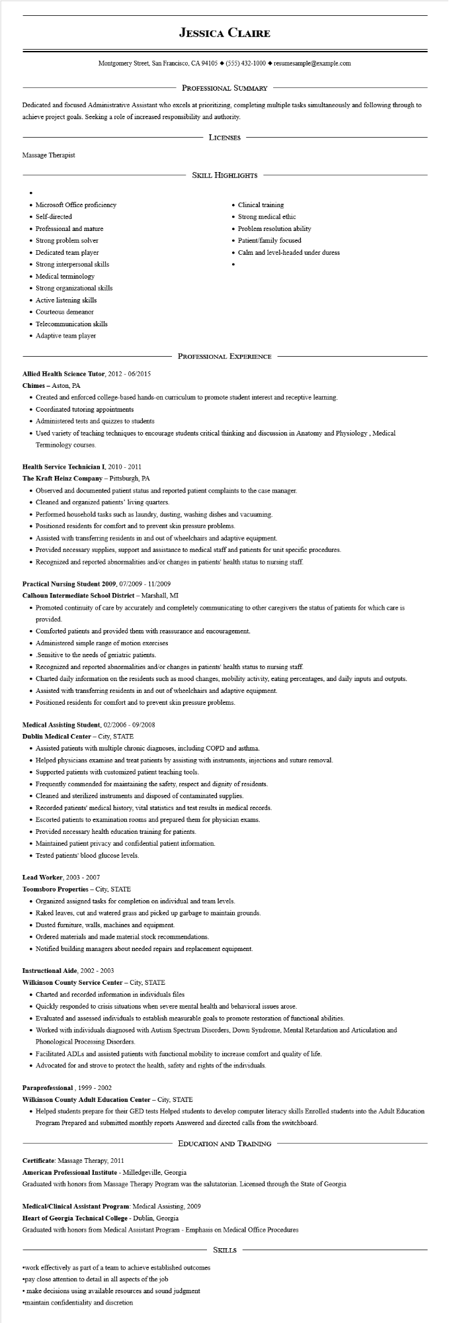

**JESSICA CLAIRE**

Montgomery Street, San Francisco, CA 94105 ♦ (555) 432-1000 resumesample@example.com

PROFESSIONAL SUMMARY

Dedicated and focused Administrative Assistant who excels at prioritizing, completing multiple tasks simultaneously and following through to achieve project goals. Seeking a role of increased responsibility and authority.

Massage Therapist

•

LICENSES

SKILL HIGHLIGHTS

• Microsoft Office proficiency

• Self-directed

• Professional and mature

• Strong problem solver

• Dedicated team player

• Strong interpersonal skills

• Medical terminology

• Strong organizational skills

• Active listening skills

• Courteous demeanor

• Telecommunication skills

• Adaptive team player

• Clinical training

• Strong medical ethic

• Problem resolution ability

• Patient/family focused

• Calm and level-headed under duress

PROFESSIONAL EXPERIENCE

**Allied Health Science Tutor, 2012 - 06/2015**

**Chimes**

Aston, PA

• Created and enforced college-based hands-on curriculum to promote student interest and receptive learning.

• Coordinated tutoring appointments

• Administered tests and quizzes to students

• Used variety of teaching techniques to encourage students critical thinking and discussion in Anatomy and Physiology, Medical Terminology courses.

**Health Service Technician I, 2010 - 2011**

**The Kraft Heinz Company - Pittsburgh, PA**

• Observed and documented patient status and reported patient complaints to the case manager.

• Cleaned and organized patients' living quarters.

• Performed household tasks such as laundry, dusting, washing dishes and vacuuming.

• Positioned residents for comfort and to prevent skin pressure problems.

• Assisted with transferring residents in and out of wheelchairs and adaptive equipment.

• Provided necessary supplies, support and assistance to medical staff and patients for unit specific procedures.

• Recognized and reported abnormalities and/or changes in patients' health status to nursing staff.

**Practical Nursing Student 2009, 07/2009 - 11/2009**

**Calhoun Intermediate School District - Marshall, MI**

• Promoted continuity of care by accurately and completely communicating to other caregivers the status of patients for which care is provided.

• Comforted patients and provided them with reassurance and encouragement.

• Administered simple range of motion exercises

• Sensitive to the needs of geriatric patients.

• Recognized and reported abnormalities and/or changes in patients' health status to nursing staff.

• Charted daily information on the residents such as mood changes, mobility activity, eating percentages, and daily inputs and outputs.

• Assisted with transferring residents in and out of wheelchairs and adaptive equipment.

• Positioned residents for comfort and to prevent skin pressure problems.

**Medical Assisting Student, 02/2006-09/2008**

Dublin Medical Center - City, STATE

• Assisted patients with multiple chronic diagnoses, including COPD and asthma.

• Helped physicians examine and treat patients by assisting with instruments, injections and suture removal.

• Supported patients with customized patient teaching tools.

Frequently commended for maintaining the safety, respect and dignity of residents.

• Cleaned and sterilized instruments and disposed of contaminated supplies.

• Recorded patients' medical history, vital statistics and test results in medical records.

• Escorted patients to examination rooms and prepared them for physician exams.

• Provided necessary health education training for patients.

• Maintained patient privacy and confidential patient information.

• Tested patients' blood glucose levels.

Lead Worker, 2003 - 2007

**Toomsboro Properties - City, STATE**

• Organized assigned tasks for completion on individual and team levels.

• Raked leaves, cut and watered grass and picked up garbage to maintain grounds.

• Dusted furniture, walls, machines and equipment.

• Ordered materials and made material stock recommendations.

• Notified building managers about needed repairs and replacement equipment.

**Instructional Aide, 2002 - 2003**

**Wilkinson County Service Center - City, STATE**

• Charted and recorded information in individuals files

• Quickly responded to crisis situations when severe mental health and behavioral issues arose.

• Evaluated and assessed individuals to establish measurable goals to promote restoration of functional abilities.

• Worked with individuals diagnosed with Autism Spectrum Disorders, Down Syndrome, Mental Retardation and Articulation and Phonological Processing Disorders.

• Facilitated ADLs and assisted patients with functional mobility to increase comfort and quality of life.

• Advocated for and strove to protect the health, safety and rights of the individuals.

**Paraprofessional, 1999 - 2002**

**Wilkinson County Adult Education Center - City, STATE**

• Helped students prepare for their GED tests Helped students to develop computer literacy skills Enrolled students into the Adult Education

Program Prepared and submitted monthly reports Answered and directed calls from the switchboard.

**EDUCATION AND TRAINING**

**Certificate: Massage Therapy, 2011**

**American Professional Institute - Milledgeville, Georgia**

Graduated with honors from Massage Therapy Program was the salutatorian. Licensed through the State of Georgia

**Medical/Clinical Assistant Program: Medical Assisting, 2009**

Heart of Georgia Technical College - Dublin, Georgia

Graduated with honors from Medical Assistant Program - Emphasis on Medical Office Procedures

SKILLS

•work effectively as part of a team to achieve established outcomes

•pay close attention to detail in all aspects of the job

• make decisions using available resources and sound judgment

⚫maintain confidentiality and discretion