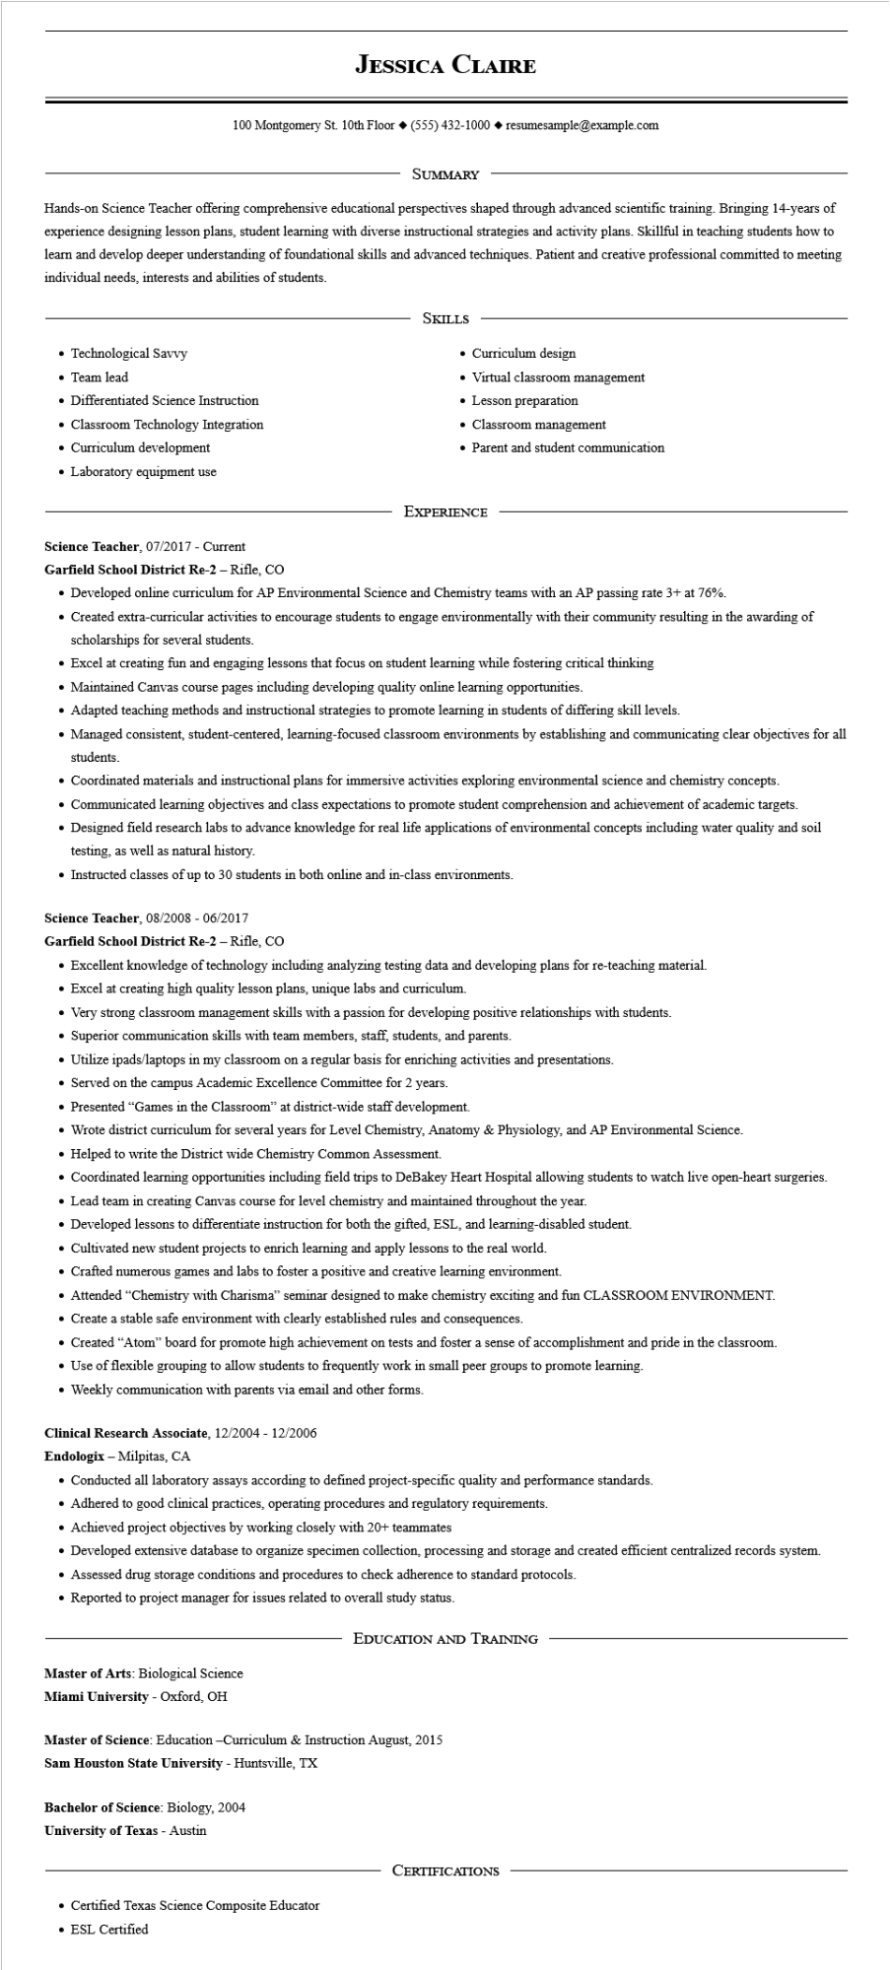

**JESSICA CLAIRE**

100 Montgomery St. 10th Floor◆ (555) 432-1000◆ resumesample@example.com

SUMMARY

Hands-on Science Teacher offering comprehensive educational perspectives shaped through advanced scientific training. Bringing 14-years of experience designing lesson plans, student learning with diverse instructional strategies and activity plans. Skillful in teaching students how to learn and develop deeper understanding of foundational skills and advanced techniques. Patient and creative professional committed to meeting individual needs, interests and abilities of students.

• Technological Savvy

• Team lead

• Differentiated Science Instruction

• Classroom Technology Integration

• Curriculum development

• Laboratory equipment use

SKILLS

• Curriculum design

• Virtual classroom management Lesson preparation

• Classroom management

• Parent and student communication

**Science Teacher, 07/2017 - Current**

EXPERIENCE

**Garfield School District Re-2 - Rifle, CO**

• Developed online curriculum for AP Environmental Science and Chemistry teams with an AP passing rate 3+ at 76%.

• Created extra-curricular activities to encourage students to engage environmentally with their community resulting in the awarding of scholarships for several students.

• Excel at creating fun and engaging lessons that focus on student learning while fostering critical thinking

• Maintained Canvas course pages including developing quality online learning opportunities.

• Adapted teaching methods and instructional strategies to promote learning in students of differing skill levels.

• Managed consistent, student-centered, learning-focused classroom environments by establishing and communicating clear objectives for all students.

• Coordinated materials and instructional plans for immersive activities exploring environmental science and chemistry concepts.

• Communicated learning objectives and class expectations to promote student comprehension and achievement of academic targets.

• Designed field research labs to advance knowledge for real life applications of environmental concepts including water quality and soil testing, as well as natural history.

• Instructed classes of up to 30 students in both online and in-class environments.

Science Teacher, 08/2008 - 06/2017

**Garfield School District Re-2 - Rifle, CO**

• Excellent knowledge of technology including analyzing testing data and developing plans for re-teaching material.

• Excel at creating high quality lesson plans, unique labs and curriculum.

• Very strong classroom management skills with a passion for developing positive relationships with students.

• Superior communication skills with team members, staff, students, and parents.

• Utilize ipads/laptops in my classroom on a regular basis for enriching activities and presentations.

• Served on the campus Academic Excellence Committee for 2 years.

• Presented "Games in the Classroom" at district-wide staff development.

• Wrote district curriculum for several years for Level Chemistry, Anatomy & Physiology, and AP Environmental Science.

• Helped to write the District wide Chemistry Common Assessment.

• Coordinated learning opportunities including field trips to DeBakey Heart Hospital allowing students to watch live open-heart surgeries.

• Lead team in creating Canvas course for level chemistry and maintained throughout the year.

• Developed lessons to differentiate instruction for both the gifted, ESL, and learning-disabled student.

• Cultivated new student projects to enrich learning and apply lessons to the real world.

• Crafted numerous games and labs to foster a positive and creative learning environment.

• Attended "Chemistry with Charisma" seminar designed to make chemistry exciting and fun CLASSROOM ENVIRONMENT.

• Create a stable safe environment with clearly established rules and consequences.

• Created "Atom" board for promote high achievement on tests and foster a sense of accomplishment and pride in the classroom.

• Use of flexible grouping to allow students to frequently work in small peer groups to promote learning.

• Weekly communication with parents via email and other forms.

**Clinical Research Associate, 12/2004 - 12/2006**

**Endologix - Milpitas, CA**

• Conducted all laboratory assays according to defined project-specific quality and performance standards.

• Adhered to good clinical practices, operating procedures and regulatory requirements.

• Achieved project objectives by working closely with 20+ teammates

• Developed extensive database to organize specimen collection, processing and storage and created efficient centralized records system.

• Assessed drug storage conditions and procedures to check adherence to standard protocols.

• Reported to project manager for issues related to overall study status.

Master of Arts: Biological Science

**EDUCATION AND TRAINING**

**Miami University - Oxford, OH**

Master of Science: Education -Curriculum & Instruction August, 2015

**Sam Houston State University - Huntsville, TX**

Bachelor of Science: Biology, 2004

**University of Texas - Austin**

• Certified Texas Science Composite Educator

ESL Certified

CERTIFICATIONS