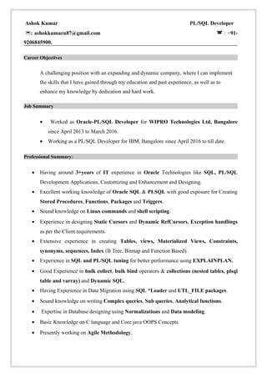

Ashok Kemer

PL/SQL Developer

9206845900

Carner Objectiv

A challenging position with an expanding and dynamic company, where I can implement the skills that I have gained through my education and past experience, as well as enhance my knowledge by dedication and hard work.

•Worked as Oracle-PL/SQL Developer WIPRO Technologies Ltd, Bangalore since April 2013 to March 2016

**Working as a PL/SQL Developer for M, Banglor since April 2016 so till date**

Profil Summary:

Having around 3-years of IT experience in Oracle Technologies like SQL, PL/SQL Development Applications, Customizing and Enhancement and Designing

• Excellent working knowledge of Oracle SQL & PLSQL with good exposure for Creating Stored Procedures. Functions, Packages and Triggers

**Sound knowledge on Linux commands and shell scripting**

**• Experience in designing Static Cursors and Dynamic RefCursors, Exception handlings as per the Client requirements.**

**Extensive experience in creating Tables, views, Materialized Views, Constraints, sequences, Indes (B Tree. Bitnup and Function Based)**

Experience in SQL and PL/SQL, taning for better performance wing EXPLAINPLAN • Good Experience in bulk collect, bulk bind operators & collections (nested tables, plsql.

table and array) and DySQL.

Having Experience in Chata Migration using SQL. "Lauder und UTI FILE packages

**Sound knowledge on writing Complex queries, Subqueries, Analytical functions**

•Expertise in Database designing sing Normalizations and Data modeling

Basic Knowledge on language and Core ja OOPS Concepts

Presently working on Agile Methodology