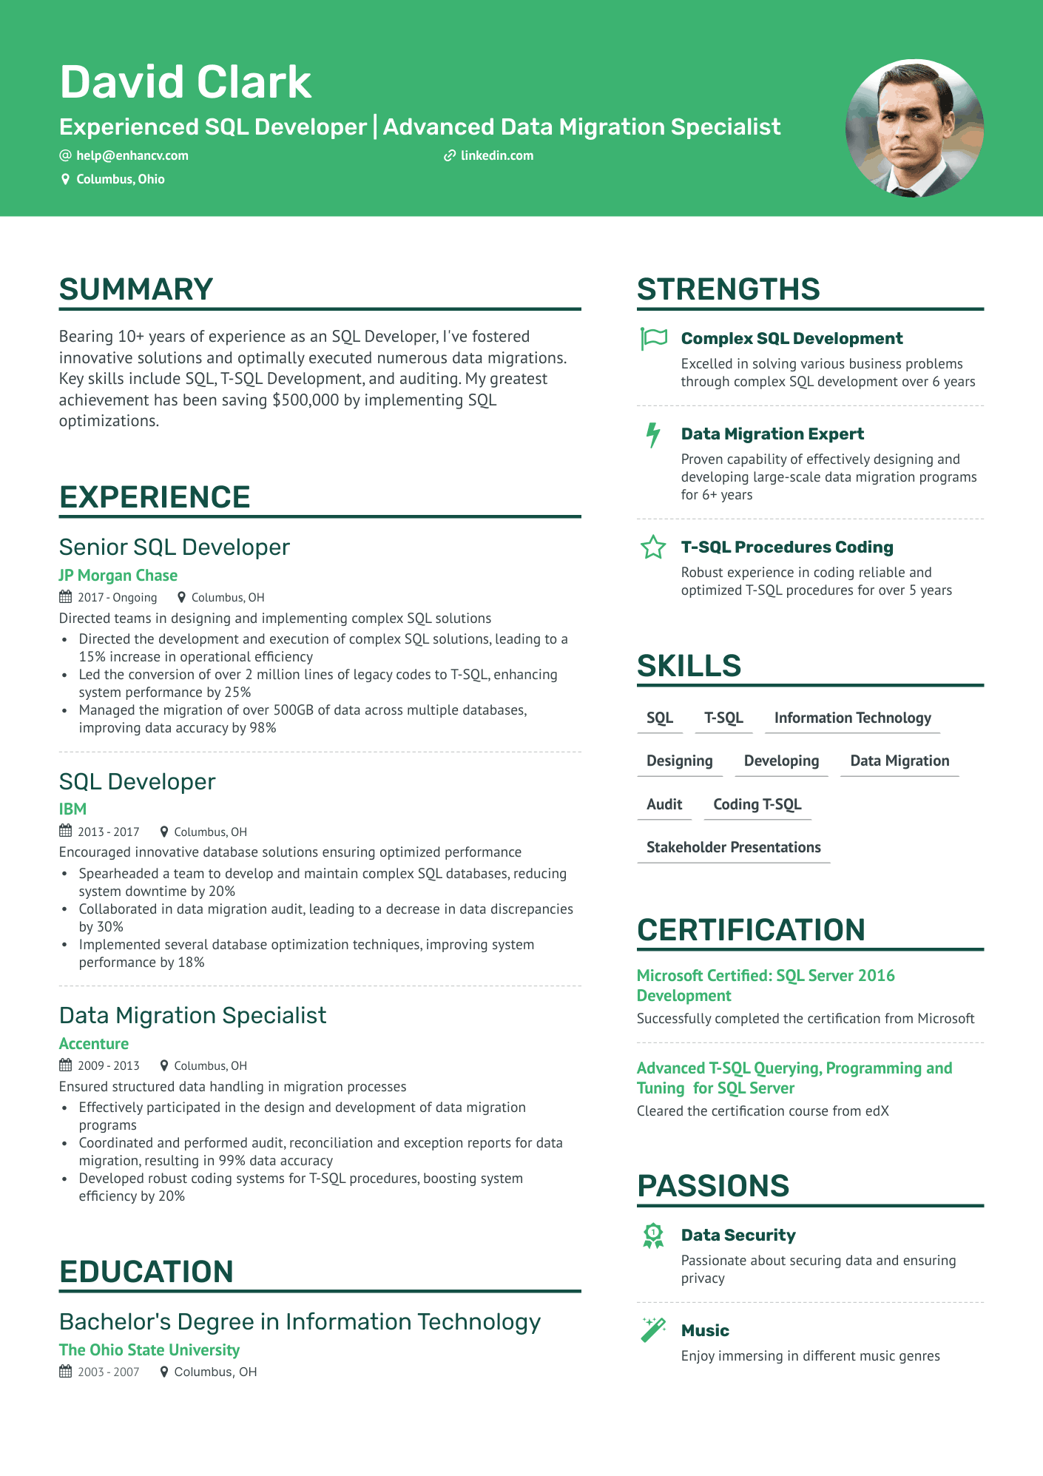

**David Clark**

Experienced SQL Developer | Advanced Data Migration Specialist

@help@enhancv.com

Columbus, Ohio

**✔ linkedin.com**

**SUMMARY**

Bearing 10+ years of experience as an SQL Developer, I've fostered innovative solutions and optimally executed numerous data migrations. Key skills include SQL, T-SQL Development, and auditing. My greatest achievement has been saving $500,000 by implementing SQL optimizations.

**STRENGTHS**

**Complex SQL Development**

Excelled in solving various business problems through complex SQL development over 6 years

**4 Data Migration Expert**

Proven capability of effectively designing and developing large-scale data migration programs for 6+ years

**T-SQL Procedures Coding**

Robust experience in coding reliable and optimized T-SQL procedures for over 5 years

**EXPERIENCE**

Senior SQL Developer

**JP Morgan Chase**

2017-Ongoing

Columbus, OH

Directed teams in designing and implementing complex SQL solutions

Directed the development and execution of complex SQL solutions, leading to a 15% increase in operational efficiency

• Led the conversion of over 2 million lines of legacy codes to T-SQL, enhancing system performance by 25%

Managed the migration of over 500GB of data across multiple databases, improving data accuracy by 98%

SQL Developer

**IBM**

2013-2017

Columbus, OH

Encouraged innovative database solutions ensuring optimized performance Spearheaded a team to develop and maintain complex SQL databases, reducing system downtime by 20%

.

•

•

Collaborated in data migration audit, leading to a decrease in data discrepancies by 30%

Implemented several database optimization techniques, improving system performance by 18%

Data Migration Specialist

**Accenture**

2009-2013

Columbus, OH

Ensured structured data handling in migration processes

·

•

Effectively participated in the design and development of data migration programs

Coordinated and performed audit, reconciliation and exception reports for data migration, resulting in 99% data accuracy

Developed robust coding systems for T-SQL procedures, boosting system efficiency by 20%

**SKILLS**

**SQL T-SQL Information Technology**

**Designing**

**Developing Data Migration**

**Audit Coding T-SQL**

**Stakeholder Presentations**

**CERTIFICATION**

**Microsoft Certified: SQL Server 2016 Development**

Successfully completed the certification from Microsoft

**Advanced T-SQL Querying, Programming and**

**Tuning for SQL Server**

Cleared the certification course from edX

**EDUCATION**

Bachelor's Degree in Information Technology The Ohio State University

2003-2007

Columbus, OH

**PASSIONS**

**Data Security**

Passionate about securing data and ensuring privacy

**Music**

Enjoy immersing in different music genres