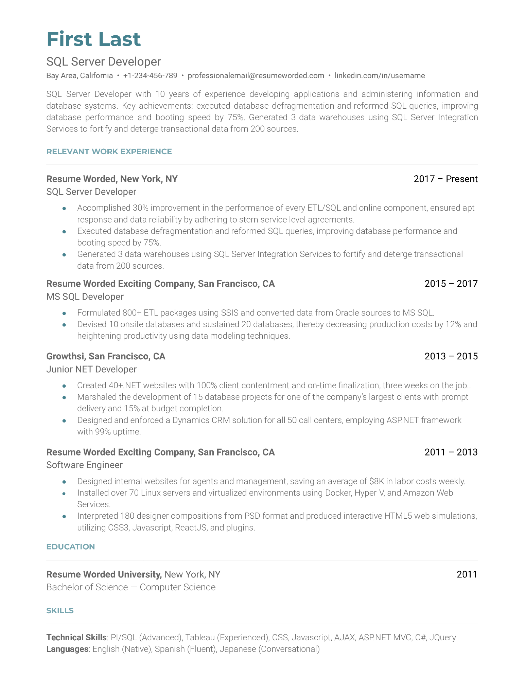

**First Last**

SQL Server Developer

•

Bay Area, California +1-234-456-789 professionalemail@resumeworded.com⚫ linkedin.com/in/username

·

SQL Server Developer with 10 years of experience developing applications and administering information and database systems. Key achievements: executed database defragmentation and reformed SQL queries, improving database performance and booting speed by 75%. Generated 3 data warehouses using SQL Server Integration Services to fortify and deterge transactional data from 200 sources.

**RELEVANT WORK EXPERIENCE**

**Resume Worded, New York, NY**

SQL Server Developer

2017 - Present

Accomplished 30% improvement in the performance of every ETL/SQL and online component, ensured apt response and data reliability by adhering to stern service level agreements.

Executed database defragmentation and reformed SQL queries, improving database performance and booting speed by 75%.

Generated 3 data warehouses using SQL Server Integration Services to fortify and deterge transactional data from 200 sources.

**Resume Worded Exciting Company, San Francisco, CA**

MS SQL Developer

2015 2017

Formulated 800+ ETL packages using SSIS and converted data from Oracle sources to MS SQL. Devised 10 onsite databases and sustained 20 databases, thereby decreasing production costs by 12% and heightening productivity using data modeling techniques.

**Growthsi, San Francisco, CA**

Junior NET Developer

•

2013 - 2015

Created 40+.NET websites with 100% client contentment and on-time finalization, three weeks on the job.. Marshaled the development of 15 database projects for one of the company's largest clients with prompt delivery and 15% at budget completion.

Designed and enforced a Dynamics CRM solution for all 50 call centers, employing ASP.NET framework with 99% uptime.

**Resume Worded Exciting Company, San Francisco, CA**

Software Engineer

2011 - 2013

Designed internal websites for agents and management, saving an average of $8K in labor costs weekly. Installed over 70 Linux servers and virtualized environments using Docker, Hyper-V, and Amazon Web Services.

Interpreted 180 designer compositions from PSD format and produced interactive HTML5 web simulations, utilizing CSS3, Javascript, ReactJS, and plugins.

**EDUCATION**

**Resume Worded University, New York, NY**

Bachelor of Science - Computer Science

**SKILLS**

Technical Skills: PI/SQL (Advanced), Tableau (Experienced), CSS, Javascript, AJAX, ASP.NET MVC, C#, JQuery Languages: English (Native), Spanish (Fluent), Japanese (Conversational)

2011