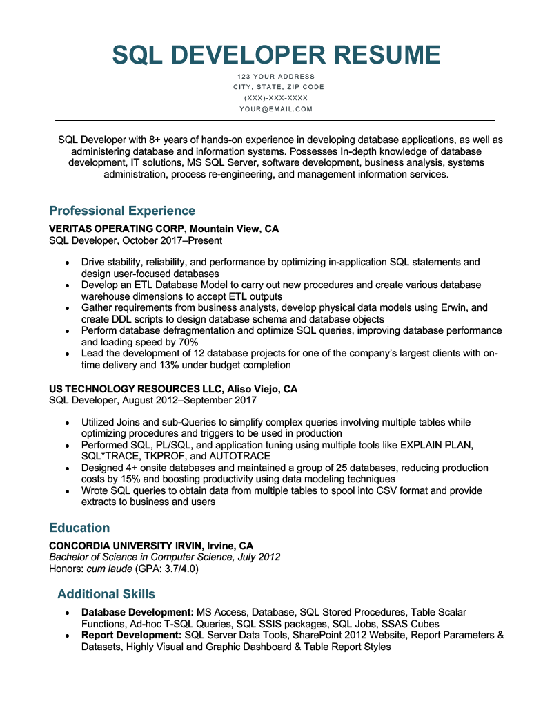

**SQL DEVELOPER RESUME**

123 YOUR ADDRESS CITY, STATE, ZIP CODE (XXX)-XXX-XXXX YOUR@EMAIL.COM

SQL Developer with 8+ years of hands-on experience in developing database applications, as well as administering database and information systems. Possesses In-depth knowledge of database development, IT solutions, MS SQL Server, software development, business analysis, systems administration, process re-engineering, and management information services.

**Professional Experience**

VERITAS OPERATING CORP, Mountain View, CA SQL Developer, October 2017-Present

⚫ Drive stability, reliability, and performance by optimizing in-application SQL statements and design user-focused databases

• Develop an ETL Database Model to carry out new procedures and create various database warehouse dimensions to accept ETL outputs

• Gather requirements from business analysts, develop physical data models using Erwin, and create DDL scripts to design database schema and database objects

• Perform database defragmentation and optimize SQL queries, improving database performance and loading speed by 70%

• Lead the development of 12 database projects for one of the company's largest clients with on- time delivery and 13% under budget completion

**US TECHNOLOGY RESOURCES LLC, Aliso Viejo, CA**

SQL Developer, August 2012-September 2017

• Utilized Joins and sub-Queries to simplify complex queries involving multiple tables while optimizing procedures and triggers to be used in production

•

Performed SQL, PL/SQL, and application tuning using multiple tools like EXPLAIN PLAN, SQL*TRACE, TKPROF, and AUTOTRACE

• Designed 4+ onsite databases and maintained a group of 25 databases, reducing production costs by 15% and boosting productivity using data modeling techniques

• Wrote SQL queries to obtain data from multiple tables to spool into CSV format and provide extracts to business and users

**Education**

**CONCORDIA UNIVERSITY IRVIN, Irvine, CA**

*Bachelor of Science in Computer Science, July 2012*

Honors: cum laude (GPA: 3.7/4.0)

**Additional Skills**

•

Database Development: MS Access, Database, SQL Stored Procedures, Table Scalar Functions, Ad-hoc T-SQL Queries, SQL SSIS packages, SQL Jobs, SSAS Cubes

• Report Development: SQL Server Data Tools, SharePoint 2012 Website, Report Parameters & Datasets, Highly Visual and Graphic Dashboard & Table Report Styles