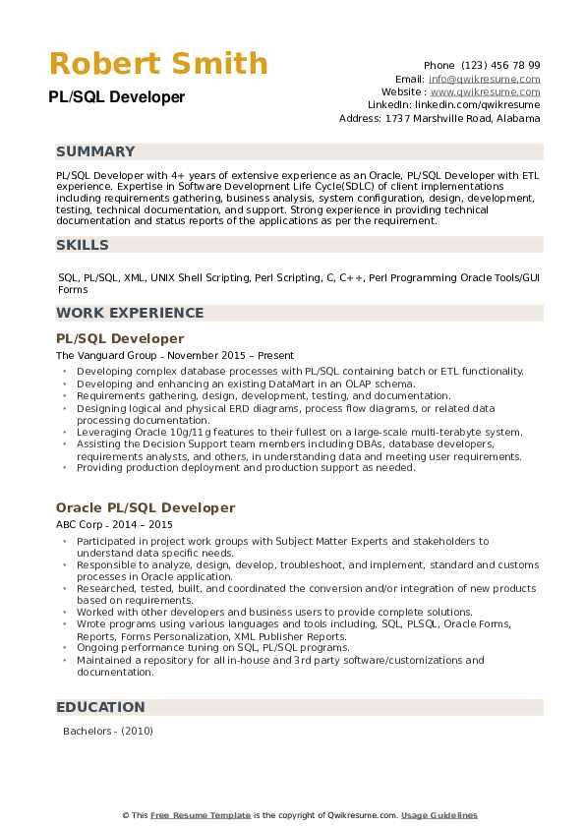

**Robert Smith**

PL/SQL Developer

Phone (123) 456 78 99

Email: info@qwikresume.com Website: www.qwikresume.com Linkedin: linkedin.com/qwikresume Address: 1737 Marshville Road, Alabama

**SUMMARY**

PL/SQL Developer with 4+ years of extensive experience as an Oracle, PL/SQL Developer with ETL experience. Expertise in Software Development Life Cycle(SDLC) of client implementations including requirements gathering, business analysis, system configuration, design, development, testing, technical documentation, and support. Strong experience in providing technical documentation and status reports of the applications as per the requirement.

SKILLS

SQL, PL/SQL, XML, UNIX Shell Scripting, Perl Scripting, C, C++, Perl Programming Oracle Tools/GUI Forms

**WORK EXPERIENCE**

PL/SQL Developer

The Vanguard Group - November 2015 - Present

• Developing complex database processes with PL/SQL containing batch or ETL functionality. Developing and enhancing an existing DataMart in an OLAP schema.

•

.

Requirements gathering, design, development, testing, and documentation.

Designing logical and physical ERD diagrams, process flow diagrams, or related data processing documentation.

Leveraging Oracle 10g/11g features to their fullest on a large-scale multi-terabyte system. • Assisting the Decision Support team members including DBAs, database developers, requirements analysts, and others, in understanding data and meeting user requirements, •Providing production deployment and production support as needed.

Oracle PL/SQL Developer

ABC Corp-2014-2015

•

"

"

Participated in project work groups with Subject Matter Experts and stakeholders to understand data specific needs.

Responsible to analyze, design, develop, troubleshoot, and implement, standard and customs processes in Oracle application.

Researched, tested, built, and coordinated the conversion and/or integration of new products based on requirements.

Worked with other developers and business users to provide complete solutions.

Wrote programs using various languages and tools including, SQL, PLSQL, Oracle Forms,

Reports, Forms Personalization, XML Publisher Reports.

⚫ Ongoing performance tuning on SQL, PL/SQL programs.

• Maintained a repository for all in-house and 3rd party software/customizations and documentation.

EDUCATION Bachelors - (2010)

This Free Resume Template is the copyright of Qwikresume.com. Usage Guidelines