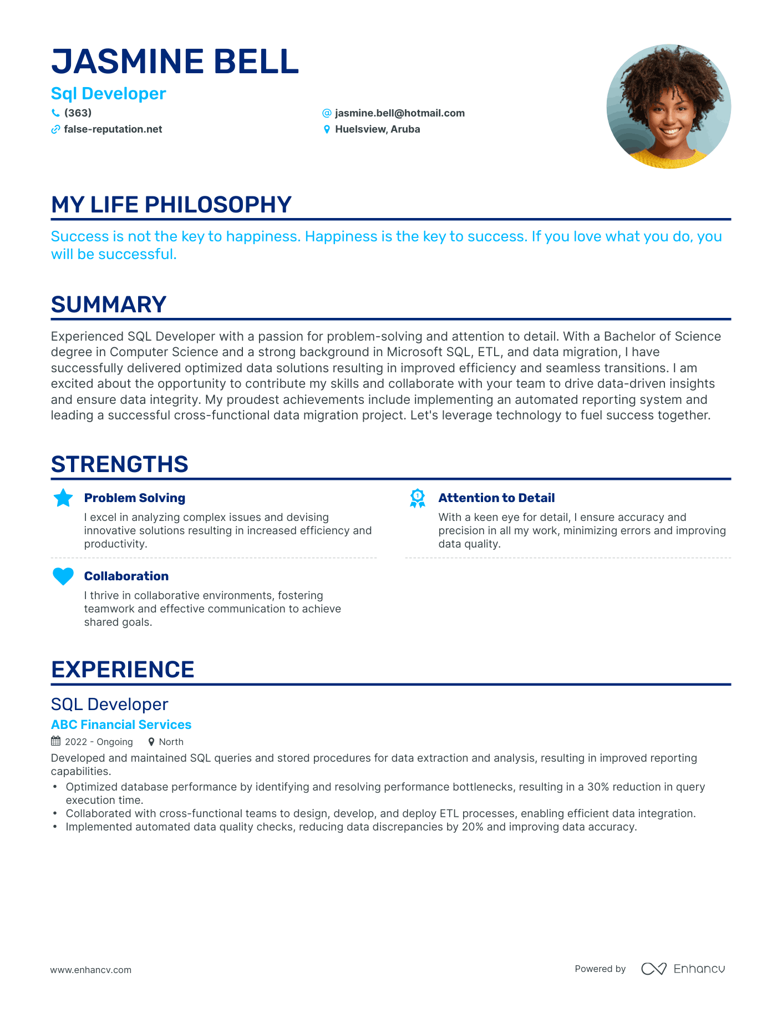

**JASMINE BELL**

**Sql Developer**

**(363)**

**✔ false-reputation.net**

**@jasmine.bell@hotmail.com Huelsview, Aruba**

**MY LIFE PHILOSOPHY**

Success is not the key to happiness. Happiness is the key to success. If you love what you do, you will be successful.

**SUMMARY**

Experienced SQL Developer with a passion for problem-solving and attention to detail. With a Bachelor of Science degree in Computer Science and a strong background in Microsoft SQL, ETL, and data migration, I have successfully delivered optimized data solutions resulting in improved efficiency and seamless transitions. I am excited about the opportunity to contribute my skills and collaborate with your team to drive data-driven insights and ensure data integrity. My proudest achievements include implementing an automated reporting system and leading a successful cross-functional data migration project. Let's leverage technology to fuel success together.

**STRENGTHS**

**Problem Solving**

I excel in analyzing complex issues and devising innovative solutions resulting in increased efficiency and productivity.

**Collaboration**

I thrive in collaborative environments, fostering

teamwork and effective communication to achieve shared goals.

**EXPERIENCE**

SQL Developer

**ABC Financial Services 2022 Ongoing**

North

**Attention to Detail**

With a keen eye for detail, I ensure accuracy and precision in all my work, minimizing errors and improving data quality.

Developed and maintained SQL queries and stored procedures for data extraction and analysis, resulting in improved reporting capabilities.

•

•

•

Optimized database performance by identifying and resolving performance bottlenecks, resulting in a 30% reduction in query execution time.

Collaborated with cross-functional teams to design, develop, and deploy ETL processes, enabling efficient data integration. Implemented automated data quality checks, reducing data discrepancies by 20% and improving data accuracy.

www.enhancv.com

Powered by ∞ Enhancu