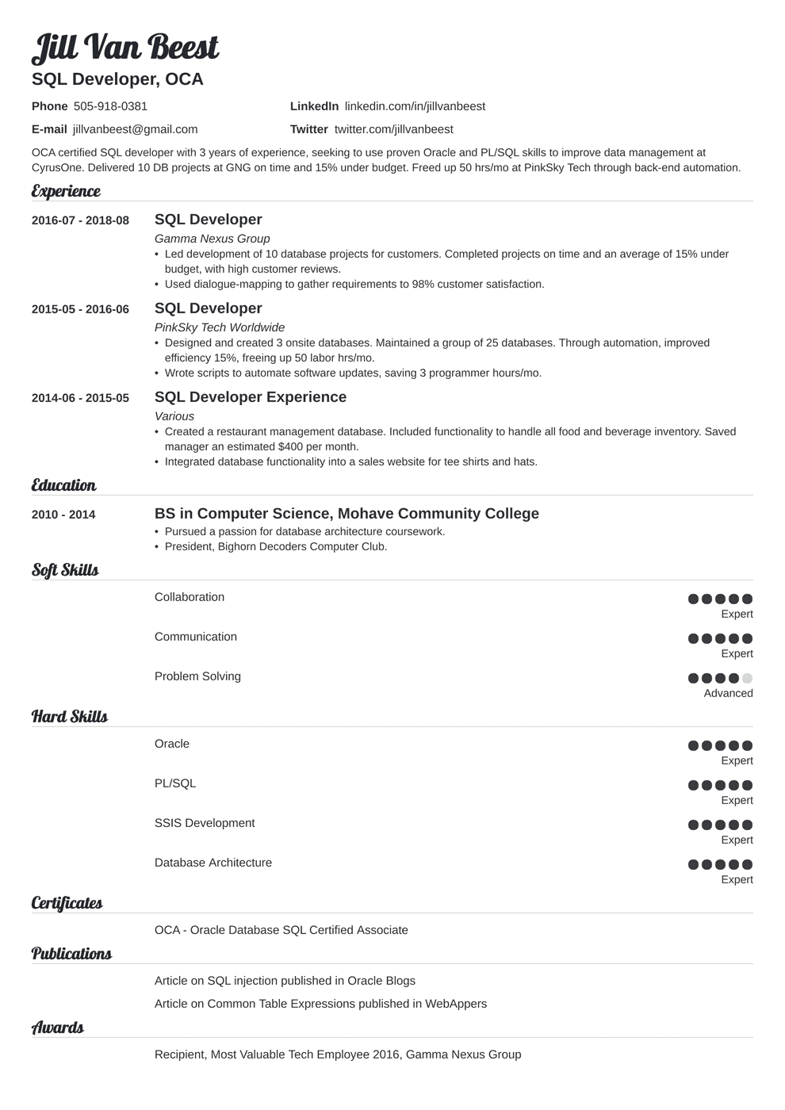

Jill Van Beest

SQL Developer, OCA

Phone 505-918-0381

E-mail jillvanbeest@gmail.com

LinkedIn linkedin.com/in/jillvanbeest

Twitter twitter.com/jillvanbeest

OCA certified SQL developer with 3 years of experience, seeking to use proven Oracle and PL/SQL skills to improve data management at CyrusOne. Delivered 10 DB projects at GNG on time and 15% under budget. Freed up 50 hrs/mo at PinkSky Tech through back-end automation.

**Experience**

2016-07- 2018-08

**2015-05-2016-06**

2014-06-2015-05

Education

**2010 - 2014**

***Soft Skills***

SQL Developer

*Gamma Nexus Group*

• Led development of 10 database projects for customers. Completed projects on time and an average of 15% under budget, with high customer reviews.

• Used dialogue-mapping to gather requirements to 98% customer satisfaction.

**SQL Developer**

*PinkSky Tech Worldwide*

• Designed and created 3 onsite databases. Maintained a group of 25 databases. Through automation, improved efficiency 15%, freeing up 50 labor hrs/mo.

• Wrote scripts to automate software updates, saving 3 programmer hours/mo.

**SQL Developer Experience**

*Various*

• Created a restaurant management database. Included functionality to handle all food and beverage inventory. Saved manager an estimated $400 per month.

• Integrated database functionality into a sales website for tee shirts and hats.

**BS in Computer Science, Mohave Community College Pursued a passion for database architecture coursework.**

• President, Bighorn Decoders Computer Club.

**Hard Skills**

Collaboration

Communication

Problem Solving

Oracle

PL/SQL

SSIS Development

Database Architecture

Certificates

OCA - Oracle Database SQL Certified Associate

Publications

Article on SQL injection published in Oracle Blogs Article on Common Table Expressions published in WebAppers

***Awards***

Recipient, Most Valuable Tech Employee 2016, Gamma Nexus Group

Expert

Expert

Advanced

Expert

Expert

Expert

Expert