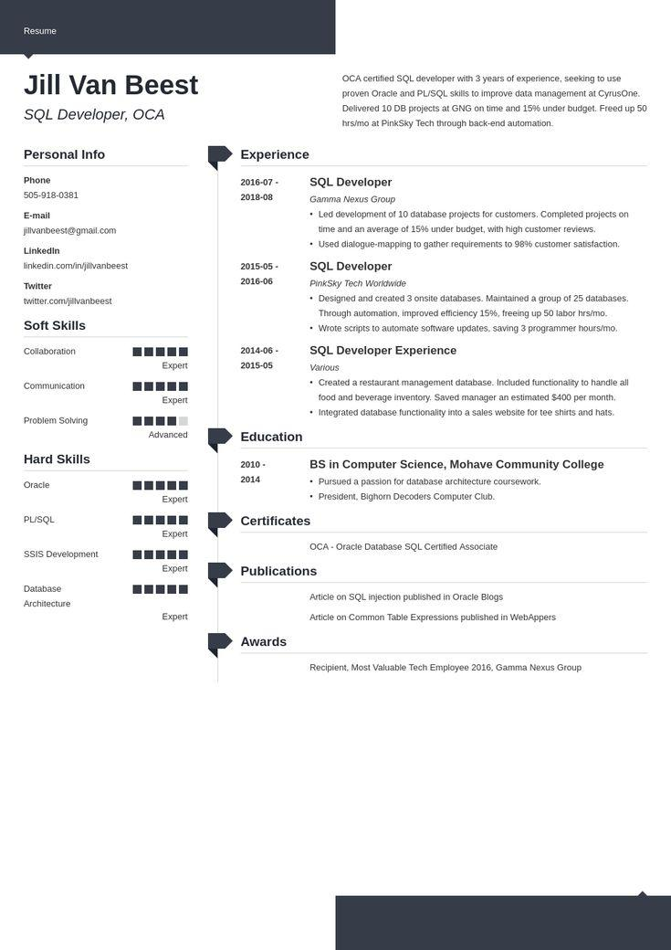

Resume

**Jill Van Beest**

*SQL Developer, OCA*

Personal Info

Phone

505-918-0381

E-mail

jillvanbeest@gmail.com

linkedin.com/in/jillvanbeest

LinkedIn

Twitter

twitter.com/jillvanbeest

Soft Skills

Collaboration

Experience

2016-07- 2018-08

2015-05-

2016-06

Expert

2014-06- 2015-05

Communication

Expert

OCA certified SQL developer with 3 years of experience, seeking to use proven Oracle and PL/SQL skills to improve data management at CyrusOne. Delivered 10 DB projects at GNG on time and 15% under budget. Freed up 50 hrs/mo at PinkSky Tech through back-end automation.

SQL Developer

Gamma Nexus Group

• Led development of 10 database projects for customers. Completed projects on time and an average of 15% under budget, with high customer reviews.

• Used dialogue-mapping to gather requirements to 98% customer satisfaction.

SQL Developer

PinkSky Tech Worldwide

• Designed and created 3 onsite databases. Maintained a group of 25 databases. Through automation, improved efficiency 15%, freeing up 50 labor hrs/mo.

• Wrote scripts to automate software updates, saving 3 programmer hours/mo. SQL Developer Experience

Various

• Created a restaurant management database. Included functionality to handle all food and beverage inventory. Saved manager an estimated $400 per month.

• Integrated database functionality into a sales website for tee shirts and hats.

Problem Solving

Advanced

Education

Hard Skills

**2010- 2014**

Oracle

Expert

BS in Computer Science, Mohave Community College • Pursued a passion for database architecture coursework. • President, Bighorn Decoders Computer Club.

PL/SQL

Certificates

Expert

OCA - Oracle Database SQL Certified Associate

SSIS Development

Expert

Publications

Database

Architecture

Expert

Article on SQL injection published in Oracle Blogs Article on Common Table Expressions published in WebAppers

Awards

Recipient, Most Valuable Tech Employee 2016, Gamma Nexus Group