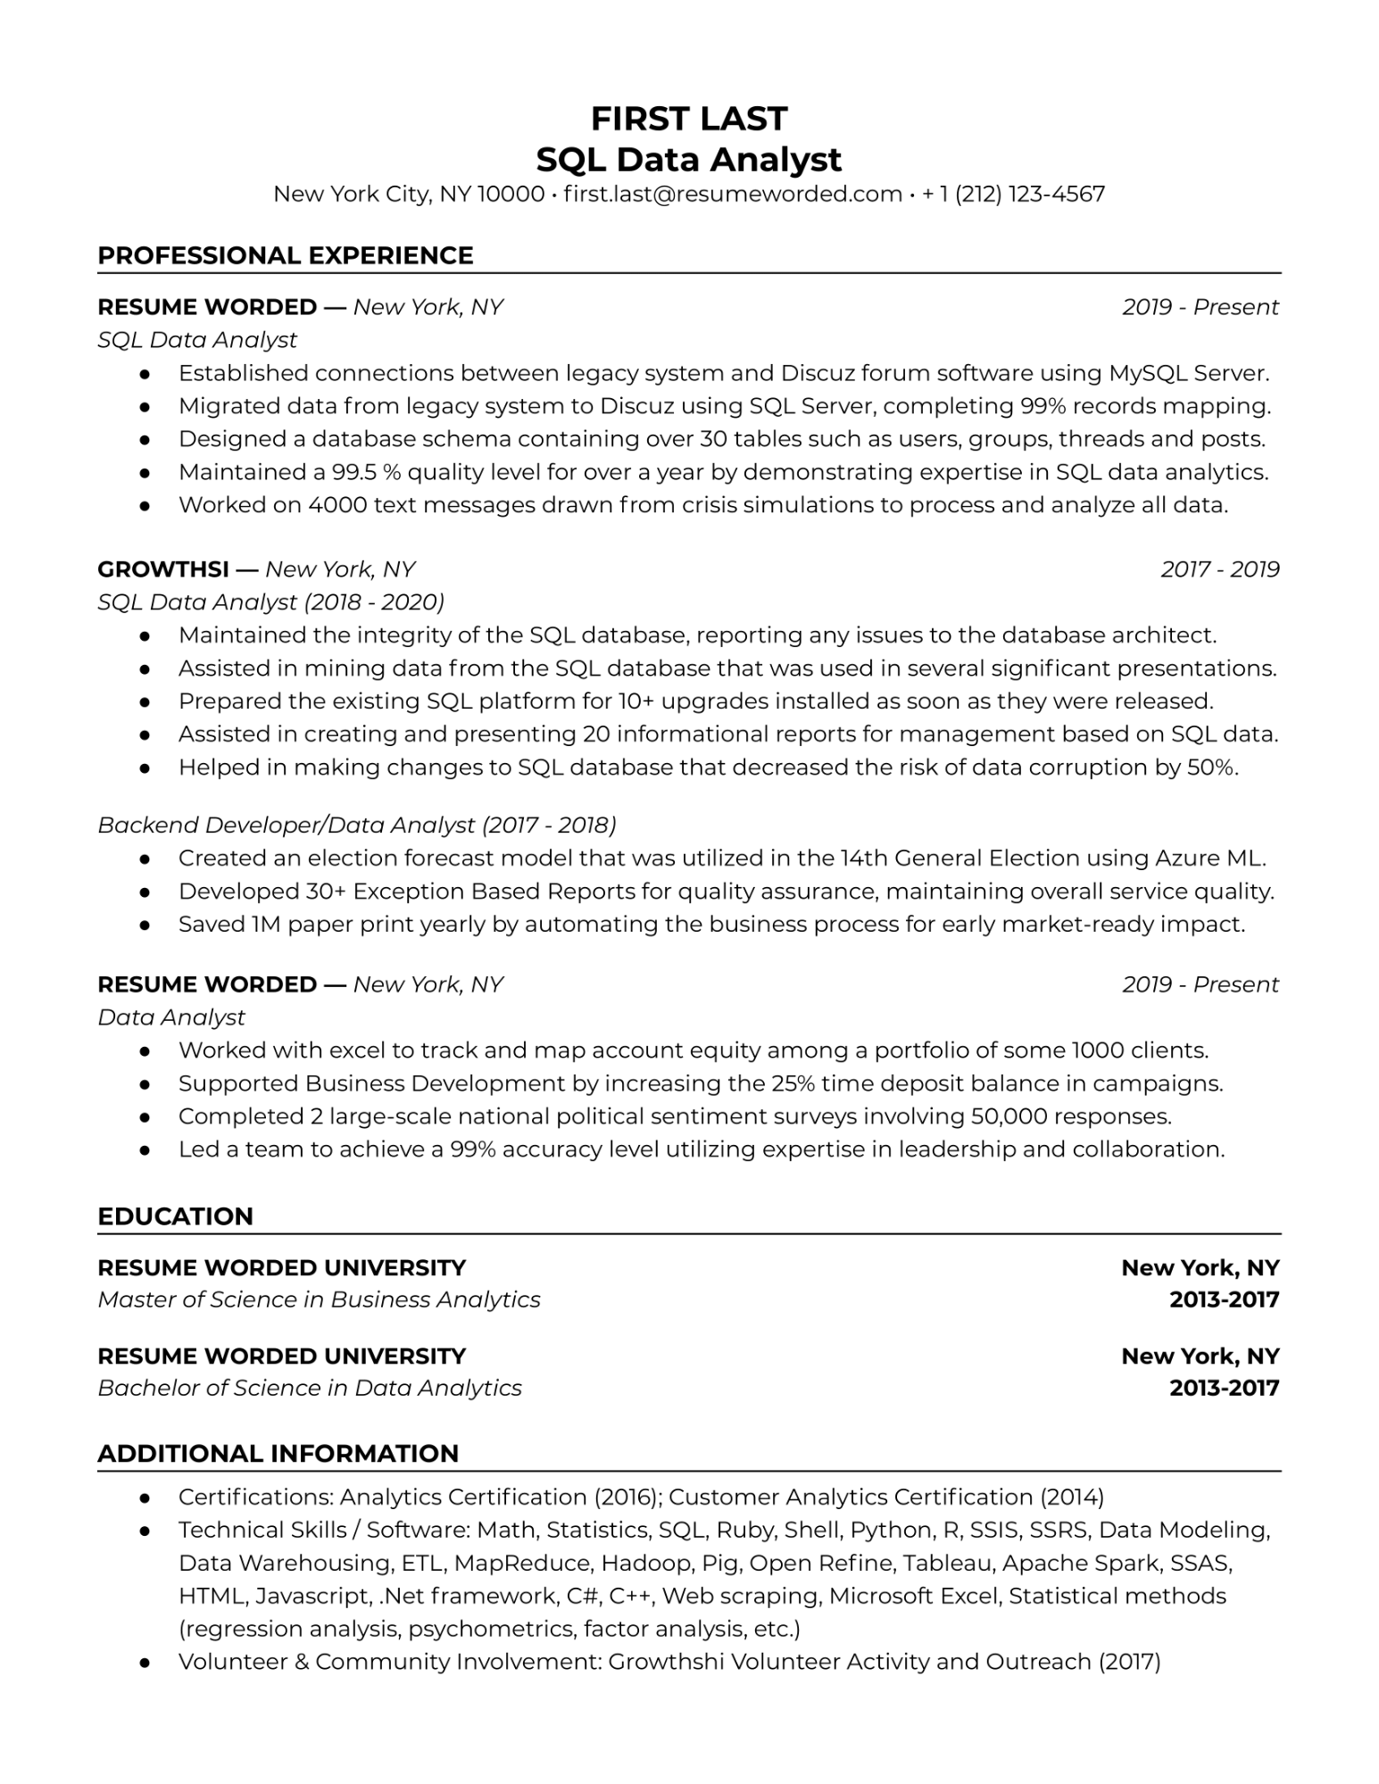

**FIRST LAST**

**SQL Data Analyst**

New York City, NY 10000⚫ first.last@resumeworded.com • +1 (212) 123-4567

**PROFESSIONAL EXPERIENCE**

**RESUME WORDED**

-

*New York, NY*

*2019-Present*

*SQL Data Analyst*

Established connections between legacy system and Discuz forum software using MySQL Server. • Migrated data from legacy system to Discuz using SQL Server, completing 99% records mapping. Designed a database schema containing over 30 tables such as users, groups, threads and posts. Maintained a 99.5 % quality level for over a year by demonstrating expertise in SQL data analytics. Worked on 4000 text messages drawn from crisis simulations to process and analyze all data.

•

**GROWTHSI - New York, NY**

*SQL Data Analyst (2018-2020)*

2017-2019

Maintained the integrity of the SQL database, reporting any issues to the database architect. Assisted in mining data from the SQL database that was used in several significant presentations. Prepared the existing SQL platform for 10+ upgrades installed as soon as they were released. Assisted in creating and presenting 20 informational reports for management based on SQL data. • Helped in making changes to SQL database that decreased the risk of data corruption by 50%.

•

*Backend Developer/Data Analyst (2017-2018)*

Created an election forecast model that was utilized in the 14th General Election using Azure ML. Developed 30+ Exception Based Reports for quality assurance, maintaining overall service quality. • Saved IM paper print yearly by automating the business process for early market-ready impact.

**RESUME WORDED Data Analyst**

·

—

*New York, NY*

*2019 - Present*

Worked with excel to track and map account equity among a portfolio of some 1000 clients. Supported Business Development by increasing the 25% time deposit balance in campaigns. Completed 2 large-scale national political sentiment surveys involving 50,000 responses.

• Led a team to achieve a 99% accuracy level utilizing expertise in leadership and collaboration.

**EDUCATION**

**RESUME WORDED UNIVERSITY**

*Master of Science in Business Analytics*

**New York, NY 2013-2017**

**RESUME WORDED UNIVERSITY**

*Bachelor of Science in Data Analytics*

**New York, NY 2013-2017**

**ADDITIONAL INFORMATION**

Certifications: Analytics Certification (2016); Customer Analytics Certification (2014) Technical Skills / Software: Math, Statistics, SQL, Ruby, Shell, Python, R, SSIS, SSRS, Data Modeling, Data Warehousing, ETL, MapReduce, Hadoop, Pig, Open Refine, Tableau, Apache Spark, SSAS, HTML, Javascript, .Net framework, C#, C++, Web scraping, Microsoft Excel, Statistical methods (regression analysis, psychometrics, factor analysis, etc.)

• Volunteer & Community Involvement: Growthshi Volunteer Activity and Outreach (2017)