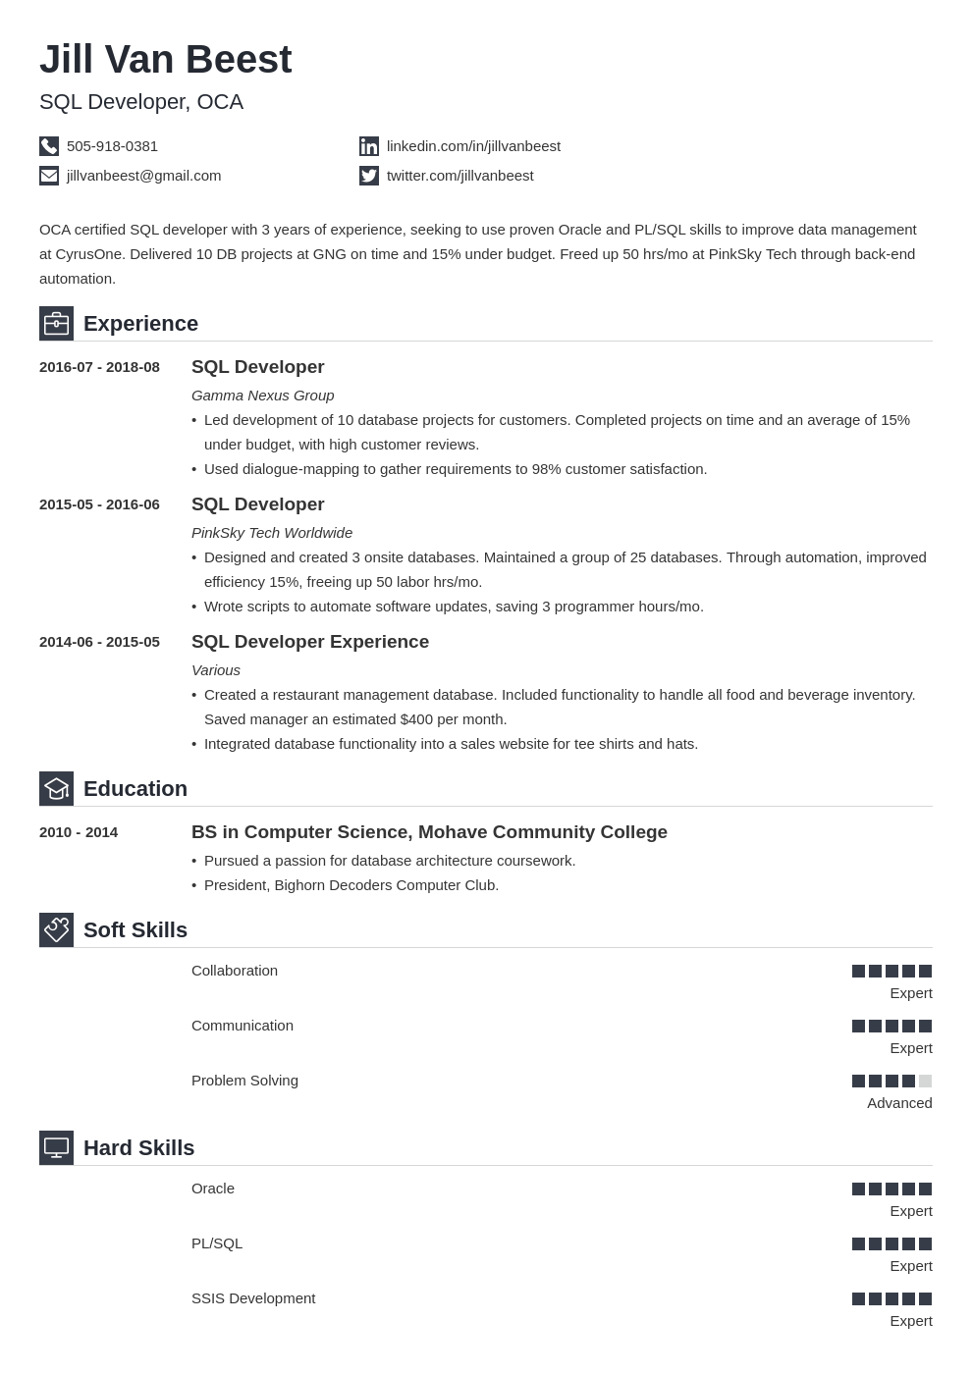

**Jill Van Beest**

SQL Developer, OCA

505-918-0381

jillvanbeest@gmail.com

in linkedin.com/in/jillvanbeest twitter.com/jillvanbeest

OCA certified SQL developer with 3 years of experience, seeking to use proven Oracle and PL/SQL skills to improve data management at CyrusOne. Delivered 10 DB projects at GNG on time and 15% under budget. Freed up 50 hrs/mo at PinkSky Tech through back-end automation.

**Experience**

**2016-07 - 2018-08**

**SQL Developer**

**2015-05-2016-06**

**2014-06-2015-05**

**Education**

**2010 - 2014**

**Soft Skills**

*Gamma Nexus Group*

• Led development of 10 database projects for customers. Completed projects on time and an average of 15% under budget, with high customer reviews.

• Used dialogue-mapping to gather requirements to 98% customer satisfaction.

**SQL Developer**

*PinkSky Tech Worldwide*

• Designed and created 3 onsite databases. Maintained a group of 25 databases. Through automation, improved efficiency 15%, freeing up 50 labor hrs/mo.

• Wrote scripts to automate software updates, saving 3 programmer hours/mo.

**SQL Developer Experience**

*Various*

• Created a restaurant management database. Included functionality to handle all food and beverage inventory. Saved manager an estimated $400 per month.

• Integrated database functionality into a sales website for tee shirts and hats.

**BS in Computer Science, Mohave Community College**

• Pursued a passion for database architecture coursework.

• President, Bighorn Decoders Computer Club.

Collaboration

Communication

Problem Solving

**Hard Skills**

Oracle

Expert

Expert

Advanced

Expert

PL/SQL

Expert

SSIS Development

Expert