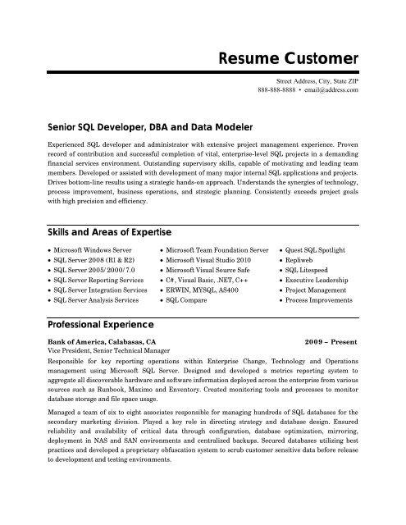

**Resume Customer**

Street Address, City, State ZIP 888-888-8888 email@address.com

Senior SQL Developer, DBA and Data Modeler

Experienced SQL developer and administrator with extensive project management experience. Proven record of contribution and successful completion of vital, enterprise-level SQL projects in a demanding financial services environment. Outstanding supervisory skills, capable of motivating and leading team members. Developed or assisted with development of many major internal SQL applications and projects. Drives bottom-line results using a strategic hands-on approach. Understands the synergies of technology. process improvement, business operations, and strategic planning. Consistently exceeds project goals with high precision and efficiency.

Skills and Areas of Expertise

Microsoft Windows Server

• SQL Server 2008 (R1 & R2) • SQL Server 2005/2000/7.0 ⚫ SQL Server Reporting Services • SQL Server Integration Services SQL Server Analysis Services

Professional Experience

• Microsoft Team Foundation Server Microsoft Visual Studio 2010

• Microsoft Visual Source Safe ⚫ C#, Visual Basic, .NET, C++ ⚫ERWIN, MYSQL, AS400 • SQL Compare

Bank of America, Calabasas, CA Vice President, Senior Technical Manager

• Quest SQL Spotlight • Repliweb

• SQL. Litespeed

• Executive Leadership • Project Management Process Improvements

**2009 - Present**

Responsible for key reporting operations within Enterprise Change, Technology and Operations management using Microsoft SQL Server. Designed and developed a metrics reporting system to aggregate all discoverable hardware and software information deployed across the enterprise from various sources such as Runbook, Maximo and Enventory. Created monitoring tools and processes to monitor database storage and file space usage.

Managed a team of six to eight associates responsible for managing hundreds of SQL databases for the secondary marketing division. Played a key role in directing strategy and database design. Ensured reliability and availability of critical data through configuration, database optimization, mirroring, deployment in NAS and SAN environments and centralized backups. Secured databases utilizing best practices and developed a proprietary obfuscation system to scrub customer sensitive data before release to development and testing environments.