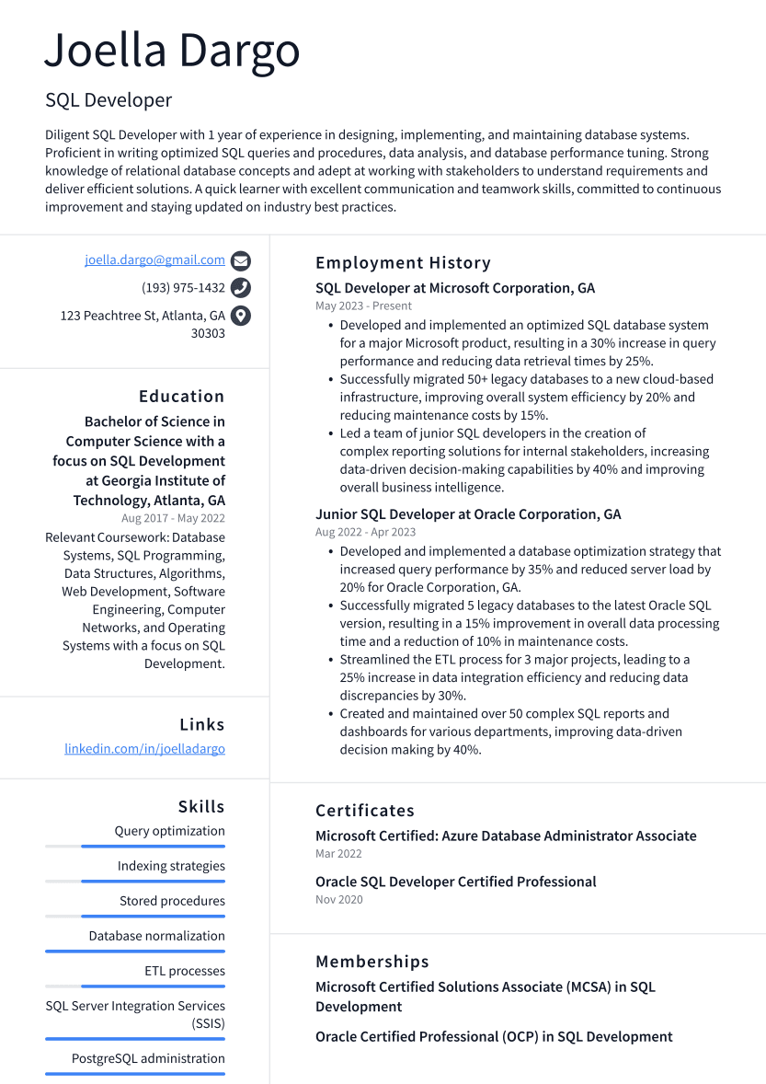

Joella Dargo

SQL Developer

Diligent SQL Developer with 1 year of experience in designing, implementing, and maintaining database systems. Proficient in writing optimized SQL queries and procedures, data analysis, and database performance tuning. Strong knowledge of relational database concepts and adept at working with stakeholders to understand requirements and deliver efficient solutions. A quick learner with excellent communication and teamwork skills, committed to continuous improvement and staying updated on industry best practices.

joella.dargo@gmail.com

(193) 975-1432

123 Peachtree St, Atlanta, GA

30303

Education

Bachelor of Science in Computer Science with a focus on SQL Development

**at Georgia Institute of Technology, Atlanta, GA Aug 2017 - May 2022**

Relevant Coursework: Database Systems, SQL Programming, Data Structures, Algorithms, Web Development, Software Engineering, Computer Networks, and Operating Systems with a focus on SQL Development.

Links

linkedin.com/in/joelladargo

Employment History

SQL Developer at Microsoft Corporation, GA May 2023 - Present

• Developed and implemented an optimized SQL database system for a major Microsoft product, resulting in a 30% increase in query performance and reducing data retrieval times by 25%.

• Successfully migrated 50+ legacy databases to a new cloud-based infrastructure, improving overall system efficiency by 20% and reducing maintenance costs by 15%.

• Led a team of junior SQL developers in the creation of

complex reporting solutions for internal stakeholders, increasing data-driven decision-making capabilities by 40% and improving overall business intelligence.

Junior SQL Developer at Oracle Corporation, GA Aug 2022-Apr 2023

• Developed and implemented a database optimization strategy that increased query performance by 35% and reduced server load by 20% for Oracle Corporation, GA.

• Successfully migrated 5 legacy databases to the latest Oracle SQL version, resulting in a 15% improvement in overall data processing time and a reduction of 10% in maintenance costs.

• Streamlined the ETL process for 3 major projects, leading to a 25% increase in data integration efficiency and reducing data discrepancies by 30%.

• Created and maintained over 50 complex SQL reports and dashboards for various departments, improving data-driven decision making by 40%.

Skills

Query optimization

Indexing strategies

Stored procedures

Database normalization

ETL processes

SQL Server Integration Services

(SSIS)

PostgreSQL administration

Certificates

Microsoft Certified: Azure Database Administrator Associate Mar 2022

Oracle SQL Developer Certified Professional

Nov 2020

Memberships

Microsoft Certified Solutions Associate (MCSA) in SQL Development

Oracle Certified Professional (OCP) in SQL Development