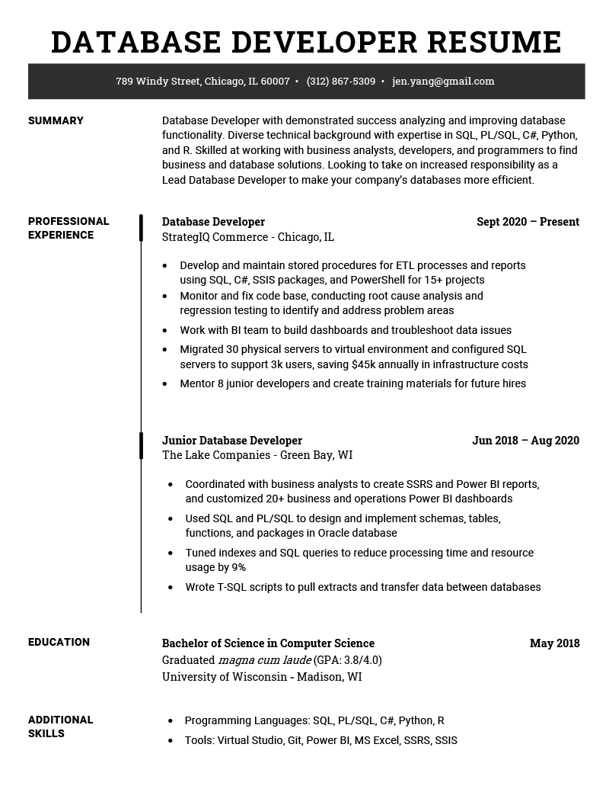

**DATABASE DEVELOPER RESUME**

**SUMMARY**

**PROFESSIONAL EXPERIENCE**

789 Windy Street, Chicago, IL 60007 (312) 867-5309⚫ jen.yang@gmail.com

Database Developer with demonstrated success analyzing and improving database functionality. Diverse technical background with expertise in SQL, PL/SQL, C#, Python, and R. Skilled at working with business analysts, developers, and programmers to find business and database solutions. Looking to take on increased responsibility as a Lead Database Developer to make your company's databases more efficient.

**Database Developer**

StrategIQ Commerce - Chicago, IL

Sept 2020 - Present

Develop and maintain stored procedures for ETL processes and reports using SQL, C#, SSIS packages, and PowerShell for 15+ projects

• Monitor and fix code base, conducting root cause analysis and regression testing to identify and address problem areas

Work with BI team to build dashboards and troubleshoot data issues • Migrated 30 physical servers to virtual environment and configured SQL servers to support 3k users, saving $45k annually in infrastructure costs

• Mentor 8 junior developers and create training materials for future hires

Junior Database Developer

The Lake Companies - Green Bay, WI

**Jun 2018 - Aug 2020**

• Coordinated with business analysts to create SSRS and Power BI reports, and customized 20+ business and operations Power BI dashboards

• Used SQL and PL/SQL to design and implement schemas, tables, functions, and packages in Oracle database

• Tuned indexes and SQL queries to reduce processing time and resource usage by 9%

• Wrote T-SQL scripts to pull extracts and transfer data between databases

**EDUCATION**

**ADDITIONAL SKILLS**

Bachelor of Science in Computer Science Graduated magna cum laude (GPA: 3.8/4.0) University of Wisconsin-Madison, WI

• Programming Languages: SQL, PL/SQL, C#, Python, R

•

Tools: Virtual Studio, Git, Power BI, MS Excel, SSRS, SSIS

**May 2018**