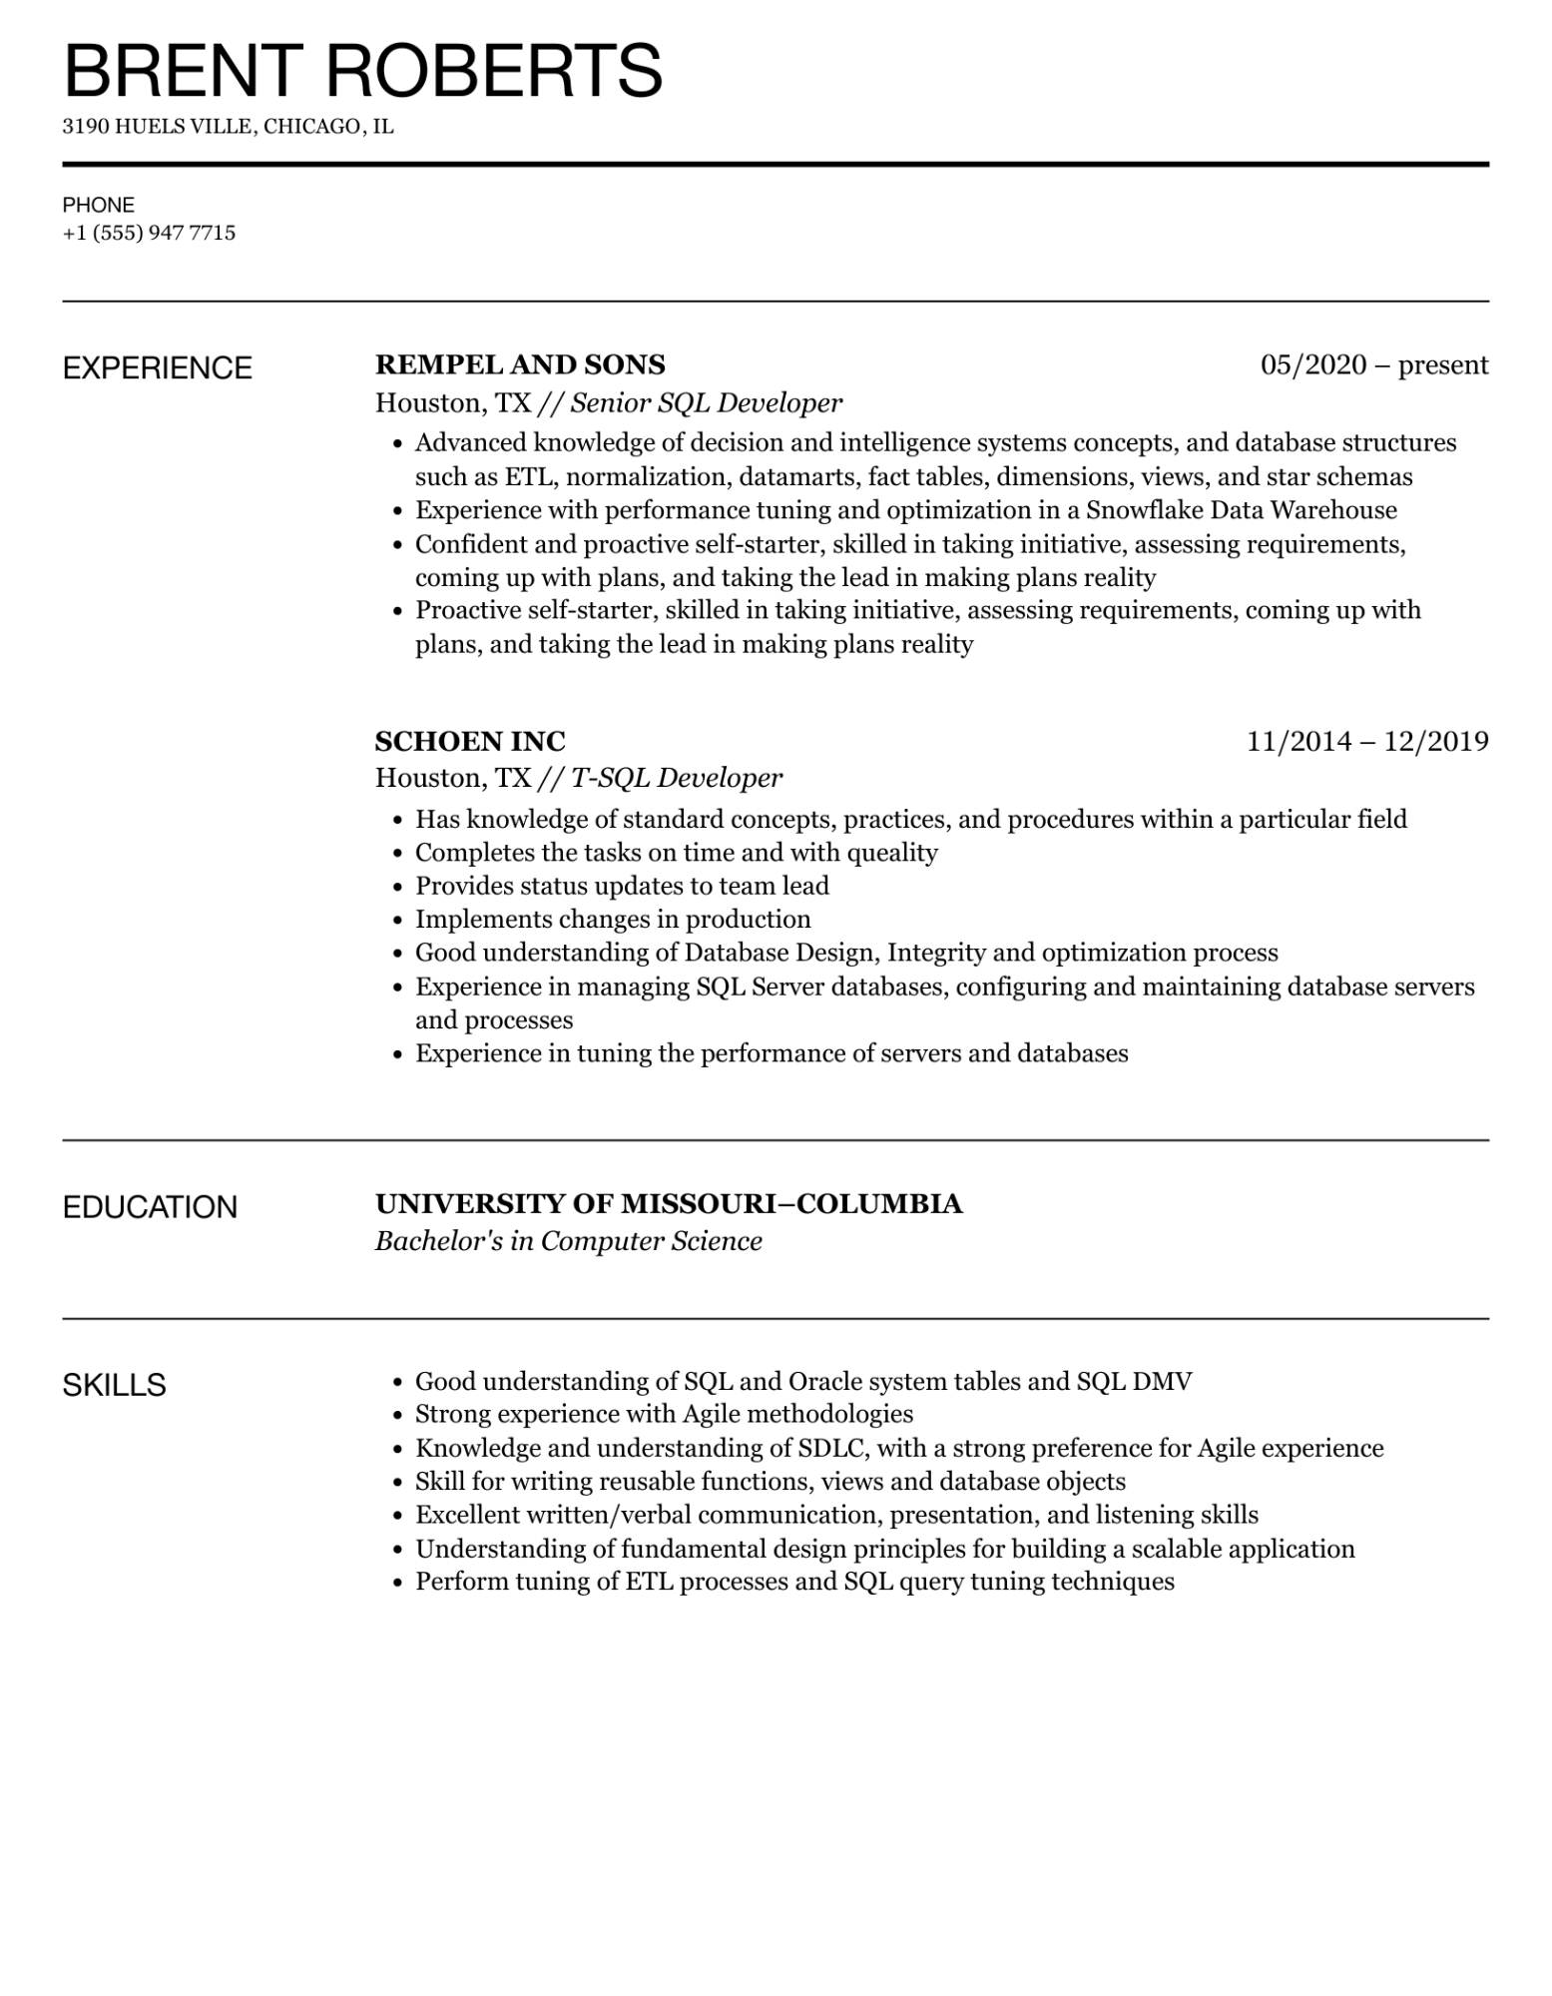

BRENT ROBERTS

3190 HUELS VILLE, CHICAGO, IL

PHONE

+1 (555) 947 7715

EXPERIENCE

**REMPEL AND SONS**

*Houston, TX // Senior SQL Developer*

05/2020 - present

• Advanced knowledge of decision and intelligence systems concepts, and database structures such as ETL, normalization, datamarts, fact tables, dimensions, views, and star schemas Experience with performance tuning and optimization in a Snowflake Data Warehouse

•

• Confident and proactive self-starter, skilled in taking initiative, assessing requirements, coming up with plans, and taking the lead in making plans reality

• Proactive self-starter, skilled in taking initiative, assessing requirements, coming up with plans, and taking the lead in making plans reality

**SCHOEN INC**

*Houston, TX // T-SQL Developer*

11/2014 - 12/2019

• Has knowledge of standard concepts, practices, and procedures within a particular field Completes the tasks on time and with queality

•

• Provides status updates to team lead

•

Implements changes in production

• Good understanding of Database Design, Integrity and optimization process

•

Experience in managing SQL Server databases, configuring and maintaining database servers and processes

• Experience in tuning the performance of servers and databases

EDUCATION

**UNIVERSITY OF MISSOURI-COLUMBIA**

*Bachelor's in Computer Science*

SKILLS

•

•

•

Good understanding of SQL and Oracle system tables and SQL DMV Strong experience with Agile methodologies

Knowledge and understanding of SDLC, with a strong preference for Agile experience

• Skill for writing reusable functions, views and database objects

• Excellent written/verbal communication, presentation, and listening skills

•

Understanding of fundamental design principles for building a scalable application

• Perform tuning of ETL processes and SQL query tuning techniques