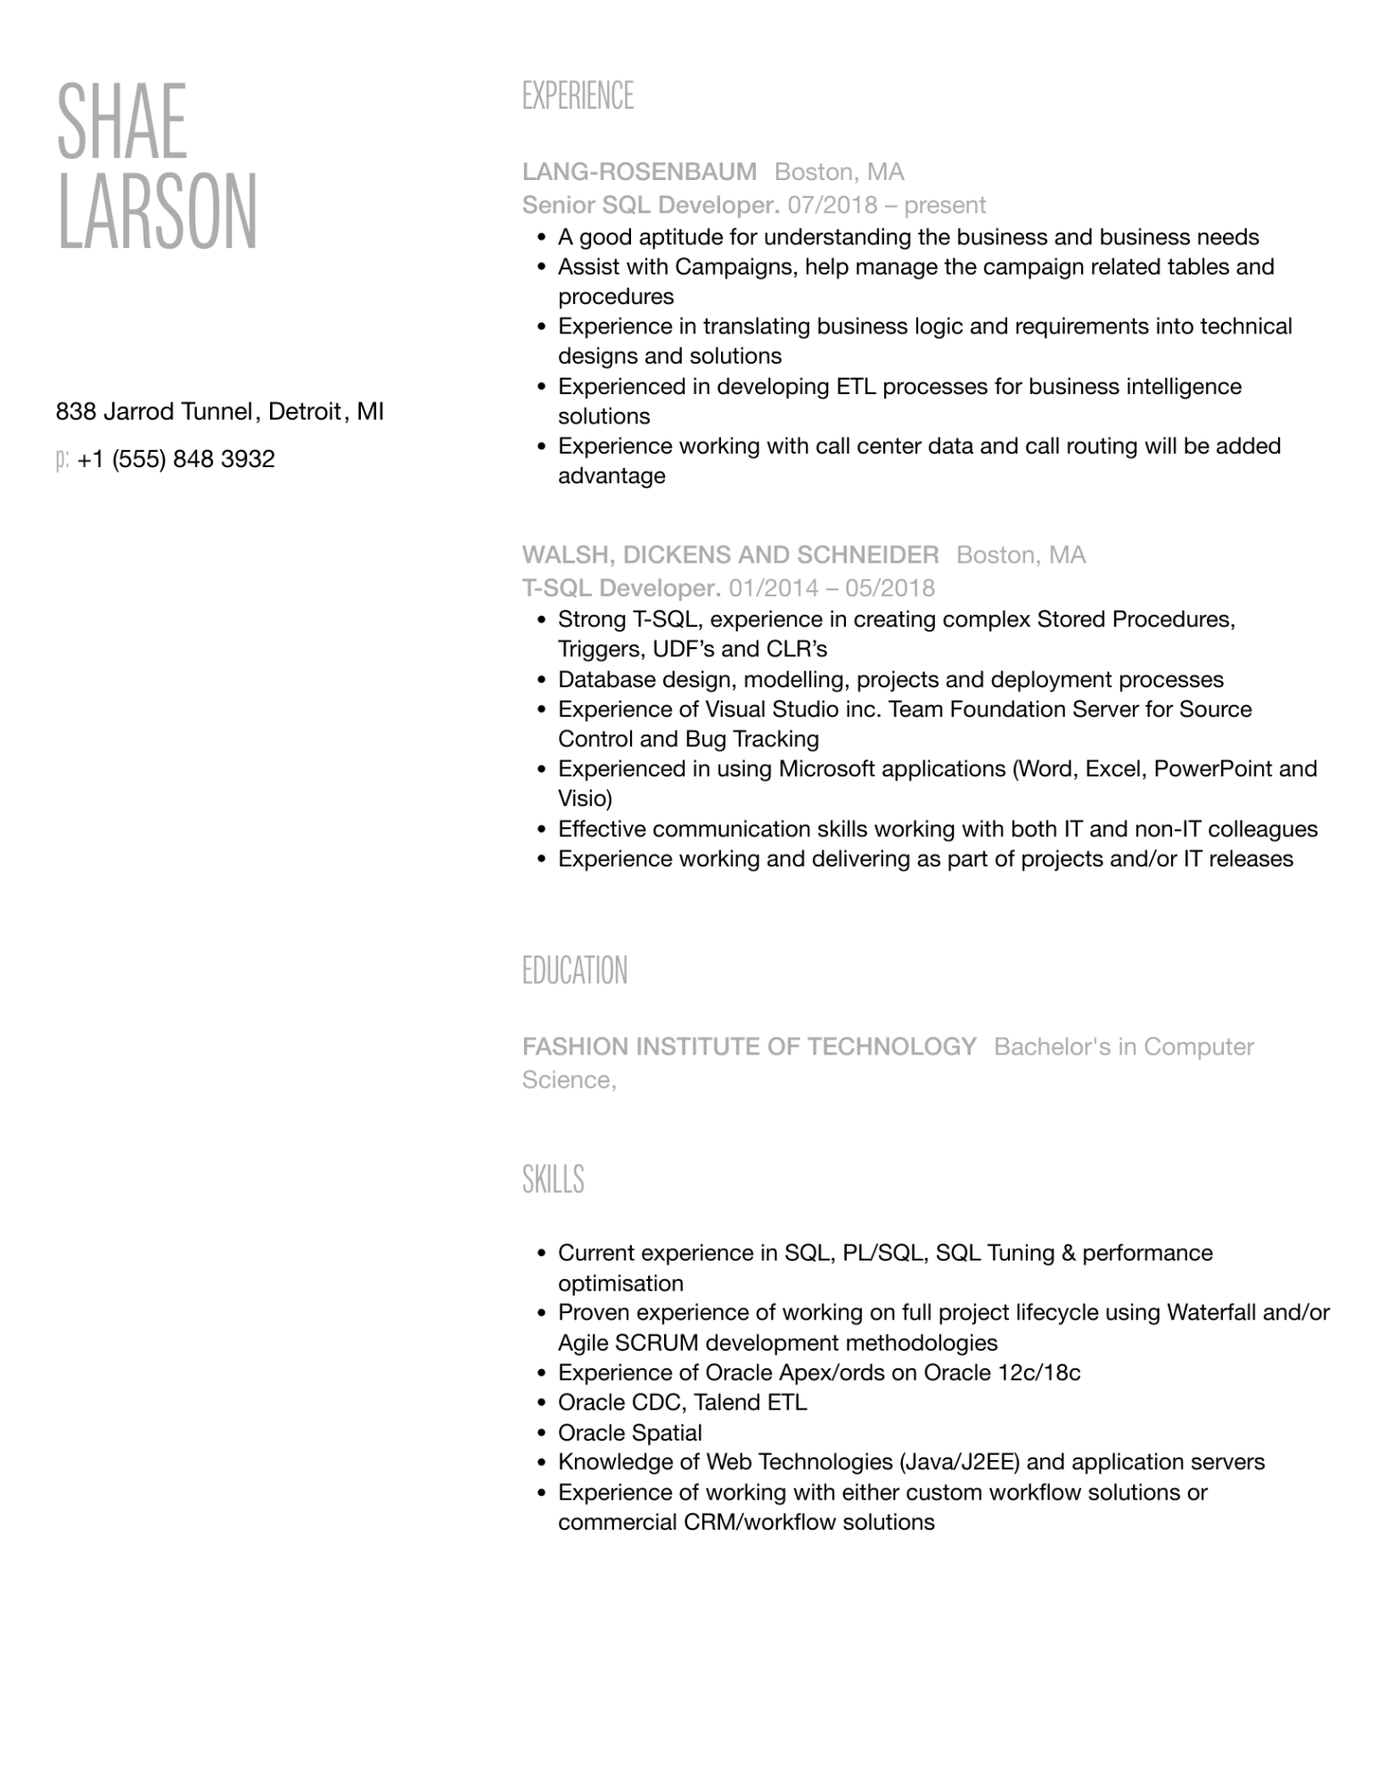

SHAE

LARSON

838 Jarrod Tunnel, Detroit, MI p: +1 (555) 848 3932

EXPERIENCE

**LANG-ROSENBAUM Boston, MA**

Senior SQL Developer. 07/2018 - present

• A good aptitude for understanding the business and business needs • Assist with Campaigns, help manage the campaign related tables and procedures

•

Experience in translating business logic and requirements into technical designs and solutions

• Experienced in developing ETL processes for business intelligence solutions

•

Experience working with call center data and call routing will be added advantage

**WALSH, DICKENS AND SCHNEIDER Boston, MA**

T-SQL Developer. 01/2014 - 05/2018

•

·

Strong T-SQL, experience in creating complex Stored Procedures, Triggers, UDF's and CLR's

• Database design, modelling, projects and deployment processes Experience of Visual Studio inc. Team Foundation Server for Source Control and Bug Tracking

•

Experienced in using Microsoft applications (Word, Excel, PowerPoint and Visio)

• Effective communication skills working with both IT and non-IT colleagues Experience working and delivering as part of projects and/or IT releases

·

EDUCATION

**FASHION INSTITUTE OF TECHNOLOGY Bachelor's in Computer Science,**

SKILLS

• Current experience in SQL, PL/SQL, SQL Tuning & performance optimisation

• Proven experience of working on full project lifecycle using Waterfall and/or

•

Agile SCRUM development methodologies

Experience of Oracle Apex/ords on Oracle 12c/18c

• Oracle CDC, Talend ETL

• Oracle Spatial

•

•

Knowledge of Web Technologies (Java/J2EE) and application servers

Experience of working with either custom workflow solutions or

commercial CRM/workflow solutions