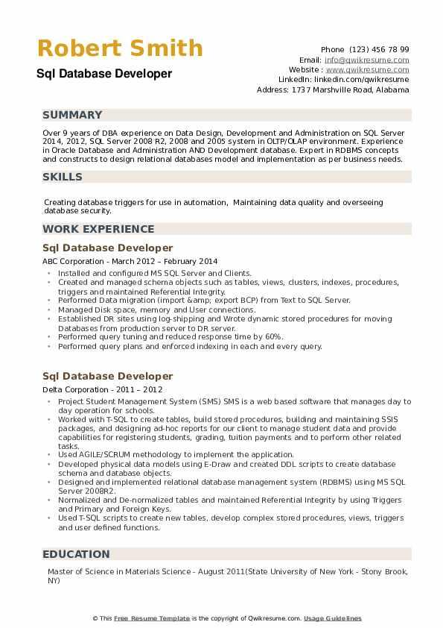

Robert Smith Sql Database Developer

SUMMARY

Phone (123) 456 78 99

Email: info@qwikresume.com

Website: www.qwikresume.com Linkedin: linkedin.com/qwikresume Address: 1737 Marshville Road, Alabama

Over 9 years of DBA experience on Data Design, Development and Administration on SQL Server 2014, 2012, SQL Server 2008 R2, 2008 and 2005 system in OLTP/OLAP environment. Experience in Oracle Database and Administration AND Development database. Expert in RDBMS concepts. and constructs to design relational databases model and implementation as per business needs.

**SKILLS**

Creating database triggers for use in automation, Maintaining data quality and overseeing database security.

**WORK EXPERIENCE**

Sql Database Developer

ABC Corporation - March 2012 February 2014

• Installed and configured MS SQL Server and Clients.

• Created and managed schema objects such as tables, views, clusters, indexes, procedures, triggers and maintained Referential Integrity.

.

.

Performed Data migration (import &amp; export BCP) from Text to SQL Server.

Managed Disk space, memory and User connections.

Established DR sites using log-shipping and Wrote dynamic stored procedures for moving Databases from production server to DR server.

⚫Performed query tuning and reduced response time by 60%.

Performed query plans and enforced indexing in each and every query.

Sql Database Developer

Delta Corporation - 2011-2012

• Project Student Management System (SMS) SMS is a web based software that manages day to day operation for schools.

.

.

"

"

Worked with T-SQL to create tables, build stored procedures, building and maintaining SSIS packages, and designing ad-hoc reports for our client to manage student data and provide capabilities for registering students, grading, tuition payments and to perform other related tasks..

Used AGILE/SCRUM methodology to implement the application.

Developed physical data models using E-Draw and created DDL scripts to create database schema and database objects.

Designed and implemented relational database management system (RDBMS) using MS SQL Server 2008R2.

• Normalized and De-normalized tables and maintained Referential Integrity by using Triggers and Primary and Foreign Keys.

• Used T-SQL scripts to create new tables, develop complex stored procedures, views, triggers and user defined functions.

**EDUCATION**

Master of Science in Materials Science - August 2011(State University of New York - Stony Brook, NY)

© This Free Resume Template is the copyright of Qwikresume.com. Usage Guidelines