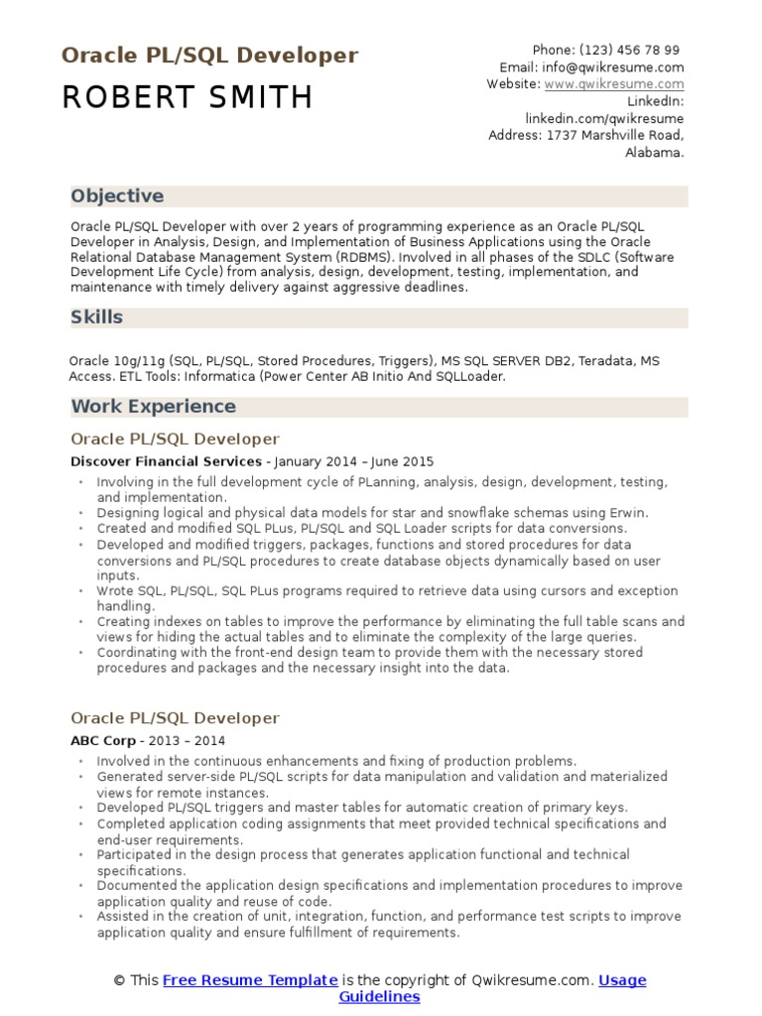

**Oracle PL/SQL Developer ROBERT SMITH**

Phone: (123) 456 78 99 Email: info@qwikresume.com Website: www.qwikresume.com

LinkedIn:

linkedin.com/qwikresume

Address: 1737 Marshville Road, Alabama.

**Objective**

Oracle PL/SQL Developer with over 2 years of programming experience as an Oracle PL/SQL Developer in Analysis, Design, and Implementation of Business Applications using the Oracle Relational Database Management System (RDBMS). Involved in all phases of the SDLC (Software Development Life Cycle) from analysis, design, development, testing, implementation, and maintenance with timely delivery against aggressive deadlines.

**Skills**

Oracle 10g/11g (SQL, PL/SQL, Stored Procedures, Triggers), MS SQL SERVER DB2, Teradata, MS Access. ETL Tools: Informatica (Power Center AB Initio And SQLLoader.

**Work Experience**

Oracle PL/SQL Developer

Discover Financial Services - January 2014 - June 2015

⚫Involving in the full development cycle of Planning, analysis, design, development, testing, and implementation.

• Designing logical and physical data models for star and snowflake schemas using Erwin. • Created and modified SQL PLUS, PL/SQL and SQL Loader scripts for data conversions. Developed and modified triggers, packages, functions and stored procedures for data conversions and PL/SQL procedures to create database objects dynamically based on user inputs.

.

• Wrote SQL, PL/SQL, SQL PLUS programs required to retrieve data using cursors and exception handling.

.

.

Creating indexes on tables to improve the performance by eliminating the full table scans and views for hiding the actual tables and to eliminate the complexity of the large queries.

• Coordinating with the front-end design team to provide them with the necessary stored procedures and packages and the necessary insight into the data.

Oracle PL/SQL Developer

ABC Corp - 2013 - 2014

.

.

.

.

Involved in the continuous enhancements and fixing of production problems. Generated server-side PL/SQL scripts for data manipulation and validation and materialized views for remote instances.

Developed PL/SQL triggers and master tables for automatic creation of primary keys.

Completed application coding assignments that meet provided technical specifications and end-user requirements.

Participated in the design process that generates application functional and technical specifications.

⚫ Documented the application design specifications and implementation procedures to improve application quality and reuse of code.

• Assisted in the creation of unit, integration, function, and performance test scripts to improve application quality and ensure fulfillment of requirements.

This Free Resume Template is the copyright of Qwikresume.com. Usage

Guidelines