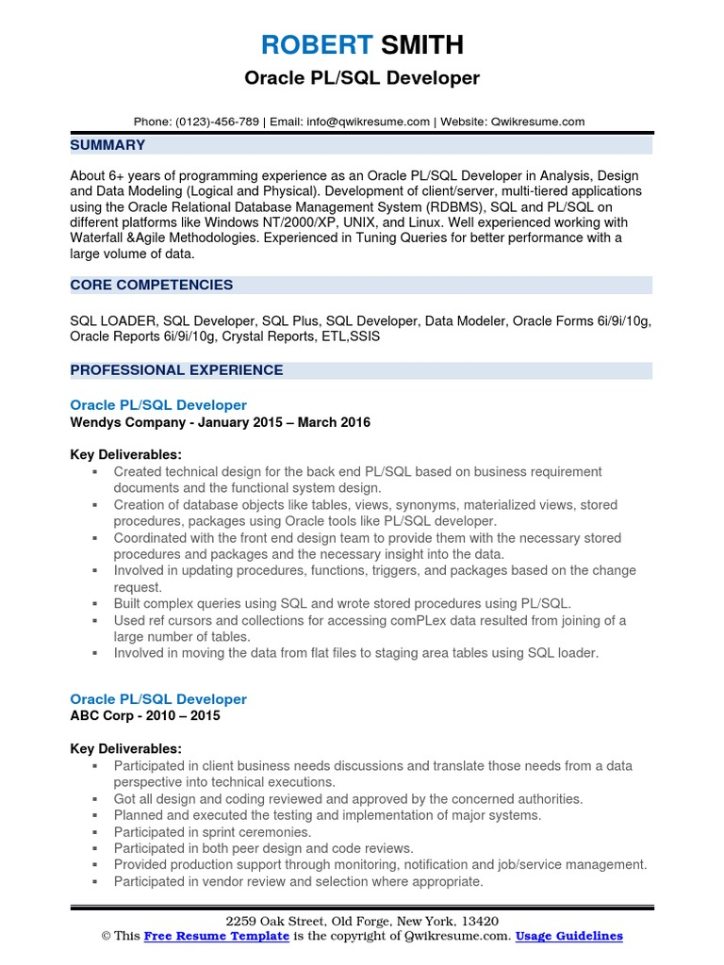

**ROBERT SMITH**

**Oracle PL/SQL Developer**

Phone: (0123)-456-789 | Email: info@qwikresume.com | Website: Qwikresume.com

**SUMMARY**

About 6+ years of programming experience as an Oracle PL/SQL Developer in Analysis, Design and Data Modeling (Logical and Physical). Development of client/server, multi-tiered applications using the Oracle Relational Database Management System (RDBMS), SQL and PL/SQL on different platforms like Windows NT/2000/XP, UNIX, and Linux. Well experienced working with Waterfall & Agile Methodologies. Experienced in Tuning Queries for better performance with a large volume of data.

**CORE COMPETENCIES**

SQL LOADER, SQL Developer, SQL Plus, SQL Developer, Data Modeler, Oracle Forms 6i/9i/10g, Oracle Reports 6i/9i/10g, Crystal Reports, ETL,SSIS

**PROFESSIONAL EXPERIENCE**

Oracle PL/SQL Developer

**Wendys Company - January 2015 - March 2016**

Key Deliverables:

Created technical design for the back end PL/SQL based on business requirement documents and the functional system design.

Creation of database objects like tables, views, synonyms, materialized views, stored procedures, packages using Oracle tools like PL/SQL developer.

Coordinated with the front end design team to provide them with the necessary stored procedures and packages and the necessary insight into the data.

Involved in updating procedures, functions, triggers, and packages based on the change request.

Built complex queries using SQL and wrote stored procedures using PL/SQL.

Used ref cursors and collections for accessing complex data resulted from joining of a large number of tables.

Involved in moving the data from flat files to staging area tables using SQL loader.

Oracle PL/SQL Developer

**ABC Corp - 2010-2015**

Key Deliverables:

• Participated in client business needs discussions and translate those needs from a data perspective into technical executions.

Got all design and coding reviewed and approved by the concerned authorities.

Planned and executed the testing and implementation of major systems.

Participated in sprint ceremonies.

Participated in both peer design and code reviews.

Provided production support through monitoring, notification and job/service management. Participated in vendor review and selection where appropriate.

2259 Oak Street, Old Forge, New York, 13420

This Free Resume Template is the copyright of Qwikresume.com. Usage Guidelines