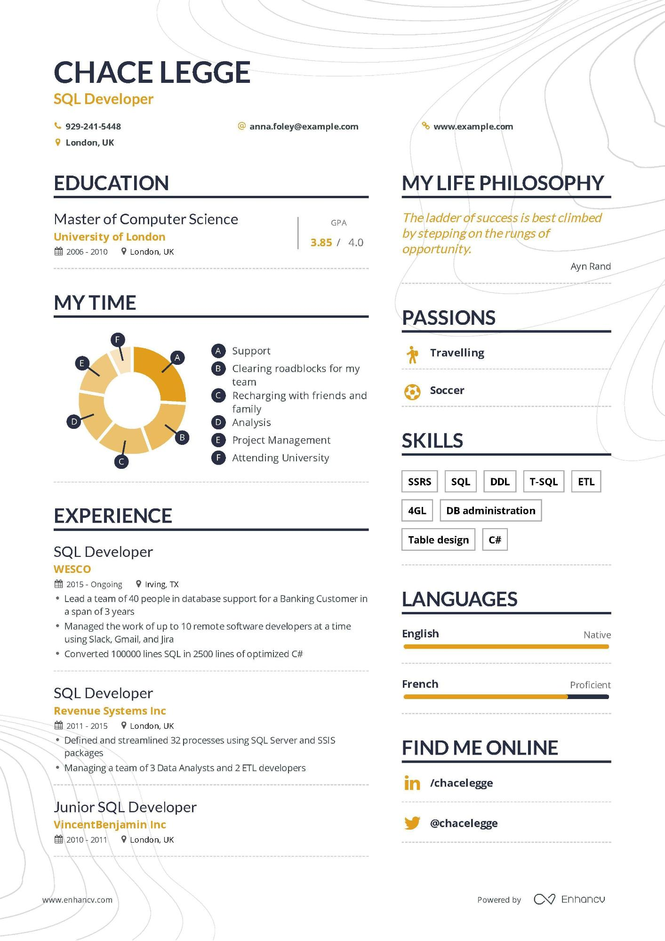

CHACE LEGGE

**SQL Developer**

**929-241-5448**

**London, UK**

**EDUCATION**

Master of Computer Science

**University of London**

2006 - 2010

London, UK

**MY TIME**

E

F

**@anna.foley@example.com**

**% www.example.com**

GPA

**3.85 / 4.0**

**MY LIFE PHILOSOPHY**

*The ladder of success is best climbed by stepping on the rungs of opportunity.*

A Support

A

B Clearing roadblocks for my

team

CRecharging with friends and

family

D Analysis

**PASSIONS**

**\* Travelling**

**Soccer**

Ayn Rand

D

B

E Project Management

**SKILLS**

F Attending University

**SSRS**

**SQL DDL T-SQL**

**ETL**

**EXPERIENCE**

SQL Developer

**WESCO**

**44**

2015- Ongoing

Irving, TX

• Lead a team of 40 people in database support for a Banking Customer in a span of 3 years

**4GL**

**DB administration**

**Table design**

**C#**

**LANGUAGES**

•

Managed the work of up to 10 remote software developers at a time using Slack, Gmail, and Jira

• Converted 100000 lines SQL in 2500 lines of optimized C#

**English**

**French**

SQL Developer

**Revenue Systems Inc**

11 2011 - 2015

London, UK

Defined and streamlined 32 processes using SQL Server and SSIS packages

Managing a team of 3 Data Analysts and 2 ETL developers

Junior SQL Developer

**VincentBenjamin Inc**

2010-2011

London, UK

**FIND ME ONLINE**

**in /chacelegge**

**@chacelegge**

www.enhancv.com

Native

Proficient

Powered by

Enhancv