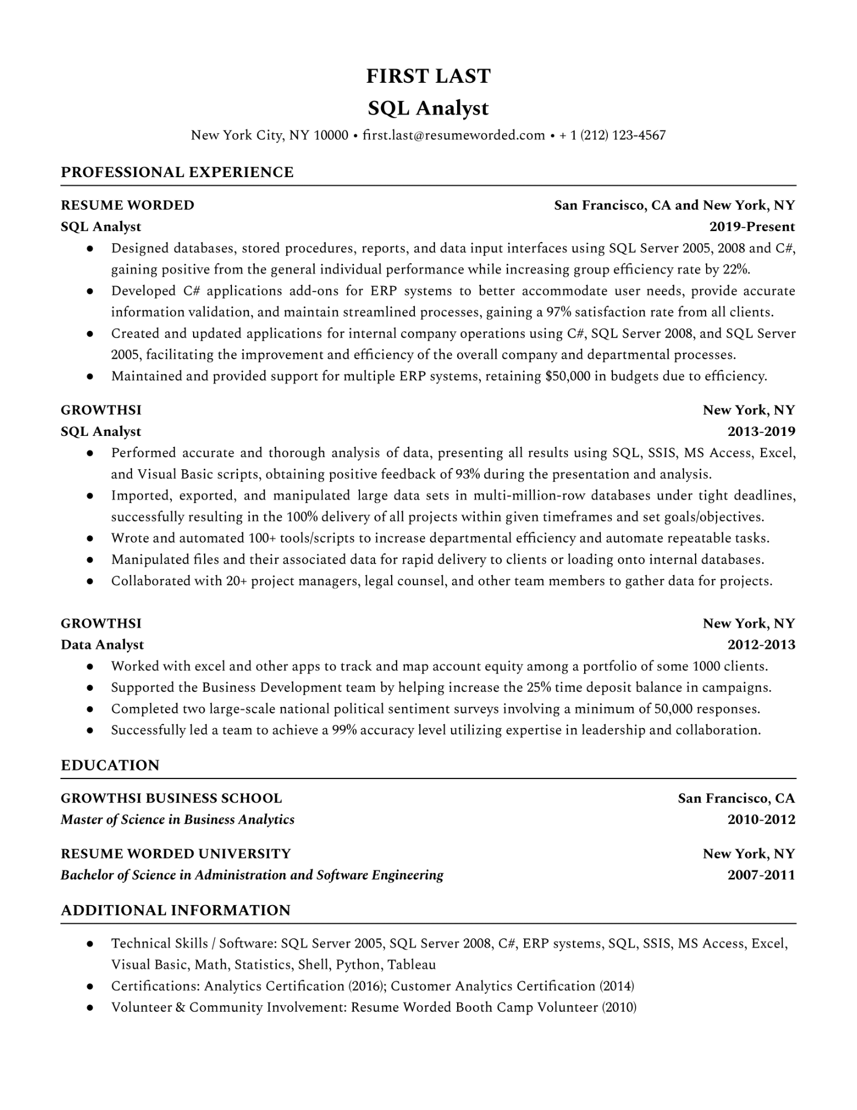

**FIRST LAST SQL Analyst**

New York City, NY 10000 first.last@resumeworded.com

**PROFESSIONAL EXPERIENCE**

**RESUME WORDED**

**SQL Analyst**

•

•

• +1 (212) 123-4567

**San Francisco, CA and New York, NY 2019-Present**

Designed databases, stored procedures, reports, and data input interfaces using SQL Server 2005, 2008 and C#, gaining positive from the general individual performance while increasing group efficiency rate by 22%.

• Developed C# applications add-ons for ERP systems to better accommodate user needs, provide accurate information validation, and maintain streamlined processes, gaining a 97% satisfaction rate from all clients. Created and updated applications for internal company operations using C#, SQL Server 2008, and SQL Server 2005, facilitating the improvement and efficiency of the overall company and departmental processes. Maintained and provided support for multiple ERP systems, retaining $50,000 in budgets due to efficiency.

•

**GROWTHSI**

**SQL Analyst**

•

•

•

•

**New York, NY 2013-2019**

Performed accurate and thorough analysis of data, presenting all results using SQL, SSIS, MS Access, Excel, and Visual Basic scripts, obtaining positive feedback of 93% during the presentation and analysis. Imported, exported, and manipulated large data sets in multi-million-row databases under tight deadlines, successfully resulting in the 100% delivery of all projects within given timeframes and set goals/objectives. Wrote and automated 100+ tools/scripts to increase departmental efficiency and automate repeatable tasks. Manipulated files and their associated data for rapid delivery to clients or loading onto internal databases. Collaborated with 20+ project managers, legal counsel, and other team members to gather data for projects.

**GROWTHSI**

**Data Analyst**

**New York, NY 2012-2013**

Worked with excel and other apps to track and map account equity among a portfolio of some 1000 clients. · Supported the Business Development team by helping increase the 25% time deposit balance in campaigns. • Completed two large-scale national political sentiment surveys involving a minimum of 50,000 responses. • Successfully led a team to achieve a 99% accuracy level utilizing expertise in leadership and collaboration.

**EDUCATION**

**GROWTHSI BUSINESS SCHOOL**

***Master of Science in Business Analytics***

**RESUME WORDED UNIVERSITY**

***Bachelor of Science in Administration and Software Engineering***

**ADDITIONAL INFORMATION**

•

**San Francisco, CA**

**2010-2012**

**New York, NY 2007-2011**

Technical Skills / Software: SQL Server 2005, SQL Server 2008, C#, ERP systems, SQL, SSIS, MS Access, Excel, Visual Basic, Math, Statistics, Shell, Python, Tableau

Certifications: Analytics Certification (2016); Customer Analytics Certification (2014)

• Volunteer & Community Involvement: Resume Worded Booth Camp Volunteer (2010)